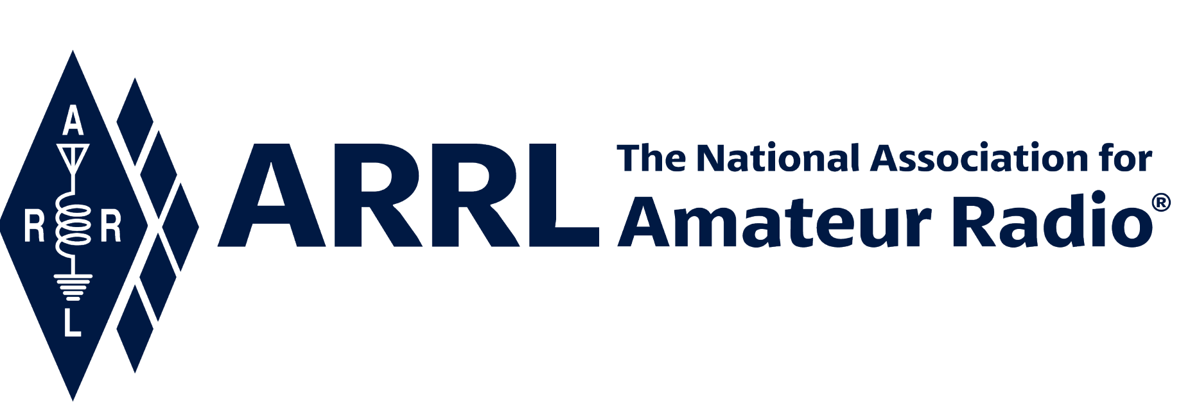
IN-NEWSLETTER
September 10, 2021

Vol. 51, No. 32 Covering September 4-8, 2021

Upcoming Meetings and Events

Events listed below are subject to change at any time; information will be updated as soon as it becomes available.

Pacificon- October 15-17, 2021

ARRL Executive Office Updates
Kelly Wells, Executive Assistant

David Minster, NA2AA, and Diane Middleton, W2DLM, hosted the IT Budget Meeting, and attended the following monthly meetings: Editorial, VEC and Lab.

Product Development
Reported by Bob Inderbitzen, NQ1R

Bob Inderbitzen, NQ1R, participated in a handful of planning meetings throughout the week including discussions with Mike Walters, W8ZY and other colleagues to help reboot the ARRL Club News e-newsletter in November. This effort will meet our goal of reinvigorating ARRL’s relationship with affiliated radio clubs. The reboot newsletter will include spotlights on vibrant clubs, best practices, event calendars, and features covering youth and collegiate clubs.

Bob also participated in the Management Council Meeting and completed revisions for the 2022/23 budget worksheets.

Materials were assembled for ARRL’s exhibit at Pacificon, which is hosting the 2021 ARRL Pacific Division Convention, October 15-17. The event will be attended by President Rick Roderick, K5UR, many Board members, Field Organization volunteers, and staff representatives Kathleen Callahan, KC1MBY and Bob Inderbitzen, NQ1R.

Director Kristen McIntyre, K6WX, is the keynote speaker for the convention’s banquet. Late last month, Jackie Ferreira, KB1PWB, Assistant Marketing Manager promoted the event and their online ticket-selling with a bulk emailing to ARRL members in the Pacific, Southwestern, and Northwestern Divisions.

In 2019, the convention attracted over 2,000 attendees to San Ramon, California. We also took our largest number of membership applications there, outside of Dayton Hamvention and Orlando HamCation.

Bob has been regularly updating the amateur radio media kits curated at www.arrl.org/media-hits. The most current ones are picked up each week for the ARRL Letter feature, “Amateur Radio in the News.”

We have been updating or removing embedded Adobe Flash and Shockwave videos on the website. Adobe has discontinued these file types, and most web browsers no longer support viewing this content. For instances when the content is still relevant, the files are being converted to MP4 videos, PowerPoint slides, and PDF files.

Development
Melissa Stemmer, KA7CLO

We are pleased to welcome Andrew C. Kirk, WB2C, of the Atlantic Division and John Hodapp, WA5TDX of the West Gulf Division, as the 325th and 326th members of the Maxim Society.

Melissa, along with ARRL Foundation Dr. David Woolweaver, K5RAV, and Scholarship Committee Chair Jim Fenstermaker, K9JF, have been working with the Kaleidoscope Scholarship Management Platform team on the implementation of the new scholarship software and database. The team has met via Zoom to discuss the design of the new application and how to streamline the process for both the applicants and the Foundation reviewers.

The 2022 ARRL Foundation Scholarship Program applications will open on November 1, 2021, and will close at midnight on December 21, 2021. All transcripts and any additional documentation needed are now required to be submitted with the application as opposed to being emailed to the Foundation as was done in the past. Scholarship recipients will be notified in May 2022. Additional information on the Scholarship Program including descriptions and terms for each scholarship can be found at www.arrl.org/scholarship-program.

Field Services
Reported by Steve Ewald, Leona Adams & Mike Walters

Tony Jones, N4ATJ, of McAdenville, (Gaston County), North Carolina has been nominated to run for the office of North Carolina Section Manager. The next term of office begins on April 1, 2022. Nominating petitions for this Section Manager election cycle are due at Headquarters by December 10, 2021.

Mike Walters conducted and led the monthly virtual meeting for all Section Managers on Tuesday evening, September 28. Mike also hosted a second virtual meeting on Wednesday, September 29th with the Section Managers and Division leaders of the Rocky Mountain Division.

W1AW
Joe Carcia

Over this past weekend, ARRL’s landscaper, CM Lawn Care, removed all the bushes and excess mulch surrounding W1AW. Fresh topsoil, and grass seed were put down, with the topsoil being graded away from the building to help with water run-off.

The various stations – D-Star, WL2K, MARS, EchoLink – situated on the desk located near the front door were disassembled. The desk was then moved into Studio Two. This allowed Joe to nearly complete the reorganization in Studio Two. New(er) PCs, footswitches, and WinUSB Keyers were also installed in Studio Two. The attention now turns to reassembling the stations into the new racks located in the main station area.

Joe participated in a conference call with Clark Burgard, N1BCG, and Bob Allision, WB1CGM, regarding the manning of W1AW on Saturday, December 11, 2021, preceding part of the 100th Anniversary of the first ARRL Transatlantic Tests (http://www.arrl.org/news/arrl-rsgb-announce-joint-events-to-celebrate-centenary-of-ham-radio-transatlantic-success ).

Scott worked on fast and slow code practice files for the week. He also processed eight (8) paper and twenty (20) electronic VUCC applications for a total of 1069 credits.

Radiosport
Sharon Taratula

Paper/Fieldcheck Processing Time | 3 Weeks
Logbook Processing Time | 5 – 6 Business Days
2021 DXCC Applications | 7,839
2021 WAS Applications | 2,509
2021 VUCC Applications | 1,446
2021 WAC Applications | 96
2021 WPX Applications | 740
2021 WAZ Applications | 675

Edited by Kelly Wells, Executive Assistant

