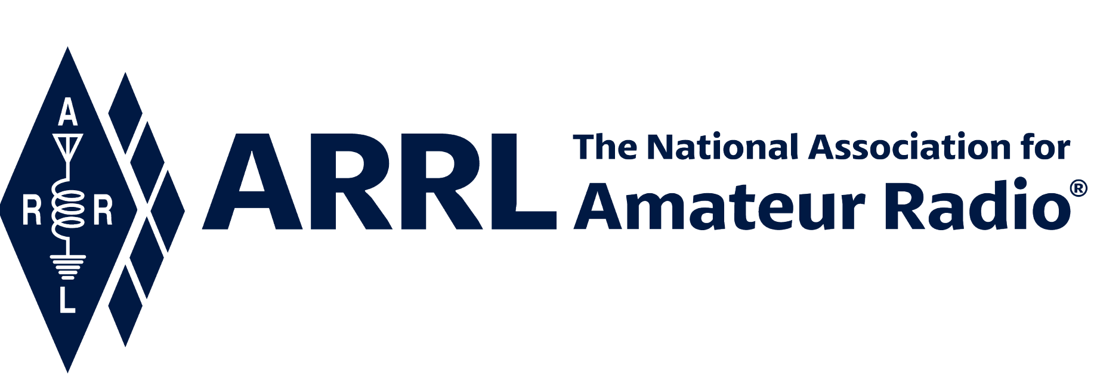
IN-NEWSLETTER
October 1, 2021

Vol. 51, No. 32 Covering September 27-October 1, 2021

Upcoming Meetings and Events

Unfortunately, no new meetings or events have been added

ARRL Executive Office Updates
Kelly Wells, Executive Assistant

David Minster, NA2AA, and Diane Middleton, W2DLM attended several more department budget meetings throughout the week.

David Minster, NA2AA, also participated as a guest speaker during the Dakota Division Hamfest, albeit virtually, on Saturday, September 25th.

Membership, Marketing & Communications
Kathleen Callahan, KC1MBY

ARRL Annual Online Auction takes place from October 8-14, 2021, with the preview of items beginning October 5. Each year, ARRL brings you the opportunity to bid on unique one-of-a-kind items, equipment, books, and memorabilia. The best part…100% of the proceeds benefit ARRL Education Programming – making it a win-win for all ARRL Members! A special thank you to our 2021 Auction Sponsor, GigaParts.



The September issue of the On the Air Email is now online. This issue is filled with tips and articles to help new hams get involved in the fun and excitement of contesting. The free email is a great resource featuring curated content from ARRL's On the Air magazine, as well as advice from veteran hams who share their stories from when they were starting out.

To register for the free monthly On the Air Email visit:

www.arrl.org/on-the-air-email-subscription

New Member Service Hours

We have extended phone support service hours from 8:00 AM – 7:00 PM ET, Monday through Thursday, to better serve our members. The Member Services team is available during these hours at 1-860-594-0200 to process address changes, online account support, new memberships, renewals, and publication and product orders.

Inquiries for Logbook of the World (LoTW) will continue to be serviced via email at LoTW-help@arrl.org.

Advertising
December QST features a new advertiser Chuck Penson, WA7ZZE promoting his Heathkit book.

New in the Online Store
ARRL Oxford Long Sleeve White

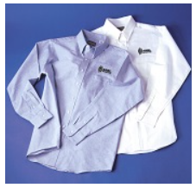
ARRL Oxford Long Sleeve in White and Light Blue
Our wrinkle-resistant long-sleeve button-down oxford shirts are back. This comfortable, classic shirt is perfect for work or casual wear. Available in white or light blue with ARRL logo embroidered in black. Price includes 1 or 2 lines of text for your name and call sign.

Features a button-down collar, left chest pocket, and extended tail-made from a 60% cotton/40% poly blend.
Available in sizes Med-XXXL.
Order at: http://www.arrl.org/shop/ARRL-Oxford-Long-Sleeve-White/

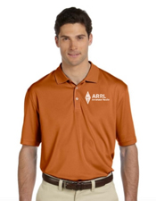

ARRL Burnt Orange Polo
This fall burnt orange polo with the ARRL logo embroidered in white is 100% double polyester mesh, breathable with moisture-wicking. Double-needle stitched sleeves and bottom hem; Back neck yoke, ribbed collar, and three-button placket.
Available in sizes M-4XL.
http://www.arrl.org/shop/ARRL-Fall-Burnt-Orange-Polo-6878/
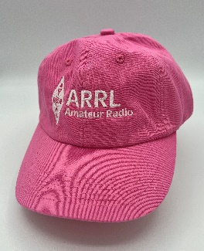
Pink Unisex Baseball Cap
Look stylish and feel great wearing this unstructured, low-profile cap featuring the ARRL logo in white. Adjustable fabric strap with brass buckle. One size fit most.
www.arrl.org/shop/Pink-ARRL-Hat/

Field Services
Steve Ewald, Leona Adams & Mike Walters

Leona Adams completed preparations for the Kansas Section Manager election. Candidate statements and ballots were printed. A special thank you to the mailroom staff, for getting the ballots in the mail ahead of the October 1 deadline!

There are two candidates running for the next term of office in Kansas: Lloyd Colston, KC5FM, and incumbent Section Manager Ron Cowan, KBØDTI. Members in Kansas have until November 19 to return their ballots to Newington.

Plans for this year’s virtual Section Manager Workshop are set. Steve Ewald has been working with fellow colleagues at headquarters to schedule six (6) virtual sessions during the month of October.

A headquarters staff leader or member will serve as the main presenter for each session, and these discussions will be tailored to help the new Section Managers to learn more about ARRL and the resources that ARRL can provide. The new Section Managers (who have come on board within the past year) have been invited. All veteran Section Managers have also been invited to allow them a chance to review a particular subject and/or to learn more.

W1AW
Joe Carcia

Thanks to Bob Naumann, W5OV, for operating W1AW in the CQ Worldwide RTTY contest. He made 202 QSOs, all on 20 meters, for an initial claimed score of 38,228.

Joe continues with the station reorganization for Studio Two. Some re-cabling of Studio Two has been completed. Joe has been working with HQ’s landscaper to finalize plans to remove bushes and mulch surrounding the station. Joe is also in the process of finding masons to provide quotes on repointing the station.

Scott worked on slow and fast code practice files for the week. He also processed nine (9) paper and forty-one (41) electronic VUCC applications for a total of 4263 credits.

Radiosport
Sharon Taratula

Paper/Fieldcheck Processing Time | 4 Weeks
Logbook Processing Time | 5 – 6 Business Days
2021 DXCC Applications | 7,629
2021 WAS Applications | 2,455
2021 VUCC Applications | 1,418
2021 WAC Applications | 92
2021 WPX Applications | 738
2021 WAZ Applications | 657

Edited by Kelly Wells, Executive Assistant

