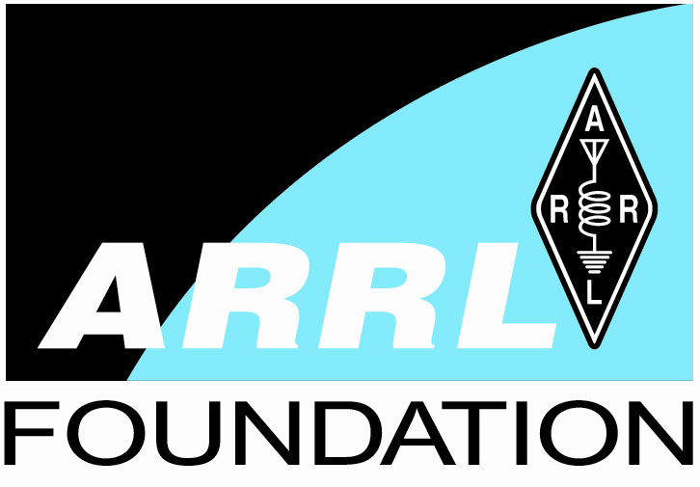
2006 ARRL Foundation Scholarship Awards
The William R. Goldfarb Memorial Scholarship
Mellissa Meye, KB0WZA, Camdenton, MO
The ARRL Scholarship to Honor Barry Goldwater - $5,000
Melissa Johnson, K1MJ, Bemidji MN
The Mary Lou Brown Scholarship - $2,500
Victor McFarland, N7VX, Coeur d'Alene ID
The Yasme Foundation Scholarships - $2,000 each
Rebecca Rich, KB0VVT, Raytown MO
Jeremy Crook, KI4BSL, Murfreesboro TN
Matthew Bailey, KI4JUD, Johnson City TN
Jonathan Troup, K0DE, Berthhoud CO
Curtis Hansen, KC2KYL, Durhamville NY
The You've Got a Friend in Pennsylvania Scholarships - $2,000 each
Victoria Reid, AA3OT, Sigel PA
Charles Johnson N3HX, New Castle PA
The Earl I. Anderson Scholarship - $1,250
Trevor Fulk, N9YM, Indianapolis IN
Yankee Clipper Contest Club Youth Scholarship - $1,200
Matthew Rozea, KC2IGE, Massapequa Park NY
The Dayton Amateur Radio Association Scholarships - $1,000 each
Justin Kates, KB3JUV, Lewes DE
Stuart Bottom, KF6UDF, Modesto CA
The ARRL Foundation General Fund Scholarships - $1,000
Kathryn Ankenbauer, KD8AHA, Portage MI
Justin Kates, KB3JUV, Lewes DE
Stuart Bottom, KF6UDF, Modesto CA
The Henry Broughton, K2AE, Memorial Scholarship - $1,000
John Stratton, AA3SL, Glen Mills PA
Robert Escriva, KC2DQN, Macedon NY
The Jean Cebik Memorial Scholarship - $1,000
SarahElizabeth Baguhn, WA9SE, Mount Horeb WI
The Tom and Judith Comstock Scholarship - $1,000
Allison Dryer, KD5IVO, DeSoto TX
The Irving W. Cook, WA0CGS, Scholarship - $1,000
Dustin Hatch, KC0LER, Chanute KS
The Charles Clarke Cordle Memorial Scholarship - $1,000
David Dzimianski, KG4BWM, Nicholson GA
The New England F. E. M. A. R. A. Scholarship - $1,000 each
Brian Earley, W1BWE, Cumberland RI
Colleen Traughber, KB0PWW, Medford MA
Michael Wassell, KB1LMC, Broad Brook CT
Matthew Weaver, KB1MNP, Westport MA
The Charles N. Fisher Memorial Scholarship - $1,000
James Wenner, K6NSY, Westminster CA
The IRARC, Joseph P. Rubino, WA4MMD, Memorial Scholarship - $1,000
Stephen Simpson, KC8IOY, Ocala FL
The K2TEO Martin J. Green, Sr. Memorial Scholarship - $1,000
Krystian Wsul, AB9HW, LaCrosse WI
The NEMAL Electronics Scholarship - $1,000
Brendan Rice, KG4BCV, Johnson City TN
The Northern California DX Foundation Scholarship - $1,000 each
William Fisher, W4WJF, Vale NC
Jonathan Jewell, KI4ETM, Paducah KY
The Paul and Helen L. Grauer Scholarship - $1,000
Robert Stoffel, KC0LEJ, Omaha NE
The L. Phil and Alice J. Wicker Scholarship - $1000
Jamie Ayers, AE4DX, Galax VA
The PHD ARA Scholarship - $1,000
Kerry Manderbach, KC0VNH, St. Louis MO
The Don Riebhoff Memorial Scholarship - $1,000
Benjamin Seidenberg, KI4CXN, Southern Pines NC
The Carole J. Streeter (KB9JBR) Scholarship - $ 750
Megan Moody, KD7KTK, Springville UT
The Albuquerque Amateur Radio Club/Toby Cross Memorial Scholarship - $500
Alan Sonntag, KE5DEG, Albuquerque NM
The William Bennett, W7PHO, Memorial Scholarship - $ 500
Alan Rutledge, KE6OMO, Berkeley CA
The Challenge Met Scholarship - $ 500 each
Reid Morine, W4RSM, Wilmington NC
Alan Rudy, KC2KVO, Phoenix NY
The Central Arizona DX Association Scholarship - $500
Joe Diaz, KD7GGU, Prescott Valley AZ
The Albert H. Hix, W8AH, Memorial Scholarship - $ 500
Jacob Mason, K4STL, Lovettsville VA
The Seth Horen, K1LOM, Memorial Scholarship - $ 500
Daniel Feveryear, KB3KDS, Delta PA
The Dr. James L. Lawson Memorial Scholarship - $ 500
Anthony Hussak, KC2LGL, Lockport NY
The Louisiana Memorial Scholarship - $ 500
Arthessius Hampton, KD5UYP, Monroe LA
The Fred R. McDaniel Memorial Scholarship - $ 500
David Darrow, KD5JLK, Plano TX
The Edmond A. Metzger Scholarship - $ 500
Neil Gebhardt, KB9ZGZ, LaMoille IL
The Mississippi Scholarship - $ 500
Charles Aldrich, KD5ZSM, Ocean Springs MS
The Six Meter Club of Chicago Scholarship - $ 500
Joshua Welsh, KB9WGX, Viola IL

