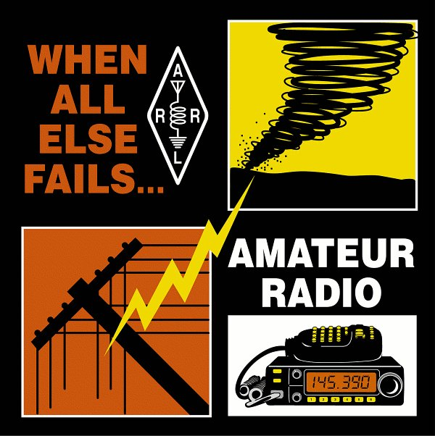
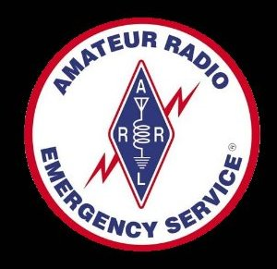

When All Else Fails, Amateur Radio Works.

By Jonathan Zimmerman-K6JGZ
and
Dennis Smith-KA6GSE
Section Emergency Coordinator Los Angeles Section

Why should HOPE members be interested in Amateur Radio? In an emergency, especially when normal communications are interrupted, this could be the most important question a HOPE member could ask. When all other forms of communication fail, Amateur Radio works. It’s that simple.

Amateur Radio operators know they will always be able to communicate with other Amateur operators in an emergency. Unlike other types of communication, cell phones, Onstar, and Nextel to name a few, Amateur Radio doesn’t depend on any other infrastructure. If you have mobile Amateur Radio in your Hummer, a battery operated radio in your home, or a handheld Amateur Radio in your pocket, you will be able to talk to other Amateur Radio Operators. Depending on the type of radio you are using, they could be in your neighborhood, your town, a nearby town, or across the country.

Amateur Radio Operators (sometimes called Ham Radio Operators or Hams) are frequently on the air. It’s not just for emergencies and their radios aren’t stashed away somewhere waiting to be used. Amateur Radio operators use their stations every day – from their vehicles and from their homes. They’re talking to friends and family and meeting new friends on the air.

Here’s why Amateur Radio works so well in an emergency. Most Hams want to be able to communicate in an emergency, so they make sure they have the proper equipment and adequate power to operate their radios – for days if necessary, during an emergency. Modern Amateur Radios are inexpensive, powerful, and require very little power to operate. Many Ham Radios can run for hours or even days on inexpensive batteries. Hams with alternate power such as Solar panels or small generators can recharge their batteries and operate indefinitely. If you had a Ham Radio in your Hummer, you could be communicating on the air as long as your fuel and batteries hold out. I operate my mobile radio all day long in my truck by running the engine occasionally to keep the battery charged up.

Amateur Radio Operators are Communicators First
Ham Radio Operators consider themselves communicators first, and radio operators second, so they organize and operate communication networks. Some nets are just for fun, but can be activated immediately in an emergency. Other radio nets are more formal and organized for local government or emergency services. And some nets are designed to operate over long distances – nationally if necessary, when disaster strikes. Because Amateur Radio operators are communicators and have the equipment, they make every effort to activate after disasters – especially disasters that damage regular lines of communications due to power outages or destruction of telephone lines. Besides, we what to know what’s going on, and radio nets are an excellent way to find out.

Last summer there was a major power outage in Los Angeles. As soon as the power went out, I plugged my portable radio into a spare battery I keep charged for emergencies and was on air in moments. Within minutes, dozens of Ham Radio operators, located all over Los Angeles, were on our net and we knew that some areas still had power and we knew which areas were experiencing a local power emergency.. One of the Hams was in contact with a Water and Power worker and we learned the blackout was caused when a series of electrical sub-stations failed. We knew it was just a power failure –nothing more than that… All this, in minutes, on our own, using Amateur Radio.

Can you image how useful we could be if HOPE members hooked up with the Ham Radio Community? Can you imagine how important it could be to have communications in your Hummer that absolutely worked, all the time, when other communications fail? You have the vehicles that can go almost anywhere and Ham Radio Operators have the communication systems that will work when you get there.

How Do I Become a Ham Radio Operator?
To operate an Amateur Radio, you need an FCC License. Amateur Radio licenses were once hard to get, but the FCC has realized that licenses to operate the higher VHF and UHF frequencies – the frequencies often used on local emergencies, are an important safety asset to any community, so the FCC has made it much easier for us to obtain an entry level Technician Class license.

The 35 question FCC Technician exam you need to pass to get your license is not that difficult and does not require Morse code. You will need to learn the basic rules and regulations of Amateur Radio operation and a little bit about how radios work.

Most people do very well on the exam by reading the "Now You're Talking" book published by the American Radio Relay League. It sells for $19.95 and is available from the Ham Radio Outlet and other radio supply stores. It's also available on line from the ARRL at www.arrl.org/catalog/?item=8810.

Other good books are the "Tech Q & A - 3rd Edition" (Catalog #8829, $12.95) and the "Technician Class Study Manual" by Gordon West ($15.95). Both are available at most radio supply stores, amateur radio stores (Ham Radio Outlet) or Radio Shack and on the Internet at either http://www.arrl.org or http://www.w5yi.org .

Sample test questions found at http://www.qrz.com are a very useful study aid. I highly recommend taking and retaking the sample tests until you are comfortable with your sample test scores. All of the questions on the FCC Exam are on the various sample tests and if you take the test enough times you will have an opportunity to learn the correct answer every question on the exam. My wife and I passed the exam by reading through the "Now You're Talking" book and taking the sample tests until we consistently did well on them. When we answered a question incorrectly, we looked it up in the book and re-read the section didn’t understand until we learned it. It’s as simple as that, and it was fun.

Hams have a long tradition of helping newcomers learn. Many areas have local Amateur Radio Clubs that offer free or inexpensive license instruction. If you are studying on your own and don’t understand something, don’t hesitate to ask around and find a Ham and ask your questions. Most Hams will be happy to help you, or will refer you to an “Elmer” in the area that’s considered an expert in explaining radio to novices.

“The most efficient way to learn to do something is with a coach or Elmer, a term dating back to the beginnings of Amateur Radio. An Elmer is someone who helps a newcomer become an established, competent Ham”.
The ARRL Operating Manuel For Radio Amateurs, 8th Edition, the American Radio Relay League, Copyright 2003

Just How Does this Communication Work?
At the local level, Amateur Radio operators have informal and formal groups to coordinate communication during emergencies. Hams may participate in local emergency organizations, or organize local "traffic nets" using easy to operate VHF (very high frequencies) and UHF (ultra high frequencies) available to any Technician Class Amateur Radio Operator.

At the state and national levels, hams are often involved with state and federal emergency management operations. Some Hams operate at the national level through the Amateur Radio Emergency Service (ARES) which is coordinated through the National Association for Amateur Radio (ARRL) and its field volunteers, and through the Radio Amateur Civil Emergency Service (RACES) which is coordinated through the Federal Emergency Management Agency (FEMA). In areas that are prone to severe weather, many hams are involved in Skywarn, operating under the National Weather Service.

Amateur Radio is recognized as a resource by the following National Relief organizations. Many of these organizations have formal agreements for emergency communication services with the Amateur Radio Emergency Service (ARES) and other Amateur Radio groups:

• Department of Homeland Security - Citizen Corps
• Federal Emergency Management Agency
• National Communications System
• American Red Cross
• Salvation Army
• National Weather Service
• Association of Public Safety Communications Officials

Here are some examples of emergencies where Amateur Radio Operators provided vital communications::

Hurricanes Katrina and Rita 2005
Four Hurricanes in Florida and the Gulf - September 2004
Hurricane Isabel - September 2003
Northeast blackout - August 2003
Midwest tornadoes - May 2003
Shuttle Columbia recovery effort - February 2003
Wildfires in Colorado - June 2002
Tornado in Maryland - April 2002
Flooding in Kentucky - March 2002
World Trade Center and Pentagon terrorist attacks - September 2001
Flooding in Texas and Louisiana (Storm Allison) - June 2001
Earthquake in India - January 2001
Earthquake in El Salvador - January 2001
Ice storms in Southwest - December 2000
Tornado in Alabama - December 2000
Avalanche in Alaska - March 2000
Fires in Los Alamos, New Mexico - May 2000
Hurricane Floyd - September 1999
Flooding in Texas - October 1998
Hurricane Georges - September 1998
Tornadoes in Florida - February 1998
“500-Year Flood," Grand Forks, N.D., and East Grand Forks, Minn. - April ,1997
Western U.S. floods - January 1997
Oklahoma City Bombing - April 1995

How to I Sign Up?
If you’re interested in becoming a Ham and operating a radio from your Hummer, contact the American Radio Relay League information site at: http://www.hello-radio.org/. Use this site to learn how to become an Amateur Radio Operator and to contact local ARRL Officials in your area they are listed at
http://www.arrl.org/sections/
Or you can write to:
ARRL
225 Main St
Newington, CT 06111
860-594-0200
Via E-mail circulation@arrl.org

For membership inquires, those can directed to:
http://www.arrl.org/join.html

Amateur Radio is fun. And it works. Always.
-end-

