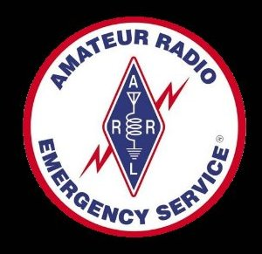 Marty Woll N6VI
21301 Candice Place, Chatsworth, CA 91311
telephone: (818) 773-9655 e-mail n6vi@arrl.org

June 1, 2009

The Honorable Henry A. Waxman
2204 Rayburn House Office Building
United States House of Representatives
Washington, DC 20515
Dear Representative Waxman:

I am writing as one of your constituents to ask that you support H.R. 2160, the "Amateur Radio Emergency Communications Enhancement Act of 2009."

I am a licensed Amateur (“Ham”) Radio operator (one of over 600,000 in the country) and volunteer around 1,000 hours a year, mainly in disaster communications. I am an instructor and battalion leader for the Los Angeles Fire Department’s Auxiliary Communication Service and training director for the Los Angeles Amateur Radio Emergency Service. I am Level 3 CERT and have taught communications to CERT classes. During last November’s Sayre Fire, I was the Amateur Radio operator who got through the fire lines and reestablished contact between Olive View Medical Center and the County Department of Health Services. I not only teach “Emcomm” (Emergency Communications), I do it, and all on an unpaid basis.

Radio Amateurs in every state donate their time and equipment, train and prepare to get the message through when all else fails. I know Hams whose volunteer efforts are hampered by the inability to erect antennas in their deed-restricted neighborhoods. H.R. 2160 is a first step toward finding solutions that will enable these volunteers to serve their communities effectively. It instructs the Secretary of Homeland Security to study the uses and capabilities of Amateur Radio communications in emergencies. The purpose of the study would be, among other things, to identify unreasonable or unnecessary impediments to enhanced Amateur Radio communications, such as the effects of private land use regulations on residential antenna installations, and to make recommendations regarding such impediments

Amateur Radio is an effective, valuable and free resource that benefits the public. Maximizing the use of competent volunteers makes more sense than ever in today’s challenging economy. Through our work with Homeland Security activities, state and local Emergency Management offices, and with numerous private agencies, Amateur Radio operators make a difference. We need your support to help address the challenges facing us as we seek to improve our capabilities to serve.

Please consider becoming a cosponsor for H.R. 2160 and please support the bill as it works its way through committee and the House of Representatives.

Sincerely,

Martin A. Woll

