Contest Advisory Committee
Semi-Annual Report

ARRL Board of Director’s Meeting
July 2016

George Wagner, K5KG
Chairman, CAC

2016 HIGHLIGHTS

YOUTH-IN-CONTESTING (YIC) — In January 2016, the PSC requested the CAC undertake a study of youth and radio contesting (“Radiosport”)

ARRL HF RULES CONSOLIDATION PROJECT (RCP) — In May 2016, the PSC requested the CAC undertake a project to consolidate the "General Rules for All ARRL Contests", the “General Rules for ARRL Contests Below 30 MHz”, and the individual contest rules into a single rule set for each of the ARRL HF contests.

CAC ADMINISTRATION — some changes were made to improve the CAC’s overall effectiveness and efficiency in the way it conducts its business. These were changes based on recommendations made to, and approved by, the PSC in 2015.

2016 PROJECTS & ISSUES
YOUTH IN CONTESTING ISSUE (YIC)
In January 2016, the PSC requested the CAC undertake a study of youth and radio contesting (“Radiosport”) with these key objectives:

- Find out whether young operators are under-represented in contesting particularly or whether contesting's young operator demographics are just representative of the current ham population.

- Engage in a broad survey of hams between 10 and 50 to assess their interest levels and preferences for contests.

- Based on a belief that Europe seems to have a stronger youth presence in radiosport [than the US], conduct research on what programs and approaches are used in Europe, and determine how European contesting programs are organized and publicized.

In specifying the YIC issue, the PSC asked that this assignment be carried out as a two-part effort. First, conduct the research, and report the findings. Second, analyze the findings and make specific recommendations. Present a preliminary or final report [this report is preliminary] prior to the Board meeting in July, 2016, with follow-up studies and/or recommendations completed over the following year.

A Youth in Amateur Radiosport Survey was rolled out in mid-April and will run until August 31, 2016. As of this writing, 950 responses have been received. Announcements in the July issues of QST, NCJ, and CQ Amateur Radio are expected to bring in additional responses.
In addition to the magazine announcements and to further advertise the survey, George, K5KG, attended Carole Perry's Youth Forum and the ARRL Youth Rally at Dayton and handed out survey advertising cards. Glenn, W0GJ, also handed out the survey cards from the NCDXF booth. Our thanks to Bob Inderbitzen, NQ1R, for having the cards designed and printed at HQ.

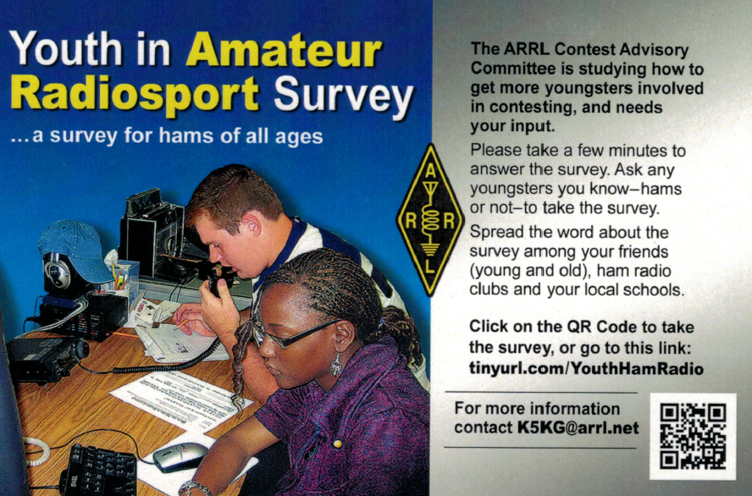

We encourage all Board members to take the survey, and spread word about it in their Divisions. (Survey cards are available from K5KG.)

Some of the more interesting trends we are seeing thus far include:
- 140 youth, ages 25 or less, have responded. This is 15% of all responses.

- Of the 140 youth who responded, the highest percentages of interests outside of ham radio are electronics, outdoor activities, and playing video games, in that order.
- Among all licensed hams who responded, approximately 29% have been licensed 5 years or less, and a somewhat larger number, 34%, have been licensed 40 years or more. 37% have been licensed from 6 to 39 years.
- 70% of all licensed respondents reported having participated in radiosport contests, with the others reporting having never participated in radiosport. Several commented that they had not heard of “radiosport”, perhaps thinking that “radiosport” was a specific contest. This may be due to “radiosport” being a somewhat new term for “contesting”.
- Among those who participate in radiosport, 40% said that radiosport could be improved by more timely publishing of scores.
- 37% of the non-contesters reported that they had not participated in radiosport because they never learned how to operate a contest.
Since the survey will run through August 31st, some of these trends may change.

In response to the survey, we are receiving large numbers of OTHER comments to the survey questions, and a few emails expressing ideas about how to get youth involved in ham radio and/or contesting. These many comments and ideas will be fully analyzed once the survey has completed. Additionally, since we will have access to detailed survey data from the youth who responded, we will be able to analyze their responses and, possibly find correlations that may lead to conclusions regarding youth participation — or lack of it — in radiosport.
We will be receiving volunteer assistance in analyzing the survey results from Bob Gerzoff, WK2Y. Bob is a recently retired statistician with background in statistical analysis of surveys. He is currently reviewing preliminary results that have been received.
Glenn, W0GJ, reported to the YIC subcommittee that NCDXF and YASME have funded three young hams to attend the IARU Region 1 (Europe/Africa) YOTA (Youth On The Air) rally in Austria in July 2016. They will be providing a report and making recommendations for YOTA involvement in IARU Region 2 (North & South America).
I want to thank the YIC subcommittee for their efforts. They are Don, K4ZA, Glenn, W0GJ, Pat, NA0N, Stan, K5GO and Dennis, W1UE.

RULES CONSOLIDATION PROJECT (RCP)

In May, 2016, the PSC requested the CAC undertake a project to consolidate the "General Rules for All ARRL Contests", the “General Rules for ARRL Contests Below 30 MHz”, and the individual contest rules into a single rule set for each of the ARRL HF contests.

In its assignment of the RCP, the PSC laid out the following guidelines:
- In the consolidation of the rules documents, the project will only consider the rules for contests that are published in the Contests and Radiosport Section of ARRL.org. [http://www.arrl.org/contests]
- The RCP is not to undertake changing any of the contest rules as they are presently written. The RCP subcommittee, however, is free to address in a separate report any contest rules that potentially need to be revised, eliminated or otherwise changed.
- The project will NOT assess log checking (LCR) software, as this will be the target of a separate project to be done at a later date.
- The project will NOT consolidate the rules for the ARRL VHF/UHF contests.
The Rules Consolidation Project (RCP) is underway with the formation of a subcommittee to handle the chores. Members of this subcommittee are Bob, K0KR, Chas, K3WW, Dave, K8CC, Pat, NA0N, and Dennis, W1UE. Collectively, the members of this subcommittee have long years of experience not only with contesting, but knowledge of the evolution of ARRL contest rules over the years, ARRL contest log checking, and work with CQWW contest rule projects.

The objective of this project is to consolidate the current three-tiers of existing rules into a single, self-contained set of rules specific to each individual ARRL HF contest. The team will initially focus on the International DX Contest, and once those rules have been consolidated and the format reviewed and approved by the PSC, they will then be used as a template for streamlining the rules of the other eight HF contests. In addition to the consolidation of the rules structure, the PSC has asked the team to develop any accompanying commentary they choose as to areas where they perceive that the rules might benefit from revision and, where appropriate, to suggest revised language.

In preparing for the launch of the RCP, Bob Neece, K0KR, reviewed the historical rules for ARRL DX, going back through the many years in which he participated in this contest. He also compared the current and historical ARRL DX rules with the format and the content of a variety of other contests. In his review and comparison, he took note of the effects, among others, of moving various bodies of information (including contest rules, together with other aspects of the contest announcements) from QST to the ARRL website. He also considered the impact upon the rules of the transition from paper to computer-based logging. Bob’s vision was that, to pursue the RCP with maximum efficiency and efficacy, it would behoove the subcommittee to have at least a basic sense of how the rules had evolved to help in understanding how we got to where we are now. Bob has drafted, but has not yet completed for distribution, a table that presents, for the benefit of the other members of the subcommittee, a compact distillation of the results of his review and comparison.

At present, there is not a timetable for the RCP. It is anticipated that once the work of consolidating the rules gets underway, and the initial template has been created, the duration of the project can be estimated.

CAC ADMINISTRATION

Some changes in the way the CAC conducts its business have been made based on recommendations made to, and subsequently approved by the PSC in 2015.

Highlights include:
- PSC made two timely assignments to the CAC in the first half of 2016.
- CAC assignments are now classified as “Projects” and “Issues”, thereby abandoning the term “taskings”.
- Projects and Issues are assigned to sub-committees of three to five members. Currently, seven CAC members are unassigned to projects or issues, so there potentially is “bandwidth” available for an additional assignment in 2016.
- Sub-committees have access to GoToMeeting (GTM) voice & video conferencing as needed to carry out their work.
- Chairman holds periodic conference calls with the CAC using GTM. The use of GTM does not preclude the use of email by the committee members.

FOLLOW UP ON 2015 RECOMMENDATIONS

- Revise the ARRL Handbook for CAC Members. Realizing that the CAC Handbook was not being distributed to CAC members, or being followed over the past several years, K5KG recommended that this document be revised and put into use. Since revising this document involves ARRL policy issues and the work of the Advisory Committees, this project is being done by Doug Rehman, K4AC, and David Norris, K5UZ.

- Ensure that positive and timely feedback is given by the PSC to the CAC regarding all of CAC decisions, recommendations, and the status of implementation of contest-related recommendations at HQ.
  - When results and recommendations from the Youth In Contesting Issue and the Rules Consolidation Project have been released, it will be important that the CAC receive timely and relevant feedback from both the PSC and HQ on this work.
- Per the current ARRL CAC Handbook, Division Directors are required to confirm annually their CAC representative’s continuation with the CAC, and ensure that new member appointments and term-limits are carried out in accordance with the Handbook’s guidelines.
  - This may not be taking place. It is important that the services of all CAC members be reaffirmed periodically by their Division Directors.

CAC MEMBERSHIP

There have been no changes in CAC membership since Pat Korkowski, NA0N, (Dakota Div.) and Glenn Johnson, W0GJ, (Midwest Div.) joined the CAC in 2015.

This is the current membership of the Contest Advisory Committee:

- Atlantic – Charles D. Fulp, Jr., K3WW
- Central – Greg W. Clark, K9IG
- Dakota – Pat Korkowski, NA0N
- Delta – Stan Stockton, K5GO
- Great Lakes – Dave Pruett, K8CC
- Hudson – George Tranos, N2GA
- Midwest – Glenn Johnson, WØGJ
- New England – Dennis Egan, W1UE
- Northwestern – Jim Cassidy, KI7Y
- Pacific – David B. Ritchie, W6DR
- Roanoke - Don Daso, K4ZA
- Rocky Mountain – Robert Neece, KØKR
- Southeastern – George Wagner, K5KG (Chairman)
- Southwestern – Glenn Rattmann, K6NA
- West Gulf – James K. George, N3BB
- RAC – Samuel A. Ferris, VE5SF
- Southeastern – Doug Rehman, K4AC (Board Liaison)

June 30, 2016
George Wagner, K5KG
Georgek5kg@aol.com
941-400-1960

