**ARRL Historical Committee Report Document #18**

**January 2019**

The ARRL Historical Committee members for 2018 were:

Rod Blocksome, K0DAS, Midwest Division Director (chair)

Tom Frenaye, K1KI, New England Division Director

Richard Norton, N6AA, Southwest Division Director

Bill Hudzik, W2UDT, Hudson Division Vice-Director

Michael Marinaro WN1M, headquarters volunteer lead

Bob Allison, WB1GCM, (Staff Liaison)

Activities of the ARRL Historical Committee in 2018 were conducted by volunteers working to organize, identify, and catalog the historical documents and artifacts at ARRL headquarters. Bob Allison, staff liaison, manages this cadre of volunteers as they all donate their time and labor to this important endeavor. This group also receives and restores vintage equipment donated to ARRL. They also design and implement interesting historical exhibits for the lobby of ARRL headquarters. The lobby exhibit is periodically refreshed with a different exhibit by this volunteer group. A detail report of the group’s work prepared by Michael Marinaro, WN1M, and Bob Allison, WB1GCM follows.

Respectfully Submitted,

Rod Blocksome, K0DAS, Chair

**HISTORICAL GROUP ACTIVITIES AT HEADQUARTERS**

**YEAR END 2018**

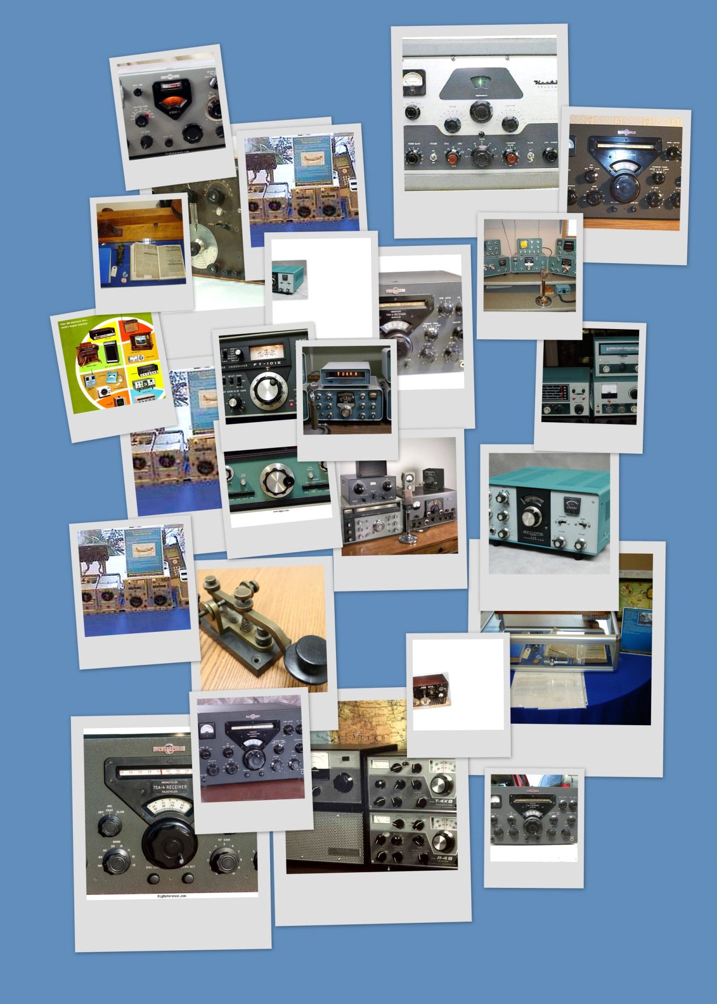

Recent Exhibits ARRL HQ Lobby

Historical Group activities at HQ continued uninterrupted. Specifically, the group conducts the following core activities:

ON GOING ACTIVITIES

* Document Archive maintenance (Phase I)–*Word* and *Access* programs.
* Secretary Minutes - 8 file drawers
* *Word* programmed - 140 file drawers
* Executive Correspondence and Report Archive (Phase II) maintenance.
* *Access* programmed -140 archival boxes, 1500 line entries, 12 fireproof

file drawers and a safe. Program is in accumulation phase.

* Media-slide, video, and film collection supplementation.

* Vintage Technical Library maintenance – shelving 700 *Excel* recorded volumes.
* Exhibitions and displays.
* Lobby - vintage equipment displays. We are in the process of mounting the twelfth consecutive lobby display featuring a complete Heathkit 'SB' series station.
* Laboratory Museum section – a portion of equipment collection and period operating station setups are arranged for viewing. A complete, operating, Drake “4” station was recently added as well as Drake novice station items.

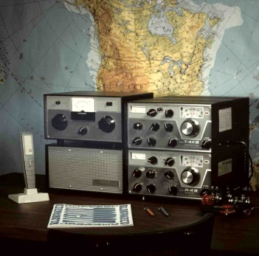

* CEO Conference Room curated. Unique items of League historical significance displayed including recent addition of Hiram Percy Maxim’s key.

* *Heritage Museum* Equipment (hardware) Collection.

Contents are securely stored and being grouped by category. Items eligible for removal are being identified. Obvious non-collectables have been disposed of. More than 1,684 individual items have been recorded in an *Excel* database.

RECENT ACCOMPLISHMENTS

* *Heritage Museum* on-line.

Embedded within the web site, in the Laboratory section, are posted linked formal articles relating to the early history of amateur radio and the League; and significant events. Ten articles and a Power Point presentation have been posted as the *Historian’s View.* There are three additional completed articles in hand awaiting posting.

This is a continuing work which will simultaneously post articles with detail information concerning the contemporary Lobby exhibit, Lab exhibit and ongoing affairs.

We are seeking more prominent recognition within the structure of our present site and a significant position within a new site.

* The Master Locator.

A Directory or Finders Guide to the location of all the paper and media material which has been archived or preserved by the Historical group has been prepared. It includes details of the various data bases in use as well as the physical storage locations. Primarily for staff use the Discovery Guide will be published internally.

Perspective - This comprehensive five page guide records and reveals the extent of the Group’s accomplishments over the past ten years.

* Gates Transmitter Restoration.

A Gates model BC-1T, one KW, AM Broadcast Transmitter is being displayed in the *Heritage Museum* section of the Laboratory. The unit is on loan from the Vintage Radio and Communications Museum of Connecticut (VRCMCT). It is has been restored to operating condition on the 75 meters and 160 meter bands. This restoration was accomplished by museum volunteers with the assistance and guidance of AM enthusiast Tim Smith, WA1HLR.

DONATION

* The *Heritage Museum* Collection recently accepted a number of items of vintage test equipment from the estate of Paul F. Godley, 2ZE, (1889-1973) famed as the monitor of the 1921 Transatlantic Tests. The equipment was used by Godley when assisting Edwin H. Armstrong in establishing the first FM radio network – “The Yankee Network”. In addition a poster size ad for the Godley Radio Company was discovered amongst the material. Background information is being accumulated and exhibition contemplated.

ON GOING PROJECTS

* Continuation of the identification and cataloging of the 35mm slide collection. The collection will be centralized on a separate hard drive with those currently on a external system. Two database programs are being evaluated to select the one most suitable for our application.

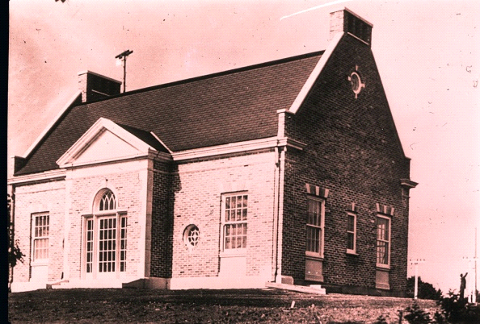

* The recently discovered register of the *first* members of the ARRL initially maintained by Secretary Clarence D. Tuska is still under study. We suspect that this register may record only the stations initially qualified to participate in the relay trunk line system but have been unable to verify this conjecture.

MAJOR PROPOSAL

The Group has proposed to management the creation of a physical *Heritage Museum* and Visitors Center designed and constructed to professional standards. This concept involves dismantling the current underutilized technical library attached to the Laboratory and revamping the adjoining display areas. The library contents are to be melded into the equipment area and adjoining sections of the warehouse. The Library space is to be completely redecorated and repurposed.

Although funds are available for this project we were requested to proceed gradually as other physical building projects must be considered as well. In anticipation of relocating the retained portions of the Library content an *Access* database is being created. However, no other actions have been taken - the first being the disassembly of the library content. This is a long term project to be undertaken in stages while our other activities are underway.

THE GROUP

The Historical Committee team at Headquarters presently consists of four principals – Bob Allison, WB1BCM Assistant Laboratory Manager who is liaison to the Committee; Michael Marinaro, WN1M, volunteer Historian, Archivist and Curator and a member of the Committee; Jonathan Allen, K2KKH/1 volunteer curator of the Museum equipment and Archivist; and Pete Turbide, W1PT volunteer technical restorer and maintainer of the Museum and donated equipment. There are other occasional participants but regrettably no permanent additions.

Organizationally, Allison and Marinaro inform the CEO and Committee chairperson of their activities and interact directly with department managers to accomplish the prescribed objectives of the team on behalf of the Committee. The team aggressively pursues recruits as succession, continuance and knowledge of the activities is of concern.

At this writing the group is looking forward to introducing their activities to the new CEO.

A meeting has been requested and a Briefing folio has been presented.

M. Marinaro

B. Allison

December 2018