Dear Valued Member,

Last year, in the wake of Federal Communications Commission decisions that did not adequately protect licensed radiocommunication services from interference from Broadband Over Power Line (BPL) systems, the ARRL went to court to challenge the FCC.

On Friday, April 25 the United States Court of Appeals for the District of Columbia Circuit confirmed what the ARRL has been saying for years about how the FCC was handling the BPL interference issue: FCC prejudice tainted the rulemaking process.

In fact, the FCC’s mishandling of the issue was so egregious that the Court took an unusual step: it did not defer to the Commission’s presumed expertise on a highly technical issue.

I am writing to you to share this exciting news because the Court’s decision was released just after the June issue of QST went to the printer. I want you, as an ARRL member, to know the details of this important victory.

The Court of Appeals found that the FCC violated the Administrative Procedure Act by not disclosing in full the staff studies on which the Commission relied. Writing for the three-judge panel that heard American Radio Relay League, Incorporated v. FCC and USA, the ARRL’s petition for review of the FCC’s Orders in ET Docket No. 04-37, Circuit Judge Judith W. Rogers said: “It would appear to be a fairly obvious proposition that studies upon which an agency relies in promulgating a rule must be made available during the rulemaking in order to afford interested persons meaningful notice and an opportunity for comment…there is no APA precedent allowing an agency to ‘cherry-pick’ a study on which it has chosen to rely in part….The League has met its burden to demonstrate prejudice by showing that it ‘ha[s] something useful to say’ regarding the unredacted studies…that may allow it to ‘mount a credible challenge’ if given the opportunity to comment….Under the circumstances, the Commission can point to no authority allowing it to rely on the studies in a rulemaking but hide from the public parts of the studies that may contain contrary evidence, inconvenient qualifications, or relevant explanations of the methodology employed….no precedent sanctions such a ‘hide and seek’ application of the APA’s notice and comment requirements.” [emphasis added]

In a concurring opinion, Circuit Judge David S. Tatel wrote: “[I]n this very case the Commission redacted individual lines [emphasis in original] from certain pages on which it otherwise relied….there is little doubt that the Commission deliberately attempted to ‘exclude[] from the record evidence adverse to its position’ [emphasis added]….”

The Court also found that the Commission failed to justify its decision to apply an “extrapolation factor that was designed to accommodate technologies different in scale, signal power, and frequencies used” to Access BPL and that it “summarily dismissed… empirical data that was submitted at its invitation.” The Court found that the FCC’s Reconsideration Order “…provides neither assurance that the Commission considered the relevant factors nor a discernable path to which the court may defer.”

While the Court did not agree with us on every point, it found that the FCC’s decision-making process was seriously flawed. The Court concluded, “On remand, the Commission shall afford a reasonable opportunity for public comment on the unredacted studies on which it relied in promulgating the rule, make the studies part of the rulemaking record, and provide a reasoned explanation of its choice of an extrapolation factor for Access BPL systems.” In explaining its choice of an extrapolation factor the Commission must either “provide a reasoned justification for retaining an extrapolation factor of 40 dB per decade for Access BPL systems sufficient to indicate that it has grappled with the 2005 studies [three published studies suggesting that an extrapolation factor of 20 dB per decade may be more appropriate], or adopt another factor and provide a reasoned explanation for it.”

You can read the entire decision in American Radio Relay League, Incorporated v. FCC and USA at: http://pacer.cadc.uscourts.gov/common/opinions/200804/06-1343-1112979.pdf.

The Court’s decision is a tremendous victory for radio amateurs and other licensed users of the radio spectrum—indeed, for anyone who cares about the federal administrative process. Yet, the remand does not guarantee that the FCC will correct its errors. We face another round of technical arguments. No doubt the FCC’s technical staff, many of whom want to do the right thing, will remain under heavy pressure to ignore the laws of physics and give preference to wishful thinking once again. When the FCC reopens the BPL proceeding as the Court has ordered, we must leave no room for these technical issues to be settled on anything other than technical grounds. There’s more work to do!

It is only because of your past support, and that of thousands of other ARRL members and friends, that we have come this far. Think of what we have accomplished on the BPL front over the past five years! Here are just a few of the high points.

- October 2002. QST carries the first editorial warning about BPL, identifying it as a particularly threatening potential source of “radio smog.”

- April 2003. The battle really begins when the FCC launches a Notice of Inquiry (NOI), ET Docket No. 03-104, to gather information and technical data on BPL. Comments from the FCC Commissioners praise this new technology – even though they know very little about it – as an alternative way to deliver broadband access to more homes. At around the same time, reports of actual interference from BPL pilot projects begin to surface.

- July 2003. ARRL responds to the April NOI with extensive comments and technical exhibits documenting interference concerns.

- August 2003. ARRL rebuts the flawed and inaccurate claims of BPL proponents in reply comments, noting: “The Commission has thus far acted only as a cheerleader for BPL. It is past time that the Commission acted in its proper role as a steward of the radio spectrum…”

- February 2004. The FCC releases a Notice of Proposed Rulemaking, ET Docket No. 04-37, as a follow up to Docket 03-104.

- March 2004. Alliant Energy activates a BPL trial system in Cedar Rapids, Iowa. Jim Spencer, W0SR notices interference the moment it’s turned on. Over the next 11 weeks a team of volunteer RF engineers documents the interference while the FCC dithers without taking any enforcement action. Alliant eventually gives up and concludes the trial early.

- May 2004. ARRL again submits extensive comments and technical exhibits demonstrating the high potential for interference. Thousands of individual radio amateurs also file comments opposing BPL interference, some with excellent documentation.

- June 2004. ARRL’s reply comments point out, among other things, the FCC’s failure to live up to its obligations under the Administrative Procedure Act (APA).

- October 2004. ARRL files a motion for FCC Chairman Michael Powell to recuse himself from a BPL decision based on his visit to a one-sided presentation in Manassas, Virginia just two days before the decision – in violation of the FCC’s own rules. The FCC’s Office of General Counsel concocts an after-the-fact rationalization.

- Also in October 2004, the FCC meets to approve BPL rules, less than four months after receiving thousands of pages of comments and detailed technical reports. Either the FCC staff worked unusually hard over the summer, or…

- February 2005. ARRL files a petition for reconsideration documenting the FCC’s prejudicial handling of the BPL issue.

- August 2006. The FCC finally disposes of 15 petitions for reconsideration including ARRL’s. The 18 months it took them to deal with these petitions contrasts sharply with their rush to judgment in 2004.

- October 2006. ARRL retains an experienced appellate law firm and files a notice of appeal with the U.S. Court of Appeals for the District of Columbia Circuit.

- October 2007. Following months of filing briefs and reply briefs, oral argument of our appeal is held before a three-judge panel.

- November, December, January… and on into April 2008 we wait for a decision.

- April 25, 2008. Victory! A proud day for ARRL members.

While all this was going on, the ARRL technical staff—principally Ed Hare, W1RFI—was working quietly with the BPL industry, persuading them that it was in their best interest to fix the interference problem. To their credit, the leading companies have taken the problem seriously and have gone beyond what the FCC rules require. But it took great effort, including our frontal assault on the flawed FCC proceedings, to get their attention.

The responsible BPL companies have shown they can do what’s necessary to avoid interfering with Amateur Radio. FCC rules requiring all BPL companies to take these steps will protect them from irresponsible competitors. The ARRL will not rest until the FCC has given licensed radiocommunication services the protection they are entitled to under international agreements and federal law.

President Harrison and the entire ARRL Board of Directors and staff thank you for standing with the ARRL during this long process. It’s been frustrating at times, but the support of ARRL members and friends has been most gratifying throughout the struggle. I hope we can count on your continued support as we tackle the work that remains on BPL, as well as the other spectrum challenges we face.

So with our sincere thanks for your support as a member, we ask you to consider a gift to the Spectrum Defense Fund now. We must be prepared to take the next step, and the next, and the next….

I hope you’ll mail your contribution of $1000, $250, $100 or whatever amount you can manage. You can be sure that we will spend your contribution wisely and will keep you informed of our work on behalf of Amateur Radio.

Even as we celebrate, we cannot afford to become complacent. Our access to the radio spectrum is too valuable, and much too important.

Sincere 73,

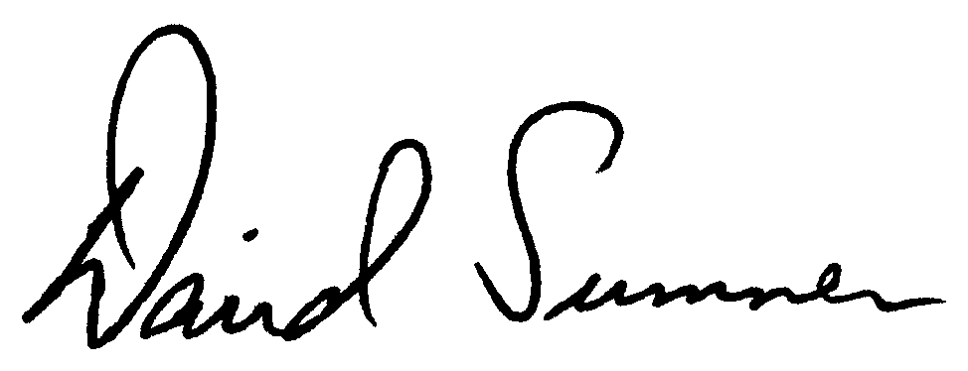

David Sumner, K1ZZ
Chief Executive Officer

P.S. Thank you for making the most generous additional contribution you can either by phone, mail or here on the web. Together we must be prepared to take the next step, and the next, and the next….

