**Document #7**

# 2019 ANNUAL MEETING

# ARRL BOARD OF DIRECTORS

# Windsor, CT

# July 19-20, 2019

## Report of the Chief Executive Officer

This is my second report to the Board and is a complement to the CFO report. Where the CFO report emphasizes the current state of the ARRL, I will report changes I am implementing and on the future of the ARRL.

In my first report, I presented a snapshot of where I believed ARRL stood as an organization, where I believed the risks were, and how I intended to manage those risks. The overarching theme was that ARRL needed to change in order to grow in its second century.

This report will describe the changes I have made, and my current assessment of the organization.

Major items to be covered:

* The staff reorganization that I described to the Board in January was implemented on February 11, 2019 with minor changes.
* The management council has become very effective in deliberative and generative discussion.
* We have implemented a “lite agile process”
* We are creating many fail-fast projects
* Updated risk assessment

## The staff reorganization

The staff reorganization that I described to the Board in January was implemented on February 11, 2019 with minor changes. The changes since the January version were: 1) moving “advocacy” to report directly to the CEO, and 2) creating a Marketing-Communication department with responsibilities over membership, marketing & pub sales, and advertising.

As a reminder, two key changes to the organization, as presented in January, were the addition of a new Product Development Manager position (filled by Bob Inderbitzen) and the consolidation of many of the current operations under the Director of Operations (Norm Fusaro). Both these positions and managers are working out extremely well and are moving ARRL forward.

The revised organization chart is shown below in Figure 1, and in a full-page version as attachment 1.

I am pleased to announce that we will have a new MarCom Manager, Kathleen Callahan, starting in August. Kathleen comes to us with over a decade of experience leading marketing and communications within membership organizations.



Figure 1, Organization Chart

The new structure seems to have been very well received, and along with the management council and agile processes being implemented (described below), has worked very well at flattening the organization, increasing cooperation and understanding across the organization! This is not to say the changes were universally well received. Obviously, in any organization, change is stressful, and some employees may feel that their position has been downgraded, or they may have issues with their new supervisor, but these things can be managed.

## The management council

The management council (MC) consists of: Howard Michel, Diane Middleton, Kris Bickell, Norm Fusaro, Bob Inderbitzen, Dave Isgur, Michael Keane, Carla Pereira, Diane Petrilli, Becky Schoenfeld. We meet every other week and have become a very effective deliberative and generative body. Once Kathleen Callahan starts in August, she will join the MC.

## Lite agile process

We have implemented a “lite agile process” with MC members filling roles as squad leader, tribe leader and chapter leader simultaneously. (Note leader, not manager)

Chapter Leader: Every functional reporting line has a chapter leader. This chapter leader must build up the right capabilities and people, equip them with the skills, tools, and standard approaches to deliver functional excellence, and ensure that they are deployed to value-creation opportunities.

Tribe Leader: Tribe leaders act as true general managers, mini-CEOs focused on value creation, growth, and serving customers. They must develop the right strategies and tactics to deliver desired business outcomes and to determine what work needs to get done, how much to invest in which efforts, and how to prioritize opportunities.

Squad Leader: Squad leaders are responsible for their projects, that is, they take the ideas we create in the MC and develop and refine goals for their project, produce a detailed plan, coordinate requirements, and negotiate with the chapter leaders to obtain the required resources.

## Fail-fast projects

We are creating many fail-fast projects managed by squad leaders. MC members, if they are not the squad leader of a particular project, are possibly a squad member on that project. Each of them needs to seek support from others, just as others will be seeking support from them.

Here are a few new approaches we are taking at ARRL.

* “On the Air” – planned to be a bi-monthly print and digital magazine targeting new hams, and a slightly different version targeting students.
* “ARRL’s So Now What?” – a bi-weekly podcast that offers information and advice for those just starting their journey into Amateur Radio. In addition to the podcast, we have also set up an email address and question submission form that many new hams are already taking advantage of in order to get their specific questions answered.
* “What is Ham Radio” video – the Lifelong Learning, QST and Communications departments have all been involved in writing and producing a new video that explains the varied elements of this hobby/avocation to non-hams.
* A new ad campaign in which “Radio Communications” takes the lead, not ARRL. It emphasizes Skills, Service and Discovery. These are ideas that should appeal to potential hams.
* New approaches to adverting (described below).

## Change

Change in the organization will be innovative evolution rather than revolution. Nothing that we do must disrupt the successful products and services that we currently have. But neither should todays operations block our evolution to excel in the future. Graphically such a philosophy would look like Figure 2. A quick look at the timeline on Figure 2 shows that outside of the Management Council, much of ARRL is still operating as it has in the past. Communications of change needs to be reemphasized throughout ARRL.

## 

Figure 2, Implementation Plan

## Risk assessment

In January, I described a risk management strategy illustrated by a “fever chart.” A fever chart graphically illustrates the importance of an item to the organization (potential impact) and the likelihood of the item failing. Figure 3 illustrates my initial assessment of the organization.

When looking at a fever chart, items in the upper right are critical to the organization, and also most likely to have negative consequences. These are the items that represent the highest risk to the organization. Items in the lower left are less important to the organization, and also less likely to cause a problem. They are lower risk. Items in the red area (upper right) need to be managed or addressed, and in doing so, they will migrate to the yellow (center) and green areas (lower left) thus reducing the risk. Items in the yellow area must ultimately be brought into the green area.

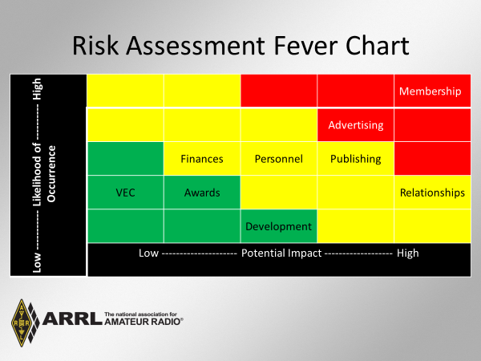

Figure 3, January 2019 Risk Assessment

Several things have changed since January. My current assessment is shown in Figure 4. While some of these changes are transitory, they are nevertheless worthy of mention. By looking at Figure 4, you can see that VEC and Development have moved in a negative direction, and advertising has moved in a positive direction.

Development: I view the change in Development as transitory. The reason is simple; the ARRL Development Manager recently resigned. While having the position vacant increases the risk that Development goals for 2019 will not be met, I believe that in the long run this is an opportunity to hire a manager that has certified development credentials.

VEC: My concern with VEC stems from a 14% decline in new ham licenses in the first six months of 2019 compared to 2018. Initially this decrease was assumed to be related to the U.S. Government shutdown earlier this year, but the numbers have not bounced back. If this trend continues, it will impact VEC directly, and ultimately membership and product sales. This will require close watching.

Advertising: While not seeing big changes, we have developed several new sources of revenue including a code proficiency certificate with sponsorship from Vibroplex, advertising inserts in outgoing retail packages, and advertising on the “So Now What” Podcast.

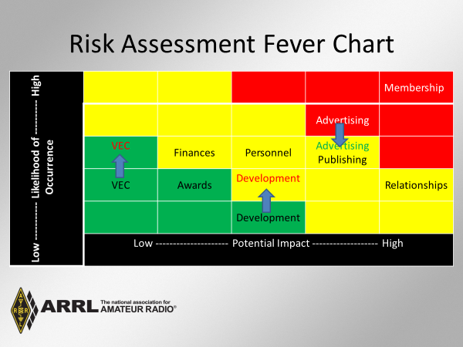

Figure 4, July 2019 Risk Assessment

In addition to these changes, we are on track to improve membership. My projection from January, Figure 5, is still valid.

Through an integrated development of the AMS and LMS, and with a focus on developing content for the newly licensed Technician class amateurs, I expect to improve new member recruitment and retention. Additionally, we are developing plans for a revised youth membership, with a focus on students, complete with a new products and services, and new ways of reaching out to them. As these plans develop, I will be bringing details to the Board. The improvement in recruitment and retention will likely increase overall membership over our current projections and will reduce the likelihood that membership numbers will be a problem (move it downward on the fever chart).

Simultaneously with improved membership recruitment and retention, we will be developing new sources of revenue. These additional sources of revenue will reduce the impact membership has on the organization risk, thus moving it to the left on the fever chart.

These steps will require time to develop, and more time before the impact will be seen, thus a slight improvement is projected for 2021, and a larger improvement for 2022.

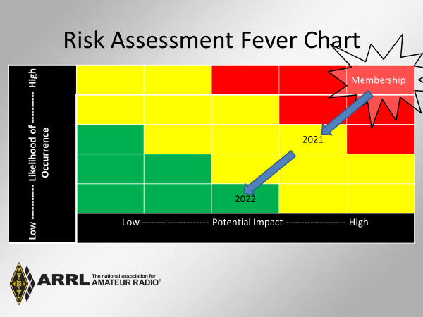

Figure 5, Projection for Membership Risk Reduction

Simultaneously with the changes described immediately above, as we develop the 2020-2021 Plan, all departments will be developing concrete milestones and measurable goals to move all areas on the fever chart down and to the left. It is likely that the 2020-2021 Plan will show an increase in spending—an investment in the business—that will pay off in the long run.



Attachment 1, Organization Chart