Annex C

Bandwidths of Amateur Systems

C.1 Introduction

This is the best information available on actual bandwidths of systems used in the Amateur Radio Service. Generally, they are organized by bandwidth, starting with narrow bandwidths that could fit within 200 Hz. Where possible, standard ITU emissions and bandwidths from Recommendation ITU-R SM.1138 are shown because they have international stature and are carried into domestic regulations, such as FCC Rules.

Group 1 Bandwidths ≤ 200 Hz

C.2 CW Morse Telegraphy

C.2.1 Transmission Bandwidths

Recommendation ITU-R SM.1138 on necessary bandwidths shows the following:

Description of emission | Necessary bandwidth |  | Designation  of emission
Description of emission | Formula | Sample calculation | Designation  of emission
Continuous wave telegraphy, Morse code | B_{n} = BK  K = 5 for fading circuits  K = 3 for non-fading circuits | 25 words per minute  B = 20, K = 5  Bandwidth: 100 Hz | 100HAA1AAN

Note that the speed in words per minute (WPM) and the speed in bauds (B) are related by a ratio of 1.25/1. The occupied bandwidth depends not only on the keying speed but more so on the rise and fall times of the keying pulses. Key clicks result if the transition times are too abrupt. ARRL traditionally has used rise and fall times of 5 ms. 5-ms rise and fall time are suitable for up to 36 WPM on fading circuits and 60 WPM on non-fading circuits and that the bandwidth would be 150 Hz.

In keeping with past ARRL use of 5-ms rise and fall times, a bandwidth of 150 Hz could be suitable for CW Morse telegraphy and the emission designator would be 150HA1AAN. Pushed to the limit, a 200-Hz bandwidth would permit a maximum speed of 50 WPM on fading circuits and 83.3 WPM on non-fading circuits.

C.2.2 Aural Reception of CW Morse Telegraphy

The human ear and processing in the brain combine to create a variable-bandwidth filter that is a function of the speed of the received signal, the audio tone and probably the skill of the operator. Quoted below is interesting information on the response of the ear in copying CW signals from Technical Correspondence on page 48 of April 1969 QST. It relates effective bandwidth to audio pitch.

AURAL SELECTIVITY

Technical Editor, QST:

For some time I have wondered why I was better able to copy c.w. signals through interference if I kept the pitch of the desired signal relatively low. Perhaps others have been curious about this also.
An explanation of this phenomenon was found recently in Introduction to Radar Systems, by M. I. Skolnik. In Chapter 9, Mr. Skolnik presents a curve of the effective passband of the ear, as a function of frequency. As can be seen from fig. 2, over the range of approximately 200 to 1000 Hz. the effective band-width is less than 60 Hz. Above 1000 Hz. it begins to widen rapidly. The original source of this curve is “Basic Correlates of the Auditory Stimulus,” by J. C. R. Locklider in The Handbook of Experimental Psychology. This source also contains much more material on the subject of hearing.
Fig. 2 indicates some of the theoretical basis for the selection of 800 to 1000 Hz. as a popular center-frequency range for audio filters. Unfortunately, no data was found on the slope of the sides of the ear’s bandpass curve. – Ronald A. Jacob, WB5BJG/WB4GYX.

C.3 PSK31

PSK-31 uses audio phase-shift keying fed into a single-sideband suppressed-carrier transmitter. Since the first letter of the emission symbol is determined by the modulation of the main carrier, the first symbol is J. Because it is a phase-shifted tone modulating an SSB-SC transmitter, the second symbol is 2 (not 1, which would have been appropriate only for direct modulation of the carrier). B appears to be appropriate for the third symbol as it is a conversational digital mode somewhat like RTTY rather than D, which is for data.

http://www.qsl.net/yo5ofh/doc/psk31%20bandwidth.htm has some spectrum plots. This plot shows that the bandwidth of the main lobe of the PSK31 signal is 31.1 Hz.

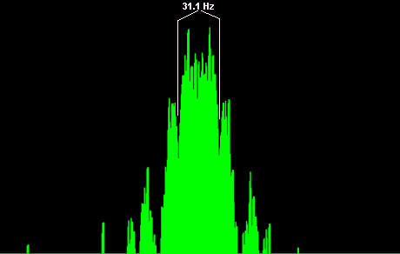

However, this does not take into account the lobes just outside of the main lobe that are attenuated less than 26 dB.

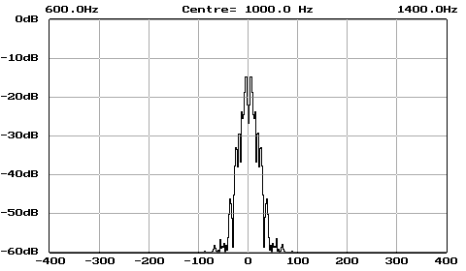

The second plot is a little difficult to read because of minor lobes just below the -26 dB point but it says the bandwidth is about 50 Hz. In ARRL's HF Digital Handbook, on page 4-11, there is a statement by Peter Martinez, G3PLX: "A practical filter might be twice that width (62.5 Hz) at the 60-dB-down points with a delay-time of two bits (64 ms)." Since this refers to a -60-dB bandwidth of 62.5 Hz, and bearing in mind the 50 Hz bandwidth mentioned above, it would appear safe to assign a 60-Hz bandwidth to PSK31 as demodulated in a sound card using DSP filtering. The emission designator 60H0J2B appears to be appropriate.

PSK-31 has a bandwidth of 60 Hz and can operate well within a bandwidth of 200 kHz.

Group 2 Bandwidths 200-500 Hz

C.4 MFSK-16

The MFSK16 is based on the multi-tone FSK modulation and uses FEC (Forward Error Correction) techniques as well as interleaving. The MFSK16 provides 31 WPM text throughput with FEC and 62 WPM with no FEC.

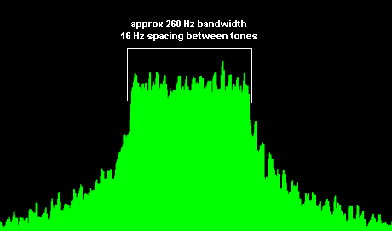

Source: http://people.wiesbaden.netsurf.de/~signals/FFT/MFSK-16.HTML

The 26-dB bandwidth is approximately 260 Hz, i.e., is narrow enough to fit in a 500-Hz bandwidth. The emission designator is 260HJ2DBCN.

C.5 RTTY

Radioteletype (RTTY) is more formally known as narrow-band direct-printing (NBDP) telegraphy. The ITU Radio Regulations (Recommendation ITU-R SM.1138 on necessary bandwidths) shows the following for NBDP but adapted to amateur speeds and shifts:

Description of emission | Necessary bandwidth |  | Designation  of emission
Description of emission | Formula | Sample calculation | Designation  of emission
Amateur RTTY (45 Bd) | B_{n} = 2M + 2DK  M = B/2 | B = 45.45  D = 85 Hz (170 Hz shift)  K = 1.2  Bandwidth: 249 Hz | 249HJ2BBN

An RTTY at the normal 45-bauds using 170 Hz shift has a bandwidth of 249 Hz and is narrow enough to fit in a 500-Hz bandwidth.

C.6 AMTOR

Description of emission | Necessary bandwidth |  | Designation  of emission
Description of emission | Formula | Sample calculation | Designation  of emission
AMTOR | B_{n} = 2M + 2DK  M = B/2 | B = 100  D = 35 Hz (70 Hz shift)  K = 1.2  Bandwidth: 304 Hz | 304HJ2BCN

The AMTOR signal it is narrow enough to operate inside a 500-Hz bandwidth.

C.7 PACTOR

PACTOR packets are either 96 bits long sent at 100 bauds or 192 bits long sent at 200 bauds, with the data rate dependent on conditions. It uses audio frequency shift keying.

Description of emission | Necessary bandwidth |  | Designation  of emission
Description of emission | Formula | Sample calculation | Designation  of emission
PACTOR (100 Bd) | B_{n} = 2M + 2DK  M = B/2 | B = 100  D = 100 Hz (200 Hz shift)  K = 1.2  Bandwidth: 340 Hz | 340HJ2BCN
PACTOR (200 Bd) | B_{n} = 2M + 2DK  M = B/2 | B = 200  D = 100 Hz (200 Hz shift)  K = 1.2  Bandwidth: 440 Hz | 440HJ2BCN

The bandwidth of a PACTOR signal at the normal is too wide to fit in a 200-Hz bandwidth. However, it is narrow enough to operate inside a 500-Hz bandwidth.

C.8 PACTOR-II

PACTOR II is an adaptive mode that uses various DPSK modulation schemes and different code rates depending on conditions. The tones are spaced at 200 Hz within an audio baseband of 400-2600 Hz. Modulation is two-tone differential phase-shift keying (DPSK). PACTOR II performs its initial link set-up using PACTOR as the default mode. An automatic handover to PACTOR II is made only if both stations are capable of PACTOR operation.

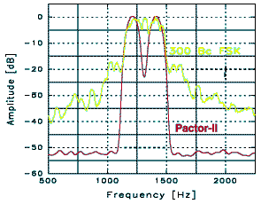
Source: www.scs-ptc.com/pactor2.html

The above graphic shows the 26-dB bandwidth of PACTOR II to be about 375 Hz, so it could fit in a 500-Hz bandwidth.

Group 3 Bandwidths 500-600 Hz

C.9 HF Packet Radio

HF packet radio uses Bell 103 modems that operate using FSK at speeds up to 300 bauds. Originate tones are 1070 Hz space and 1270 Hz mark. Answer tones are 2025 Hz space and 2225 Hz mark. Whether originate or answer tones are used, the frequency shift is 200 Hz.

Description of emission | Necessary bandwidth |  | Designation  of emission
Description of emission | Formula | Sample calculation | Designation  of emission
Amateur packet radio using Bell 103 modems | B_{n} = 2M + 2DK  M = B/2 | B = 300  D = 100 Hz (200 Hz shift)  K = 1.2  Bandwidth: 540 Hz | 540HJ2BCN

An HF packet radio signal does not quite fit inside a 500 Hz bandwidth unless a K = 1 (i.e., a pure sinusoidal pulse) is used. In other words, it does not quite meet the requirement in §97.221(c)(2)”, “No transmission from automatically controlled station occupies a bandwidth of more than 500 Hz. There does not appear to be an easy way of reducing the bandwidth by reducing the baud rate, the shift or K.

C.10 G-TOR
G-TOR uses audio frequency-shift keying like and packet radio. It operates at 300 symbols/second and with the recommended frequency shift of 170 or 200 Hz.
G-TOR’s spectral characteristics are almost identical to packet radio, i.e., not quite fitting in a 500-Hz bandwidth if 200-Hz shift is used. G-TOR could fit in a 500-Hz bandwidth if a shift of 170 Hz is used.
Group 4 Bandwidths 600-2800 Hz
C.11 CLOVER-2000
While CLOVER-2000 is capable of passing uncompressed data at up to 2000 bits per second.
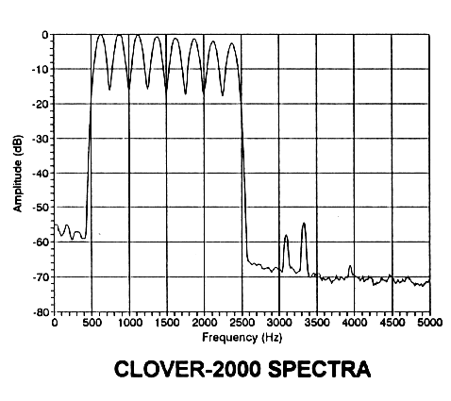
CLOVER-200 bandwidth is 2000 Hz, so it would fit inside a 2.7 kHz bandwidth.

C.12 PACTOR-III

Data compression techniques permit PACTOR-III throughput up to 5200 bit/s.

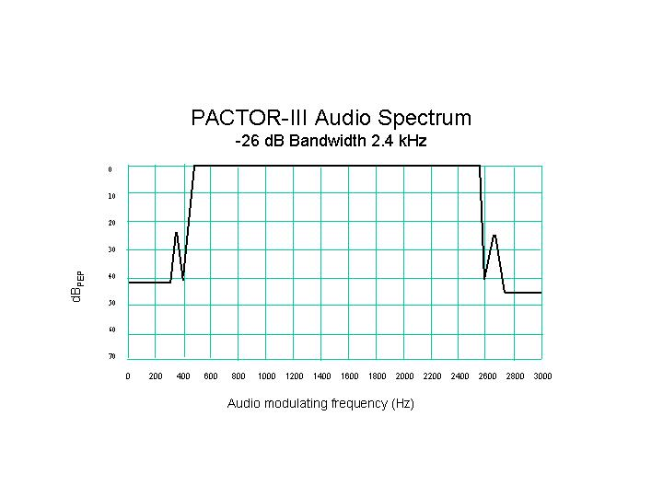
Reference: http://www.scs-ptc.com/
PACTOR-III will fit within a 2.7-kHz bandwidth. It has a fallback mode of PACTOR II, which will allow operation within a 500-Hz bandwidth.

C.13 Single Sideband Suppressed Carrier Voice

From Recommendation ITU-R SM.1138, Telephony (commercial quality):

Description of emission | Necessary bandwidth |  | Designation  of emission
Description of emission | Formula | Sample calculation | Designation  of emission
Telephony, single-sideband, suppressed carrier (single channel) | B_{n} = M – lowest modulating frequency | M = 3000  Lowest modulation frequency = 300 Hz  Bandwidth: 2700 Hz | 2K70J3EJN

SSB-SC voice will fit in a 2.8 kHz bandwidth.

C.14 HF Digital Voice

High-frequency digital voice techniques are evolving. The leading contender as an amateur radio standard is one developed by Thales Communications SA and described by Cédric Demeure and Pierre-André Laurent starting on page 49 of the Jan/Feb 2003 issue of QEX.

The version of Digital Radio Mondiale (DRM) modified to fit in a bandwidth of 300-3000 Hz will fit within a 2.8 kHz bandwidth.

C.15 Analog Slow Scan Television

Slow Scan Television (SSTV) is usually transmitted by frequency modulating an audio oscillator and feeding that into a single-sideband suppressed-carrier transmitter.

Description of emission | Necessary bandwidth |  | Designation  of emission
Description of emission | Formula | Sample calculation | Designation  of emission
Slow-scan television | B_{n} =2M + 2DK  K = 1.09 | M = 750  Lowest tone = 1200 Hz  Highest tone = 2300  Bandwidth: 2700 Hz | 2K70J3FMN

The SSTV bandwidth is 2700 Hz, which meets the requirement of FCC §97.307(f)(2), “No non-phone emission shall exceed the bandwidth of a communications quality phone emission of the same modulation type. A bandwidth of 2.8 kHz is appropriate.

C.15 Analog Facsimile

Facsimile (FAX) in the HF bands is similar to SSTV. It is usually transmitted by frequency modulating an audio oscillator and feeding that into a single-sideband suppressed-carrier transmitter.

Description of emission | Necessary bandwidth |  | Designation  of emission
Description of emission | Formula | Sample calculation | Designation  of emission
Facsimile | B_{n} =2M + 2DK  K = 1.09 | M = 750  Lowest tone = 1200 Hz  Highest tone = 2300  Bandwidth: 2700 Hz | 2K70J3CMN

The facsimile bandwidth is 2700 Hz, which meets the requirement of FCC §97.307(f)(2), “No non-phone emission shall exceed the bandwidth of a communications quality phone emission of the same modulation type. A bandwidth of 2.8 kHz is appropriate.

Group 5 Bandwidths 2700-10,000 Hz

C.15 Amplitude-Modulated Double-Sideband Voice

There is no generally excepted emission mask for amplitude-modulated double-sideband (AM-DSB) voice in the amateur service. It is generally assumed that the bandwidth is 6 kHz but it is unusual to see any additional information such as whether that is necessary bandwidth, occupied bandwidth or a bandwidth of X dB down. The occupied bandwidth depends on the modulation high-frequency cut-off characteristics. Some former broadcast transmitters are in use, so broadcasting standards are examined as well in an effort to define AM DSB bandwidth.

Transmitters of Commercial Quality

The narrowest practicable bandwidth for AM-DSB voice is commercial quality according to Recommendation ITU-R SM.1138:

Description of emission | Necessary bandwidth |  | Designation  of emission
Description of emission | Formula | Sample calculation | Designation  of emission
Telephony, double-sideband, (single channel) | B_{n} = 2M  M may vary between 4 000 and 10 000 depending on the quality desired | M = 3000  Bandwidth: 6000 Hz | 6K00A3EJN

Transmitters Designed for Medium Wave Sound Broadcasting

FCC rules §73.44(b) requires:

Emissions 10.2 kHz to 20 kHz removed from the carrier must be attenuated at least 25 dB below the unmodulated carrier level, emissions 20 kHz to 30 kHz removed from the carrier must be attenuated at least 35 dB below the unmodulated carrier level, emissions 30 kHz to 60 kHz removed from the carrier must be attenuated at least [5 + 1 dB/kHz] below the unmodulated carrier level, and emissions between 60 kHz and 75 kHz of the carrier frequency must be attenuated at least 65 dB below the unmodulated carrier level. Emissions removed by more than 75 kHz must be attenuated at least 43 + 10 Log (Power in watts) or 80 dB below the unmodulated carrier level, whichever is the lesser attenuation, except for transmitters having power less than 158 watts, where the attenuation must be at least 65 dB below carrier level.

It would appear that medium wave broadcast transmitters are not suitable for short-wave applications without modification to restrict bandwidth. Transmitters designed for short-wave broadcasting are described below.

Transmitters Designed for Short-Wave Sound Broadcasting

Recommendation ITU-R SM.1138 specifies the following for short-wave sound broadcasting transmitters:

Description of emission | Necessary bandwidth |  | Designation  of emission
Description of emission | Formula | Sample calculation | Designation  of emission
Sound broadcasting, double-sideband, (single channel) | B_{n} = 2M | Speech and music  M = 4000  Bandwidth: 8000 Hz | 8K00A3EGN

Somewhat inconsistently, Recommendation ITU-R BS.639 gives necessary bandwidth of emissions in LF, MF and HF broadcasting. It specifies: “In short-wave broadcasting, the necessary bandwidth of emission for AM-DSB should in no case exceed the value of 9 kHz.”

BS.639 includes an analysis of bandwidth including the audio-frequency bandwidth (in kHz) according to the cut-off filter used (with a 4.5-kHz cut-off frequency).
In the ET Docket 02-16 Report and Order adopted February 23, 2003, the FCC modified §73.766 of its rules governing short-wave broadcasting to read: “The highest modulating frequency shall not exceed 4.5 kHz,” which brings the US domestic rules in conformity with Recommendation, ITU-R BS.639.

For amateur applications, if the above curve were scaled from a 4.5-kHz cut-off to a 3-kHz cut-off frequency, the following would result:

For a 120-dB/octave curve (A), the 26-dB bandwidth would be 7.72 kHz.
For an 80-dB/octave curve (B), the 26-dB bandwidth would be 8.26 kHz.
For a 40-dB/octave curve (C), the 26-dB bandwidth would be 8.66 kHz.

Both commercial quality and broadcast quality AM-DSB transmitters are in use in the amateur service. Commercial quality transmitters could meet a bandwidth of 6 kHz. Transmitters designed for medium-wave or short-wave broadcasting could be built to or modified to be consistent with Recommendation ITU-R SM.1138 and meet a bandwidth limit of 8 kHz, in which case a 120-dB/octave audio filter would be required.

C.13 Angle-Modulated Voice at MF/HF

Current FCC §97.307(f)(1) requires that “No angle-modulated emission may have a modulation index greater than 1 at the highest modulation frequency.”

Prior to the FCC rules “rewrite” of 1988, there was a limitation that below 29 MHz, the bandwidth of an angle-modulated voice signal should not exceed that of an AM-DSB emission, nominally 6 kHz. A tortured analysis was needed to pretend that an angle-modulated voice signal will fit in the same bandwidth as an AM-DSB signal. Such an analysis was presented in the 1986 ARRL Handbook as a rationale for a 6-kHz bandwidth and 6K00F3EJN emission designator:

You cannot use 5-kHz or even 3-kHz deviation without greatly exceeding the 6-kHz bandwidth limit. In fact, the usual FM bandwidth formulas will not work in this case, and it is necessary to examine the power in the second pair of sidebands and limit it to about 1% of the toeal. If this were done assuming sinusoidal modulation at 3000 Hz, the highest modulation index would be 0.4, and deviation would be limited to 1.2 kHz. In practice however, the energy distribution in a complex (voice) wave is such that the modulation index for any one frequency component is reduced as compared to the index with a sine wave having the same peak amplitude as the voice wave. Thus, for voice, a modulation index of 0.6 and a 1.8-kHz deviation will ensure that the second part of sidebands will be 27 dB below the unmodulated carrier level.

A more realistic emission would be practical for the amateur service at MF/HF would be:

Description of emission | Necessary bandwidth |  | Designation  of emission
Description of emission | Formula | Sample calculation | Designation  of emission
Angle-modulated commercial telephony | B_{n} = 2M + 2DK  K = 1 | D = 1000  M = 3000  Bandwidth: 8000 Hz | 8K00F3EJN

A bandwidth limit of 8 kHz is suggested for angle-modulated voice in the MF/HF bands.

Group 6 Bandwidths >10,000 Hz

Recommendation ITU-R SM.1138 shows the following for frequency-modulated telephony (commercial quality):

Description of emission | Necessary bandwidth |  | Designation  of emission
Description of emission | Formula | Sample calculation | Designation  of emission
Commercial telephony | B_{n} = 2M + 2DK  K = 1  (typically, but under certain conditions a higher value of K may be necessary) | For an average case of commercial telephony  D = 5000  M = 3000  Bandwidth: 16000 Hz | 16K0F3EJN

