**ARRL Historical Committee Report Document # 18**

**July 2019**

The ARRL Historical Committee members for 2019 are:

Rod Blocksome, K0DAS, Midwest Division Director (chair)

Richard Norton, N6AA, Southwest Division Director

Tom Delaney, W8WTD, Great Lakes Division Vice-Director

Bill Hudzik, W2UDT, Hudson Division Vice-Director

Michael Marinaro WN1M, headquarters volunteer lead

Bob Allison, WB1GCM, (Staff Liaison)

Activities of the ARRL Historical Committee in the first six months of 2019 were conducted by volunteers working to organize, identify, and catalog the historical documents and artifacts at ARRL headquarters. Bob Allison, staff liaison, manages this cadre of volunteers as they all donate their time and labor to this important endeavor.

This group also receives and restores vintage equipment donated to ARRL. They design and implement interesting historical exhibits for the lobby of ARRL headquarters. The lobby exhibit is periodically refreshed with a different exhibit by this volunteer group. A detail report of the group’s work prepared by Michael Marinaro, WN1M, and Bob Allison, WB1GCM follows.

Respectfully Submitted,

Rod Blocksome, K0DAS, Chair

**The Historical Group at Headquarters**

**REPORT OF ACTIVITIES – FIRST HALF 2019**

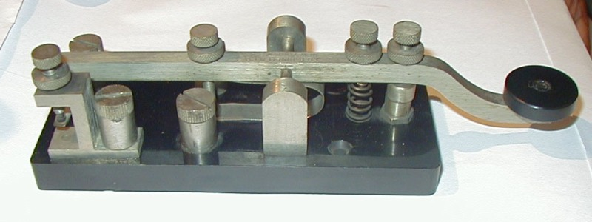Marconi spark-gap key

**LOBBY EXHIBITS**

**CURRENT: HEATHKIT 1960’s NOVICE STATION**

**COMING: HEATHKIT SB-101 TRANSCEIVER**

**HEATHKIT “LUNCH BOXES”**

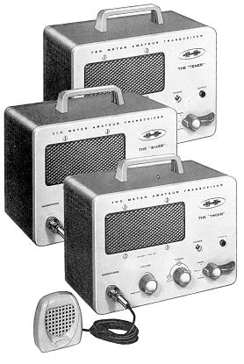

The Historical Group activities at ARRL HQ continued uninterrupted. Specifically, the group conducts the following core activities:

**ON-GOING ACTIVITIES**

Document Archive Maintenance (Phase I) continues using *MS Word* and *Access* programs. The Secretary Minutes are contained in 8 file drawers and other *Word* programmed documents are contained in 140 file drawers.

Executive Correspondence and Report Archive (Phase II) maintenance is in the accumulation phase. It is *Access* programmed with1500 line entries. Materials are contained in 140 archival boxes, 12 fireproof file drawers, and a safe.

The Media-slide, video and film collection is being supplemented.

Vintage Technical Library Maintenance involves shelving 700 *Excel* recorded volumes.

Exhibitions and displays:

* Vintage Equipment Lobby Displays – A typical Heath-kit Novice Station is currently on view. This is the thirteenth consecutive presentation.
* Laboratory Museum Section – A portion of the equipment collection and period operating station setups are arranged for viewing.
* The CEO Conference Room is curated. Unique items of League historical significance are displayed including the recent addition of Hiram Percy Maxim’s key.

The *Heritage Museum* Equipment (amateur hardware) Collection is securely stored and being grouped by category. Items eligible for removal are being identified. Obvious non-collectables have been disposed of. More than 1800 individual items have been recorded in an *Excel* database.

**RECENT ACCOMPLISHMENTS**

1. *Heritage Museum* On-Line.

Embedded within the ARRL web site, in the Laboratory section, are posted linked formal articles relating to the early history of amateur radio, the League, and significant events. Eight articles and a power point presentation have been posted as the *Historian’s View.* There are three additional completed articles in hand awaiting posting:

*#10 ORIGINATION - WIRELESS COMES TO AMERICA*

*#11 ATLANTIC WIRELESS CRISSCROSS*

*#12 EPILOGUE - CHROCILERS OF THE VESTIGES OF “MARCONI TOWERS”*

These three original articles describe Marconi’s work in the U.S. from 1899 to 1920. These events occurred contemporaneously with the creation of the League and its early years presented in the first nine chapters of the *Historian’s View.* Newly discovered information reveals details of the erection and operations of CC, the featured America Marconi’s pioneer transatlantic spark station on Cape Cod.

1. The Master Locator.

A Directory or Finders Guide to the location of all the paper and media material which has been archived or preserved by the Historical group has been prepared. It includes details of the various data bases in use as well as the physical storage locations. Primarily for staff use, the Discovery Guide will be published internally.

This comprehensive five-page guide records and reveals the extent of the Group’s accomplishments over the past ten years.

**DONATIONS**

We received some additional Collins Radio “S” Line equipment and a Collins model KWM-380 transceiver. We are considering a lobby exhibit of the family of Collins transceivers.

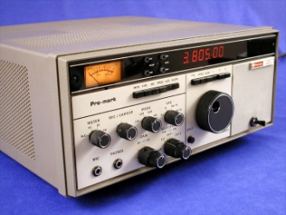

**ON GOING PROJECTS**

1. Vacuum Tube Collection.

We have undertaken to reorganize our collections of vacuum tubes and test equipment. We have a large quantity of tubes stored which require consolidation, cataloging and a plan for disposition. Similar actions will be applied to our array of test equipment, spanning many eras, which must be further identified and determined for retention.

1. 35mm Slide Collection.

Consistent with our cataloging efforts, we have undertaken the identification and cataloging of the 35mm slide collection. The collection will be centralized on a separate hard drive with those currently on an external system. Various database programs are being evaluated to select the one most suitable for our application.

1. ARRL First Member Register.

The recently discovered register of the *first* members of the ARRL initially maintained by Secretary Clarence D. Tuska is still under study. We suspect that this register may record only the stations initially qualified to participate in the relay trunk line system but have been unable to verify this.

**MAJOR PROPOSAL**

We are seeking more prominent recognition of ARRL heritage within the structure of the present web site and a significant position within a new site.

**THE GROUP**

The Historical Committee team at Headquarters presently consists of four principals – Bob Allison, WB1BCM Assistant Laboratory Manager who is liaison to the Committee; Michael Marinaro, WN1M volunteer Historian, Archivist and Curator and a member of the Committee; Jonathan Allen, K2KKH/1 volunteer curator of the Museum equipment and Archivist; and Pete Turbide, W1PT volunteer technical restorer and maintainer of the Museum and donated equipment. There are other occasional participants but regrettably no permanent additions.

Organizationally, Allison and Marinaro inform the CEO and Committee chairperson of their activities and interact directly with department managers to accomplish the prescribed objectives of the team on behalf of the Committee. The team aggressively pursues new recruits as succession, continuance and knowledge of the activity is of concern.

M. Marinaro

B. Allison

June 2019