Document #26
Entry Level Licensing Committee
July 2018 – ARRL Board

The ELL Committee has been mostly inactive since the January Board meeting. At that Board meeting, a petition to the FCC was authorized for the purpose of modernizing the Technician license by adding some band segments for digital and voice modes on 80, 40 and 15 meters. Our filing to the FCC was made on February 28, 2018 and as of this writing the proposal has not been given a Rule Making (RM-) number.

The ELL Committee has been monitoring the conversations in the Amateur community in various on-line forums as well as club meeting discussions. As a whole, the response has been positive, though comments have run from strongly opposed to change to strongly in favor of the proposal.

In order to stay out in front of this effort, ARRL should be planning some strategic efforts to lay the groundwork for a positive response to the FCC when they ask for comments.

During the January Board meeting the board also voted, “Moved, to amend the ARRL 2018-2019 Plan to add a maximum of $30,000 to fund the discovery and strategy phase of the Lifelong Learning Initiative Project presented by Mintz & Hoke and to report the findings to A&F Committee and to the Board of Directors on or before the July Board meeting.” The full project has not been funded yet.

The project is initially intended to focus on how ARRL interacts with newly licensed hams and to build resources that will help them to get on the air and involved in various aspects of ham radio. The manager for this project has been hired – Kris Bickell/K1BIC. The ELL Committee strongly supports this effort and is looking forward to learning more as the project evolves.

One area where we suggest future resources should be allocated is in marketing ham radio to the general public, efforts to target specific groups (Makers, STEM, etc), then how we work with people who show an interest in getting licensed. As we’ve reported previously, improving upon the training and testing process is essential.

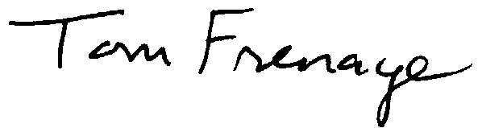
Committee members

Tom Frenaye, K1KI, chairman
Bonnie Altus, AB7ZQ
Tom Delaney, W8WTD
Maria Somma, AB1FM
Bruce Blain, K1BG
Andrea Wayward, KG4IUM
Ward Silver, N0AX

