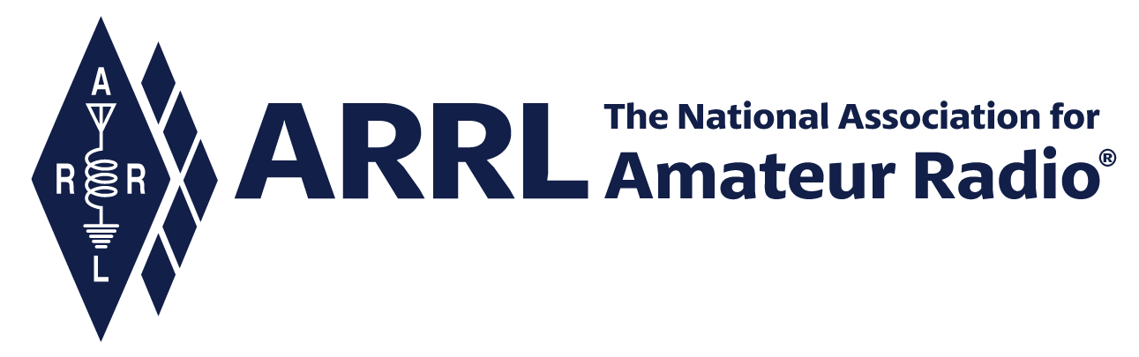
IN-NEWSLETTER
April 8, 2022

Vol. 54, No. 7 Covering two weeks, March 25 – April 8, 2022
Upcoming Meetings and Events

Events listed below are subject to change at any time; information will be updated as soon as it becomes available. See also the ARRL Contest Calendar and Hamfest and Convention Database.

Rookie Roundup (Phone) | April 10, 2022
Raleigh ARRL Hamfest (RARSfest), hosting the ARRL Roanoke Div. Conv., North Carolina | April 16, 2022
World Amateur Radio Day | April 18, 2022
Dayton Hamvention, an ARRL-sanctioned hamfest, Xenia, Ohio | May 20-22, 2022

SEA-PAC, hosting the ARRL Northwestern Division Convention, Seaside, Oregon | June 3-5, 2022

International Digital Contest | June 4-5, 2022

ARRL June VHF Contest | June 11-13, 2022

Kids Day | June 18, 2022
HAM RADIO International Amateur Radio Exhibition, Friedrichshafen, Germany | June 24-26, 2022
ARRL Field Day | June 25-26, 2022

Teachers Institute – TI-1, Newington, Connecticut | June 27 - July 1, 2022

IARU HF World Championship | July 9-10, 2022

Teachers Institute – TI-2, Newington, Connecticut | July 11 - July 15, 2022

Standing Committee Meetings: A&F, EM&FS, P&S | July 14, 2022

ARRL Board of Directors Meeting | July 15-16
Teachers Institute – TI-1, Dayton, Ohio | July 18 - July 22, 2022
Teachers Institute – TI-1, Newington, Connecticut | July 25 - July 29, 2022
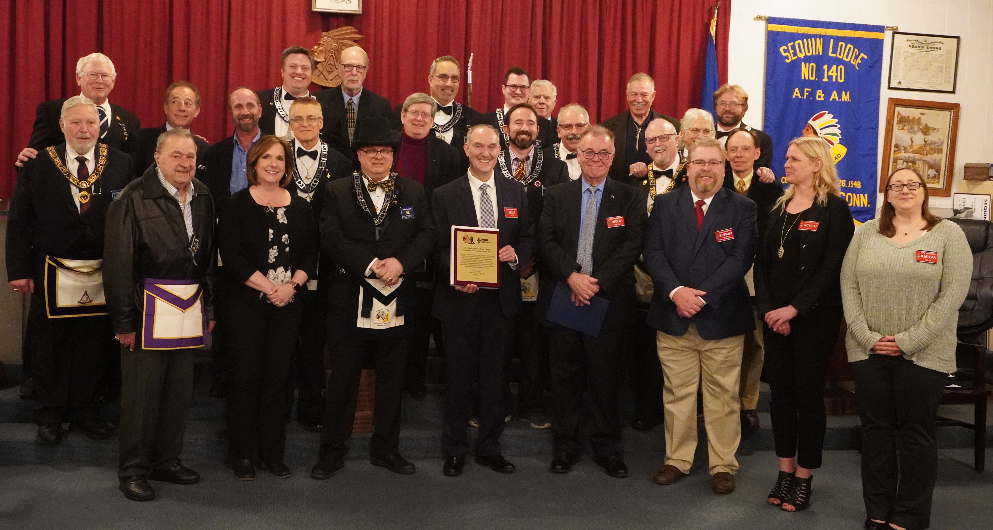
Members of the Sequin-Level Lodge #140 Ancient Free & Accepted Masons, of Newington, Connecticut, honored ARRL in a special presentation on April 7, 2022. Among those who participated were (front row, right to left) ARRL staff representatives Kim McNeill, KM1IPA, Assistant Member Services Manager; Yvette Vinci, KC1AIM, Member Services Manager; Josh Johnston, KE5MHV, Director of Emergency Management; Bob Naumann, W5OV, Director of Operations; Bob Inderbitzen, NQ1R, Director of Public Relations and Innovation; Lodge #140 Master Jon Faasen, AA1EZ, and Town of Newington Mayor Beth DelBuono.

ARRL Honored by Masons in Newington, Connecticut

Members of the Sequin-Level Lodge #140 Ancient Free & Accepted Masons, located in the Town of Newington, Connecticut, recognized ARRL with a presentation on Thursday, April 7, 2022. The special recognition was organized and led by the Lodge’s Master, Jon Faasen, AA1EZ. Jon is also an ARRL Membership Services Representative in the Membership, Marketing & Communications Department!

We’re grateful for the effort made by Jon and his fellow Masons to recognize ARRL for our contribution as part of the Newington community, and our role in serving ARRL members and radio amateurs worldwide. The Mayor of Newington, Beth DelBuono, participated in the presentation, issuing an official Town Proclamation honoring ARRL.

The honors bestowed on ARRL were accepted by a representative group of HQ staff members that included Kim McNeill, KM1IPA, Assistant Member Services Manager; Yvette Vinci, KC1AIM, Member Services Manager; Josh Johnston, KE5MHV, Director of Emergency Management; Bob Naumann, W5OV, Director of Operations, and Bob Inderbitzen, NQ1R, Director of Public Relations and Innovation.

Bob Inderbitzen offered remarks that followed the presentations, thanking Jon and the Masons of Lodge #140, and Newington Mayor DelBuono. He also shared background about ARRL’s presence as a Newington fixture since 1938.

While ARRL was established in Hartford in 1914, our association set roots in Newington when construction started on a new headquarters station in late summer 1937 on our current seven-acre site. Locating ARRL’s station, which before then had operated with the call sign W1INF, to Newington followed President Hiram P. Maxim’s death in February 1936, and the Great Flood in New England which all but destroyed the station located at nearby Brainard Field in Hartford a month later. The new station opened in Newington in 1938, operating with Maxim’s call sign, W1AW, granted to ARRL by the FCC as a permanent memorial to him. The station’s little brick building and its antenna farm stood alone on its Main Street, Newington property until 1962 when ARRL re-located its administrative headquarters into a newly constructed building on the same property.

Bob also highlighted the leading role that ARRL and its members have made to advancing amateur radio for more than a century. “For many radio amateurs around the world – ARRL headquarters in Newington might as well be the center of our universe,” he said. “ARRL is devoted to the greatest hobby in the world.”
Executive Office

The cutover for the integration of Personify with the website and related web services went live on Thursday, March 31. Member Services staff are supporting any members requiring assistance with website login and/or account registration.

A Member Bulletin was distributed on April 6, with an explanation for the paper used for the May issue of QST.

A power outage for utility pole maintenance near the HQ property is scheduled for Saturday, April 9, 2022. A short news item was posted: www.arrl.org/news/arrl-power-outage-scheduled-saturday-april-9
Development
Reported by Melissa Stemmer, KA7CLO
Following the February 2022 grant submission period, the ARRL Foundation Board unanimously voted to approve funding for six grant proposals. The Northeastern Indiana Amateur Radio Association of Auburn, Indiana, received a $2,941.61 award to build a portable station with many forms of analog and digital communications equipment. They plan to take the station to schools, Boy and Girl Scout events, city and county fairs, car shows, and additional gatherings where they can promote amateur radio with hands on demonstrations.

A $2,952 award was given to the Portland State Aerospace Society at Portland State University of Portland, Oregon, to finish building their OreSat Live System, which is an S band amateur radio system built on ARRL 802.11b that will allow Oregon high school students to “work” the OreSat satellite and receive live video of their location directly from space. The funds will be used for the electronics components and metal 3D printing necessary for the OreSat Live system on the spacecraft and will also allow them to finish the prototypes of the Handheld Ground Station, the educational kit aimed at Oregon students.

The Richmond Amateur Radio Club in Richmond, Virginia, was awarded $1,000 to cover one day of normal costs of the facility where they plan to present a New Ham Boot Camp. This full-day session will include various speakers presenting demonstrations and instruction on basic station assembly and operation.

A grant of $3,000 was awarded to the Pella Amateur Radio Club of Pella, Iowa, to support their Pella Exploring Space Program. Members of the Club educate students on earth science and wireless radio technology and the role it plays in everyday life. Additionally, high school students may optionally select to fly a high-altitude balloon to 100,000 feet and build experiments to collect data at high altitude. The grant will permit them to bring the program into 10 different schools over a period of two years to present these projects to over 1,000 students.

The Central Pennsylvania Repeater Association in Mechanicsburg, PA, was awarded $2,958 for implementing new solar technology and develop new training materials. In the past 10 years they have started linking repeater sites with their CPIN IP microwave network. One of the major challenges CPIN is addressing is powering remote, isolated sites on a sustainable basis. They will address this by expanding their core expertise by implementing a solar power generation and storage component to their network training regime. Providing this solar power and storage element will enable expansion of the CPIN network and do so in an ongoing, sustainable, and responsible manner while gaining expertise from the project rollout.

Finally, the Milford Amateur Radio Club, serving the Greater Cincinnati, Ohio, area, received a grant of $1,660.30 to support their project to deploy Yaesu’s Wires-X to the first wide area coverage repeater. This would be the first such deployment of a Wires-X repeater within Southwest Ohio. The award will be used to enhance their existing repeater by adding the digital capability of Wires-X to the region.

The next ARRL Foundation Grant Program proposal submission period will open on June 1, 2022, and close on June 30, 2022.
Education and Learning
Reported by Steve Goodgame, K5ATA
Ally Flynn, KM3ALF, organized a meeting with Teachers Institute instructors to finalize planning and organization of the upcoming Teachers Institute sessions. Applicants are coming in and things are coming along nicely.

Steve Goodgame, K5ATA, met with the superintendent of a school for the blind and will be visiting the site in person to gain a better understanding of the needs and tools available to the blind ham community.

Learning Center: Work continues to develop content for the Learning Center, including courses on Repeater Use and Operation, Power Options for Portable Operations, Microwave Operations, How to Choose a Field Radio, and Intro to DSTAR Operations.

Alex Norstrom, Steve Goodgame, and Bob Inderbitzen finalized the production of the YouTube video series on the End-Fed Half-Wave Antenna Kit sold by ARRL. The completed, 3-part video series is being introduced on ARRL’s YouTube channel. The first video premiered on April 5th at 6:45 PM ET, and already has 2,800 views. Parts 2 and 3 will go-live on April 12 and April 19, respectively.

Publications and Editorial

The following is a summary of e-newsletter subscribers:

e-newsletter | Current issue | Subscribers | Previous Issue | Subscribers | +/-
ARRL Letter | April 7 | 113,004 | April 1 | 112,440 | +564
ARRL Club News | March 22 | 68,624 | February 22 | 68,423 | +201
ARRL Contest Update | March 16 | 25,859 | March 2 | 25,705 | +154
ARES Letter | March 16 | 38,672 | February 16 | 38,639 | +33

Radiosport
Reported by Sharon Taratula

Week ending March 30

Processing Time | Most Recent Week | Difference Over Previous Week
Paper/Fieldcheck Processing Time | - 2 Weeks | - 0
Logbook Processing Time | 2 Business Days | 0
YTD Applications
2022 DXCC Applications | 2884 | +219
2022 WAS Applications | 891 | +73
2022 VUCC Applications | 284 | +10
2022 WAC Applications | 21 | 0
2022 WPX Applications | 167 | +13
2022 WAZ Applications | 155 | 0

Week ending April 5

Processing Time | Most Recent Week | Difference Over Previous Week
Paper/Fieldcheck Processing Time | - 2 Weeks | - 0
Logbook Processing Time | 3 Business Days | +1
YTD Applications
2022 DXCC Applications | 3058 | +174
2022 WAS Applications | 965 | +74
2022 VUCC Applications | 294 | +10
2022 WAC Applications | 29 | +8
2022 WPX Applications | 181 | +14
2022 WAZ Applications | 155 | 0

Field Services
Reported by Steve Ewald, WV1X
Leona Adams, W1LGA, reports that ARRL Headquarters has recently received Section Manager nominating petitions from three incumbent Section Managers. Mark Klein, N5HZR (Oklahoma), and Barry Porter, KB1PA (Southern Florida) will be running for new terms of office that begin on October 1, 2022. Nominating petitions for this election cycle are due at Headquarters by June 10. Rocco Conte, WU2M (Northern New York) will be running for a new term of office that starts on January 1, 2023. Petitions for this election cycle are due by September 9.

Mike Walters, W8ZY, is continuing to work with the committee involved with developing the Club Grants Program.

Product Development, Public Relations, and Outreach
Reported by Bob Inderbitzen, NQ1R
We are coming up on a deadline for hotel rooms for the ARRL team traveling to Dayton Hamvention in May. Kim McNeill, KM1IPA, is administering our hotel room block with the Marriott University of Dayton. She has forwarded our first list to the hotel to commit reservations. Reminders will be shared with Board members and Section Managers interested in volunteering as part of the team.

Many posts have been scheduled for ARRL’s social media channels, including posts promoting World Amateur Radio Day (April 18), new ARRL videos, QST content, and news items.

Bob Inderbitzen, NQ1R, has been transitioning the responsibilities of the ARRL News Editor following Rick Lindquist’s retirement from the position. Bob has been preparing a new editor to take his place. A group effort has ensured the uninterrupted publishing of the weekly ARRL Letter, ARRL News posts, and ARRL Audio News, supported by Bob and members of the editorial team including Leanna Figlewski, Caroline Kenney, Becky Schoenfeld, W1BXY, and Steve Ford, WB8IMY.

Bob traveled with Alex Norstrom to the University of Scranton in Pennsylvania for a video shoot with Professor Dr. Nathaniel Frissell, W2NAF. The recorded video supports an ARRL education project on ionospheric propagation and Cycle 25. Alex and Bob also attended an event sponsored by the budding new amateur radio club at the University, W3USR, and toured the new campus radio shack with some of the club’s officers.

ARRL Lab
Reported by Ed Hare, W1RFI

Ed Hare, W1RFI, traveled to attend the meetings of the IEEE EMC Society Board of Directors and the IEEE and international standards. Ed serves as the EMC Society Vice President for Standards. He is planning on taking on new leadership roles in the standards committees when his term expires at the end of this year. As a result of this work, amateur radio is a valuable contributor to the development of technology, recognized by industry and regulator participants in the development of industry standards.

Membership
Reported by Matt Caruso

In March we finished the month with 158,075 members, including 1,181 new members. The new members will be introduced to our new on-boarding process.

W1AW
Reported by Joe Carcia, NJ1Q

Joe Carcia, NJ1Q, updated the web code practice files and their archives. He also processed 2 Code Proficiency certificates and 1 endorsement.

Joe and Bill Spring installed a 20A/240VAC line into the transmit racks to accommodate power for a commercial 2-meter amplifier (to be installed shortly). This amplifier will be used part of the broadcast equipment. Joe designed and built a simple power distribution system to feed power to the 2-meter amplifier, as well as the bandpass filter fans and antenna relay. Joe had to rework the CW oscillators for the EchoLink, and 2-meter transmitters. Audio from these oscillators is fed into the 2-meter exciter, and the client side of EchoLink.

Joe met with volunteers from the Vintage Radio and Communications Museum (https://www.vrcmct.org/) to discuss ideas for setting up their visitor operating station located at the museum.

Scott Gee, WB9RRU, worked on fast and slow code practice files for the week. He also processed 16 electronic VUCC applications for a total of 911 credits.

Edited by Bob Inderbitzen, NQ1R, Director of Public Relations and Innovation

