Doc. 1A/IARU/1
21 October 2003

Reference: Question ITU-R 221/1
Document 1A/126 Annexes 11, 12
International Amateur Radio Union (IARU)

Compatibility between radiocommunication systems and high data rate telecommunication systems using electricity power supply

1. Reference is made to Liaison Statements from WP 6E and TG 6/7 regarding protection of HF broadcast receivers against unwanted radiation from wired systems carrying high data rate telecommunications. The IARU notes that typical HF broadcast receivers and amateur stations are both situated in residences in close proximity to such wired systems and share a common interest. Separation distances between a receiving antenna and a power line carrying data may be less than a metre.

2 Document 1A/126 Annex 12 outlines recent developments in power line telecommunications (PLT) using the electric mains to transmit data rates of 1 or more Mbit/s using frequencies from 1.6 to 30 MHz.

Annex 11, Table 2.4.3.9, reproduced in part below as Figure 1, proposed protection limits for the amateur service.

Figure 1 - Protection limits proposed for the amateur service

Frequency  (MHz) | Proposed Protection limit  (peak dB μV/m at 3 m)
1.8 | 10.19
3.5 | 7.85
7.0 | 6.13
10.1 | 7.95
14.0 | 5.94
18.1 | 4.41
21.0 | 4.01
24.9 | 3.65
28.0 | 3.45

3 European studies provided a comparison of electric field limits proposed by regulatory bodies for PLC emissions, adapted in Figure 2.
Figure 2
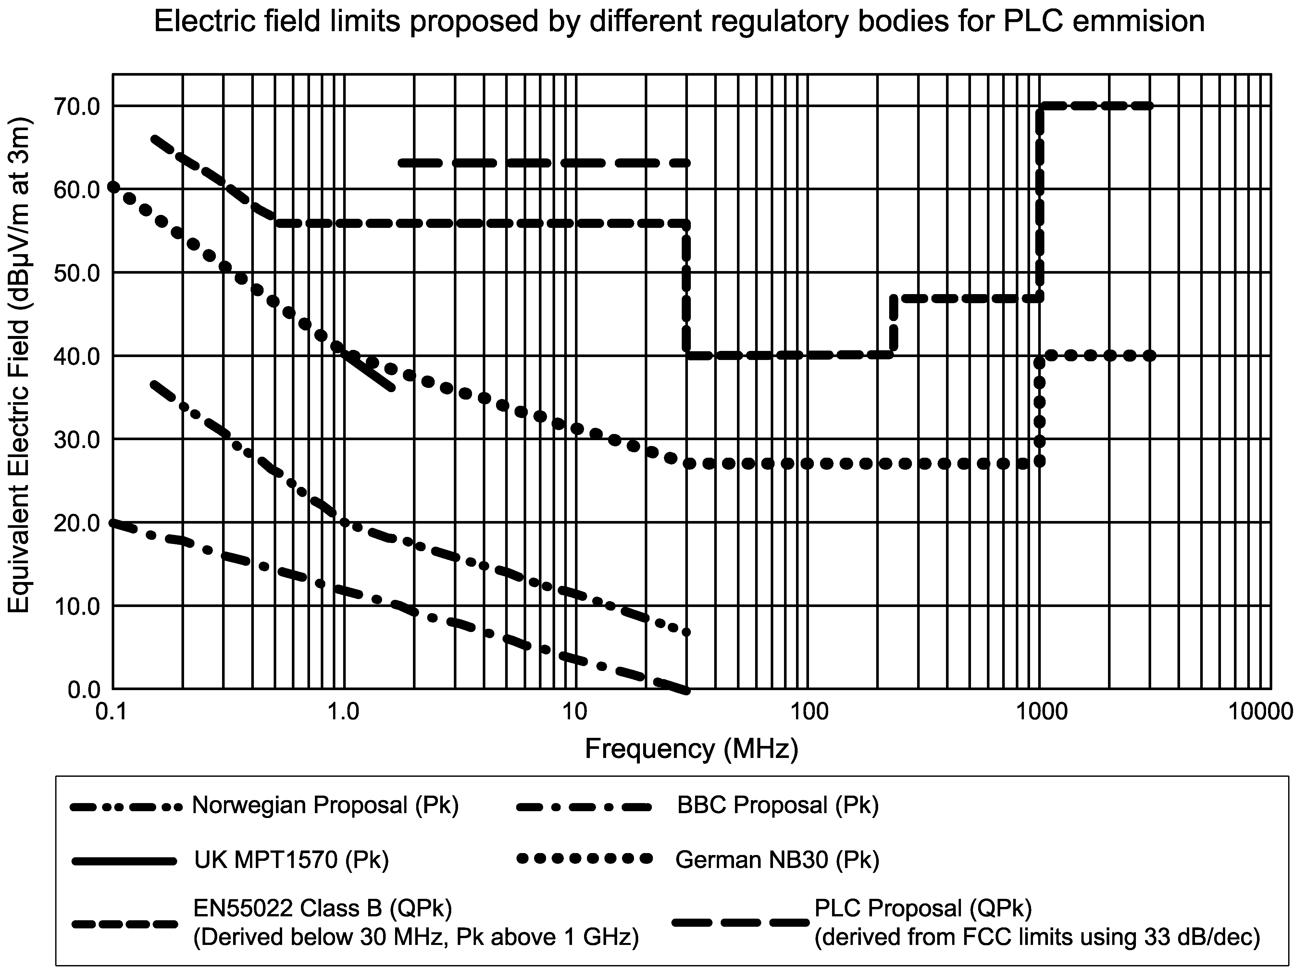

4 Similar to short-range devices, power line telecommunications (PLT) systems are largely concerns of individual administrations. Where such lines and unintended radiation go beyond national borders, there are international considerations. The IARU would prefer to see the focus shifted away from regulatory limits and toward ensuring that PLT systems do not raise the noise level in receivers used by licenced radiocommunication services. The usual standard for non-safety-of-life radiocommunication services is an I/N of –6 dB, having the effect of raising the noise level no more than 1 dB.

5 The amateur service has an active role in providing communications in emergencies and its MF, HF and VHF allocations should be protected from harmful interference. Article 25.9A (Rev. WRC–03), states: Administrations are encouraged to take the necessary steps to allow amateur stations to prepare for and meet communication needs in support of disaster relief. In many countries, amateur stations provide a valuable back up to normal communications systems in case of breakdown or overload. Administrations rely on this capability at times of emergency. Amateur stations use MF and HF allocations from 1.8 MHz through 29.7 MHz and VHF allocations from 50 to 54 MHz and 144 to 148 MHz for this purpose.

6 Working Party 8A is currently preparing a Preliminary Draft New Recommendation on characteristics of systems operating in the amateur and amateur-satellite services for use in sharing studies. The results of WP 8A’s consideration thus far are shown in Document 8A/248 Attachment 19. The amateur service receiver characteristics may be of value to WP 1A in studies related the impact of PLT emissions on radiocommunication services. Conversely, WP 1A may wish to note that PLT systems could be affected by transmissions from licenced radiocommunication stations.

7 PLT emission limits currently being proposed, or in use, by some administrations may result in interference levels that could reduce the capacity of HF transmission channels essential to the amateur service. The IARU recommends that a Liaison statement be sent to WP 8A informing them of the status of studies underway in WP 1A, and requesting comments and recommendations on acceptable levels of protection from unwanted radiation from wired systems carrying high data rate telecommunications.

____________

