**ARRL Public Relations Committee   
Report to the Board of Directors, July 2016**

The 2016 Committee Members Are:

Committee Chair, Scott Westerman, W9WSW   
Katie Allen WY7YL  
Sid Caesar, NH7C  
Randy Hall, K7AGE  
Angel Santana, WP3GW  
Media & Public Relations Manager Sean Kutzko, KX9X  
Board Liaison, Jeff Ryan, K0RM

**Mission, Purpose, and Scope**  
  
*The Public Relations Committee's (PR-COM) mission is to ensure the ARRL's public relations practices and techniques are effective in presenting Amateur Radio and the ARRL to amateurs, served agencies, and the general public.   
  
The committee's purpose is to advise the Board of Directors via the committee's Board Liaison on policy regarding public relations strategy, allocation of resources to public relations, and the structure of public relations activities.  In addition, the committee works with the Public Relations Manager (PR MGR) to define, guide, and review public relations components.  
  
The committee's scope includes media and messaging techniques, resources allocated to PR, policy governing PR activities and components, and evaluation of PR activities. The committee is not responsible for the creation or implementation of specific PR components.*

During the first 6 months of 2016, the ARRL Public Relations Committee focused on the following primary objectives:

1. **Rewrite the ARRL Public Relations 101 manual**
2. **Undertake a member feedback exercise at the Dayton Hamvention**
3. **Create a social media campaign to inspire effective Field Day PR activities**
4. **Provide strategic support for staff working on the National Parks on the Air (NOPTA) initiative**
5. **Help promote the new ARRL “The Doctor is In” podcast**
6. **Raise the ARRL staff profile across all social media platforms**
7. **Facilitate the annual selection process for public relations oriented awards**

**Public Relations 101**

Committee members sought input from PRCs and PIOs to create a full rewrite of the Public Relations 101 manual to include best practices and how-to guides to leverage the latest in traditional and social media technology. The document is undergoing final revisions and should be ready for board review by the end of the summer

**Ascertainment at Dayton**

Committee Chair, Scott Westerman, W9WSW, Norm Schklar, WA4ZXV and Janelle Haible, N0MTI circulated among attendees at the Dayton Hamvention, asking two questions: What dimension of amateur radio most interests you? And, How can the ARRL better serve you. A summary of the feedback was shared with senior leadership and is attached for your review.

**Activities in Support of Field Day 2016 and NPOTA**

A series of Field Day Public Relations Tips were created and deployed across social media channels and shared on the ARRL public relations email reflector. An example of the Twitter PR Tip series is included below.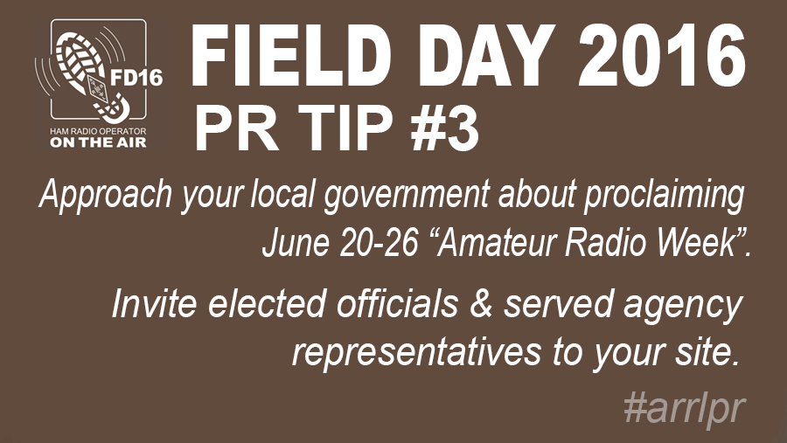

Sean Kutzko, KX9X appeared on a the Ham Radio 360 Podcast and on the 100 Watts and a Wire podcast to discuss both Field Day and NPOTA. Key volunteers from within the ARRL membership were identified and encouraged to amplify messaging through their own personal branding channels. The League’s National Parks on the Air Facebook page has 3,720 members and has emerged as a near real time spotting resource in addition to a place where participants can share best operating practices and ask questions. Sean has done a terrific job in quickly responding and has modeled the behavior, personally activating several locations, himself. PR Committee Chair, Scott Westerman, W9WSW gave a well received, 20 minute multimedia presentation on how to leverage social media for Field Day at the 2016 Dayton Hamvention

**Podcasting and Video**

The new ARRL podcast, “The Doctor Is In”, is an unqualified hit in the amateur community, with downloads and conversation growing with each subsequent edition. Podcasting and video, both live and pre-recorded have emerged as an important tools for promotion of amateur radio. It is estimated that over 100,000 amateurs listen to ham radio related podcasts every week. Promotion of League content across our official social brands and amplified by shares and retweets has become a crucial tactic for positioning the ARRL as a key resource for amateurs wanting to learn more about the various aspects of our “essential avocation”.

**Promoting ARRL Personalities**

In addition to the League’s foray into podcasting, several ARRL officials have been featured on widely circulated media during the first six months of the year, including a keynote speech by President Rick Roderick, K5UR, at the Rocky Mountain Division Hamcon Conference.

<https://soundcloud.com/scott-westerman-1/arrl-president-rick-roderick-k5ur-at-hamcon-2016>

Links to other examples of League personnel in the multi media space include:

KX9X discussing NPOTA on the 100 Watts and a Wire podcast - <http://100wattsandawire.com/100-watts-and-a-wire/2015/11/2/arrl-national-parks-on-the-air-with-sean-kutzko-kx9x>

KX9X talks about Field Day 2016 on the Ham Radio 360 podcast - <http://hamradio360.com/index.php/2016/06/14/field-day-2016-kx9x-arrl-and-the-gang/>

Reliable Communications for the RVer - <http://roadtreking.com/rt71reliable-communications-for-the-rver/>

**By the Numbers**

Twitter: 52,000 followers over 7 Different feeds.  
Facebook: 67,000 likes.. averaging 150 new likes a week.  
Instagram: 820 followers since joining this platform in February.  
  
Podcasts:  
ARRL Audio News: 2500-3000 downloads weekly. This does not factor the number of listeners that hear it over a repeater.  
ARRL The Doctor is In: between 6000-9000 downloads per episode. Advertising is making this a profitable venture.

Respectfully submitted,

Scott Westerman – W9WSW

Committee Chair