February 13, 2013

Kay Craigie, N3KN
President
ARRL
570 Brush Mountain Road
Blacksburg VA 24060-8528

Dear Kay,

On behalf of the Second Century Campaign Committee, I respectfully submit the Committee’s recommendation to set a $10 million public goal for the ARRL Second Century Campaign.
The Committee has been working steadily since its first meeting in May 2011 to identify, cultivate and solicit leadership prospects to contribute to the ARRL Endowment. So far the Committee has received more than $4 million in cash and commitments toward the goal with more prospects actively considering commitments to the campaign.
Plans to reach the $10 million goal include delivering additional leadership commitments, securing commitments from more than 300 ARRL major donors who currently contribute $1000 or more annually, and appealing to the entire ARRL membership in early 2014. In addition the Committee is considering several in-person events in California, Texas, Georgia and Minnesota which should help solidify major commitments.
The Committee plans to reach—or exceed—the goal by the end of ARRL’s Centennial Year.
Please let me know if you have any questions. I would appreciate receiving the Board’s decision as soon as possible. The announcement of a public goal should inspire urgency in prospects who are considering their commitments.
73,

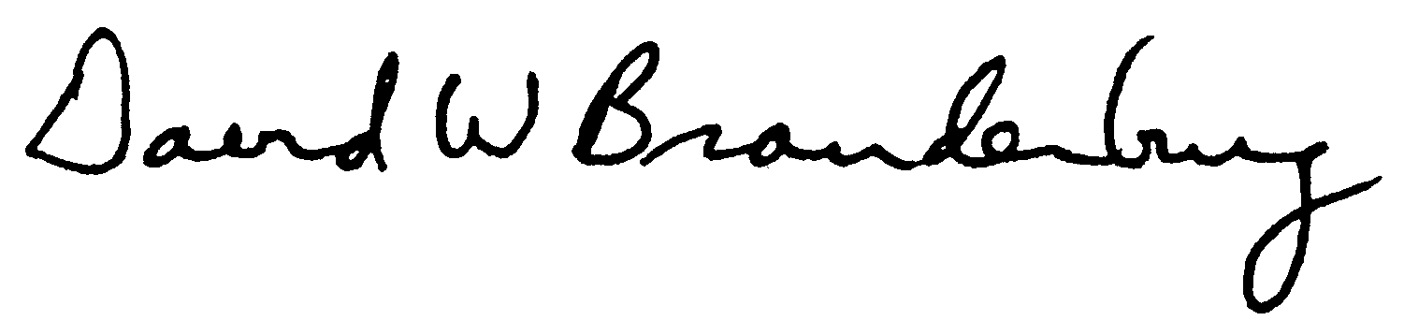
David W. Brandenburg, K5RQ
Chairman
Second Century Campaign

