**Amateur Radio on the International Space Station (ARISS)**

February 24: Frank Bauer and Kathy Lamont presented to the education committee members from the User Advisory Group of the National Space Council sanctioned by the White House to coordinate space. The presentation included the following:

* in-depth review of ARISS including many of ARISS’s metrics
* the months-long STEM activities building up to each school’s radio contact
* activities beyond ones tied to ARISS contacts, i.e., ARISS Radio Experimenters Kit, and
* teachers’ quotes on ARISS’s effectiveness for improving students’ STEM interests.

Many listeners expressed great interest in ARISS, including AIAA and Eileen Collins. She was an astronaut and ham radio operator who supported Shuttle Amateur Radio EXperiment radio contacts prior to ARISS coming into being.

Feb 24: Students from John F. Kennedy High School in Denver, CO engaged in an ARISS radio contact with Mike Hopkins; he answered 17 of their questions. Due to COVID-19, students at home connected virtually, and the link between them and Hopkins’ radio was via an ARISS radio ground station in Oregon. A YouTube video livestreamed for the public, seen by 164 people, has now been viewed by 798 individuals; the URL is: <https://youtu.be/1RgszX0npbQ>. Raytheon had funded a space lab for the school to commemorate the 50-year anniversary of the Apollo 11 launch. The lab affords engineering students hands-on engagements tied to a curriculum applicable to space engineering related to the ISS: exploring ISS-Above cameras, amateur radio, and engineering communications. Some activities included building a solar and hydrogen fuel cell car and how this applied to the ISS, bioengineering/growing plants in space, and solar-system modeling. Students built electronic kits related to amateur radio and constructed a radio antenna so as to try radio direction-finding. The school partnered with the Rocky Mountain Ham Radio group and Cherry Creek Young Amateur Radio Club to mentor students.

Screenshot: young lady at JFK High School, Denver, asking about carbonation in space

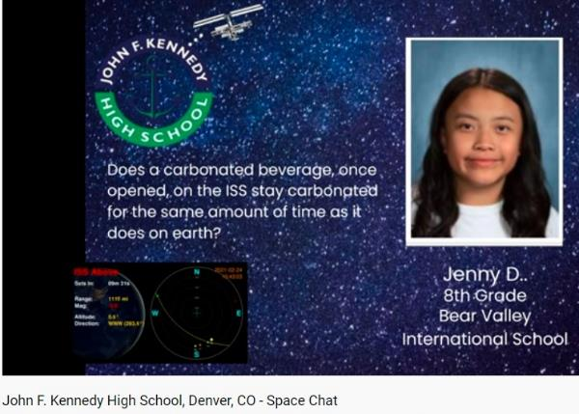

Feb 19: Bishop Guertin High School in Nashua, NH held an ARISS radio contact for Shannon Walker to be interviewed by students at home in 40 communities in New Hampshire and Massachusetts. An ARISS Mentor in Hollis, NH transmitted the audio between Walker’s radio and students; she answered 14 questions. Several outlets provided livestreaming to 2,022 viewers. The ARISS YouTube video is at<https://youtu.be/0-Dsel4_7gM> and had 642 views. Many media outlets posted reports. WMUR-TV interviewed students on Zoom and aired this on both the evening and following morning news broadcasts—see <https://youtu.be/B0KtrKoTDjA>. New Hampshire Public Radio’s article and audio are at <https://www.nhpr.org/post/nashua-students-connect-outer-space-home#stream/0>. Boston’s WCVB-TV News carried a story (<https://www.wcvb.com/article/new-hampshire-students-chat-with-international-space-station-astronaut/35605567>) as did the NH *Union Leader* and Nashua’s *The Telegraph*. Student prep for the ARISS contact included an 18-month curriculum of STEM for all grades; some examples are space exploration, life in space, and the importance of the ISS research and radio communications. The school supports extracurricular STEM-related activities in student-organized clubs--astronomy, 3-D printing, robotics, and ham radio. Over the past four years, the school collaborated with the Nashua Area Radio Society (NARS) on many student STEM activities; a few examples are understanding radio communication, building kits to send Morse code messages, and launching/tracking two high-altitude balloons with ham radio payloads. Students formally presented their collected balloon data at a NARS meeting. Activities mentored by NARS inspired a number of students to earn their ham radio licenses. The STEM Club teacher was impressed with the collaboration; she said: “THIS WAS AMAZING!!! We are so impressed by the students, faculty and partners at NARS! How fortunate our students are to have had this experience. Thanks to ALL involved. We are just blown away.”

Screenshot: A Bishop Guertin student spoke on behalf of the school’s STEM club prior to the radio contact, describing some of the club’s activities.

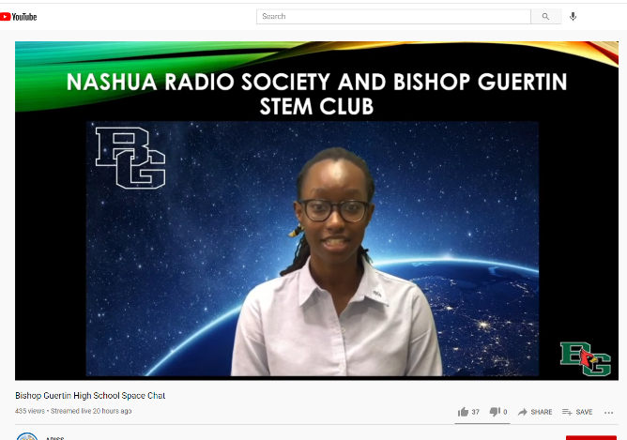

February 19: Students from Estes Park (CO) Elementary School engaged in many STEM studies in the months before their ARISS contact; details about the contact will be in next week’s report. One lesson included composing messages for thank-you cards to give to the Estes Valley Amateur Radio Club (EVARC) members who mentored students. A teacher described another lesson, done via Zoom: “EVARC members engaged our 5th graders in an awesome Q & A about ham radio operations. The kids asked some really fantastic questions!” A few students want to get their ham radio license, and one girl said she is studying for it.

2 images: a) Estes Park boy thanked hams for inspiring him about space, b) a report of the EVARC Q&A

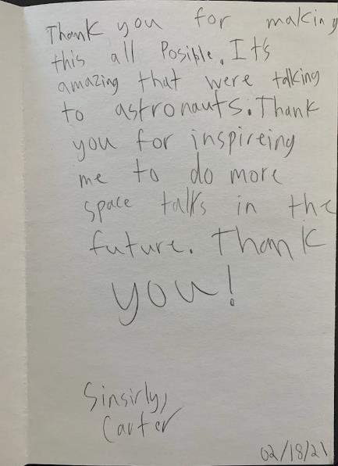 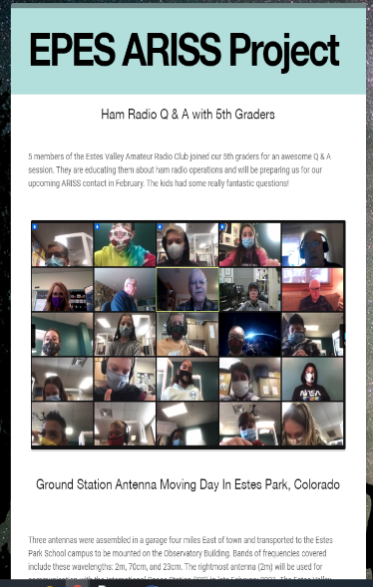

January 23: ARISS-US Education Committee member Neil Rapp presented a forum on Youth On The Air (YOTA) and ARISS at Winterfest 2021, hosted annually by the St. Louis and Suburban Radio Club, this time, virtually. Rapp spoke about the yearly YOTA event, this year’s in July, where activities include an ARISS contact and trying out radio satellite contacts. Attending the forum were over 5,000 viewers from the US, the UK, India, Indonesia, Germany, Austria, South Africa, South Korea, Sweden.

February 25: ARISS leaders John Kludt and Kathy Lamont led an ARISS Proposal Webinar for US educators with an interest in hosting an ARISS contact in 2021. 29 registrants participated in the introduction to ARISS.

February 28: ARISS Volunteer and JVC Kenwood engineer Shin Aota presented a 10-minute talk at the Japanese JAIA Fair on the ARISS radio station (with its JVC Kenwood radio) in the ISS Columbus Module. The live audience totaled 458 with 3,348 viewers afterwards. The online event, sponsored by JAIA (Japan Amateur Radio Industries Association), was held near Tokyo in previous years.

Screenshot: a slide from ARISS presentation by Shin Aota, showing astronauts with the radio

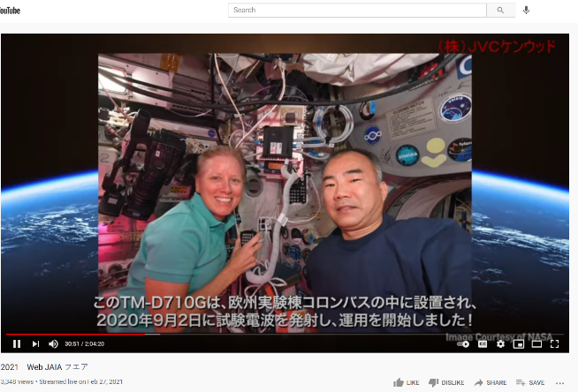

March 2-3: The ARISS team has worked very closely with NASA and ESA to identify potential ARISS radio anomaly causes and resolve the radio issues observed after the January 27th EVA.  Cabling had been installed to support commissioning the Bartolomeo platform, rerouting the cabling of the ARISS antenna to the ARISS radio system. A set of APRS tests employing three different internal cabling configurations has determined the ARISS radio system is still not operational.  Ham radio operators around the globe monitored the ARISS radio frequency for any transmission to be heard, but nothing was detected. A contingency task was approved for the March 5th EVA to return the ARISS cabling to the original configuration prior to the January 27th EVA, but there was not enough time for the crew to perform this task.

**Social Media**

Facebook - February 2021

|  |  |  |
| --- | --- | --- |
| Week | Total Reached | Total Likes by end of week |
| 2/1 - 7 | 2,631 | 6,187 |
| 2/8 – 14 | 2,309 | 6,192 |
| 2/15 – 21 | 2,940 | 6,199 |
| 2/22 – 28 | 2,691 | 6,212 |

Twitter: As of February 28, 2021, ARISS Twitter followers totaled 14,345, a slight gain over January.

Instagram: As of February 28, 2021, Instagram followers increased to 288, an 8% gain over January.

YouTube Members: As of February 28, 2021, there are 1,102 YouTube members.

ARISS Web Unique Pageviews: For February 1 – 28, the total of Unique Pageviews was 40,323.

~~Feb 19   Bishop Guertin High School, Nashua NH, ARISS contact            ARISS-US team~~

~~Feb 24  JFK High School, Denver CO, ARISS contact   ARISS-US team~~

~~Feb 26 Estes Park Elementary School, Estes Park CO, ARISS contact ARISS-US team~~

~~Mar 1 Newcastle High School, Newcastle WY, ARISS contact ARISS-US team~~

~~Mar 3 youth mentored by Peace Corps, Chisinau, Rep of Moldova, ARISS contact ARISS-Eu team~~

Mar 11 Avoca State School, Bundaberg, Queensland, Australia, ARISS contact ARISS-Japan team