**ARRL Historical Committee Report Document #18**

**January 2018**

Activities of the ARRL Historical Committee in 2017 were largely conducted by volunteers working to organize, identify, and catalog the historical documents and artifacts at ARRL headquarters. Bob Allison, staff liaison, manages this cadre of volunteers as they all donate their time and labor to this important endeavor. This group also receives and restores donated vintage equipment. They also design and implement interesting historical exhibits for the lobby of ARRL headquarters. The lobby exhibit is periodically refreshed with a different exhibit by this volunteer group. A detail report of the group’s work prepared by Michael Marinaro, WN1M, follows.

Respectfully Submitted,

Rod Blocksome, K0DAS, Chair

Tom Frenaye, K1KI

Dick Norton, N6AA

Bob Allison, WB1GCM, Staff Liaison

Michael Marinaro, WN1M

**HISTORICAL GROUP ACTIVITIES AT HEADQUARTERS**

**YEAR END 2017**

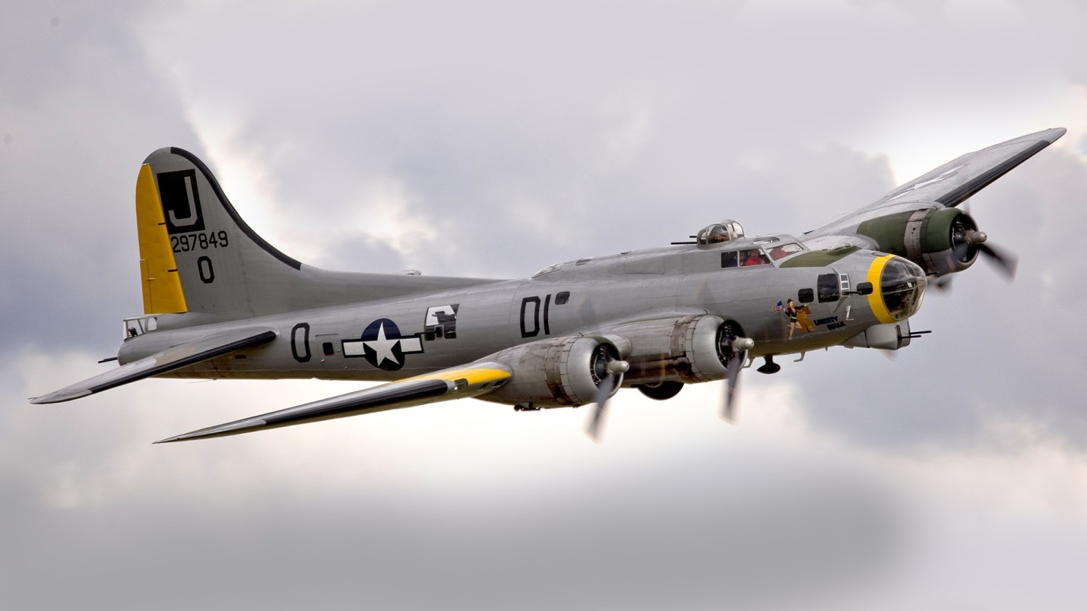

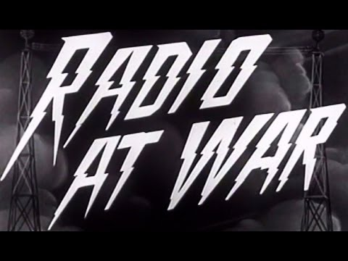

The current Lobby Exhibit features the Command Sets that provided communications aloft during WWII and amateur radio operators with equipment to convert for decades.

**ON GOING ACTIVITIES**

1. Document Archive maintenance (Phase I) – *Word* and *Access* programs.

* Secretary Minutes - 8 file drawers
* *Word* programmed - 140 file drawers

1. Executive Correspondence and Report Archive (Phase II) maintenance.
   * *Access* programmed -140 archival boxes, 1500 line entries, 12 fireproof file drawers and a safe. Program is in accumulation phase.
2. Media-slide, video, and film collection supplementation.

1. Vintage Technical Library maintenance – shelving 700 *Excel* recorded volumes..
2. Exhibitions and displays.

* Lobby-vintage equipment displays - We are in the process of mounting the ninth consecutive display featuring WWII Command Sets and accessories.
* Laboratory Museum section – A portion of the equipment collection and period operating station setups are arranged for viewing.
* CEO Conference Room - curate unique items of historical significance displayed including the recent addition of Hiram Percy Maxim’s key. (Artifacts safe stored include Maxim log books; Constitution and amendments; and various key documents).

1. Museum Equipment Collection.
   * Contents are securely stored and being grouped by category. Items (and categories) eligible for removal are being identified such as variable coils, tubes, and earphones.
   * More than 1,600 individual items have been recorded in an *Excel* database. Volunteer Curator, Jonathan Allen, K2KKH, continues to catalog new additions.
   * Donations are accepted and included or auctioned.

**NEWLY IMPLEMENTED PROGRAMS**

Postings to the new format *HERITAGE MUSEUM* section of the ARRL/Lab web site were made of seven narrative articles and a Power Point Presentation with script and narrative. This presentation section, titled the *HISTORIANS VIEW,* relates the history of the League chronologically from inception similar to a book, in consistent format and layout. Additional historical articles will be added to this section.

We are cooperating with the Media Department to complete and publicize the existence of our collection of early wireless era images. These images are maintained on the *FLICKR s*ystem and invitations to the public to view it. There are currently over 1000 images from slides viewable with more collections to be added. We have obtained authorization from the Antique Wireless Association (AWA) to include several of their slide programs which are in our collection- see: htpps://www.flckr.com/photos/imageaerial

The recently discovered register of the *first* members of the ARRL initially maintained by Secretary Clarence D. Tuska is still under study. It is a loose bound school notebook with individual type written pages in alphabetical order by last name, and calls with membership numbers listed. Also found separately, in correspondence files, the original letter of conveyance by Tuska (at Atwater Kent) to K.B. Warner and a copy of K.B. Warner’s response letter (in which he expresses his inability to understand the sequence of identifying numbers assigned).

We have been unable to establish the correlation of entries with the listings in the first edition of *The List of Stations* of 1914. This approach has not revealed any clear cross relationships. However, we have concluded that the membership numbers assigned are those born by the STATION APPOINTMENT certificates issued to each station. An included certificate states that the station is appointed an OFFICIAL RELAY STATION, is dated 1915 and is effective for one year. Therefore, we can presume that the stations listed were the *founding members of the relay system* and the League. The book has been scanned and the original archived with the other important League documents. Study continues.

**PLANNED PROJECTS**

1. Preparation of a format for the web site posting of unique equipment *FROM THE COLLECTION* initially using the items accumulated from the previous lobby exhibits for the hardware collection and consistent with newly structured *HISTORIAN’S VIEW* section.
2. Resumption of identification and cataloging of what remains of the 35mm slide collection. The collection will be centralized on a separate hard drive with those currently on the external *FLICKR* system. Two database programs are being evaluated to select the one most suitable for our application.
3. Organization and disposition of the considerable accumulation of ITU and IARU material which has not been cataloged as yet. It has been centralized but not organized.
4. Preparation of a master directory of the archival, library, and vintage equipment data bases maintained by the Archivist and Laboratory staff is in process. The intent is to have these programs accessible to all staff.

**COOPERATIVE PROGRAM**

A Gates model BC-1T, one KW, AM Broadcast Transmitter is being displayed in the Heritage Museum section in the Laboratory. The unit is on loan from the Vintage Radio and Communications Museum of Connecticut (VRCMCT). It has been restored by museum volunteers and using the internal dummy load has been operated for several hours continuously on 1230 kHz. The audio is outstanding. The next step is to convert the unit to 75 meter operation in time for the next AM rally planned for February 2018. Experienced assistance has been recruited to assist the team in accomplishing the introduction of the unit to 75 meters. In the interim the displayed unit has received a great deal of attention particularly from broadcast oriented visitors.

**MAJOR PROPOSALS**

The group has proposed to management the creation of a physical *Heritage Museum* and Visitors Center designed and constructed to professional standards. This concept involves dismantling the current underutilized technical library attached to the Laboratory and revamping the adjoining display areas. The library contents are to be melded into the equipment area and adjoining sections of the warehouse. The Library space is to be completely redecorated and repurposed.

Although funds are available for this project we have been requested to proceed gradually as other physical projects take precedent and disruption is to be avoided.

A PERT chart of project steps has been prepared.

In anticipation of relocating the retained portions of the Library content, an *Access*

database is being created. This is a long term project to be undertaken in stages while our other activities are underway.

**THE TEAM**

The Historical Committee team at Headquarters presently consists of four principals – Bob Allison, WB1BCM Assistant Laboratory Manager who is the staff liaison to the Committee; Michael Marinaro, WN1M volunteer acting as Historian, Archivist and Curator and member of the Committee; Jonathan Allen, K2KKH/1 volunteer acting as curator of the Museum equipment and Archivist; and Pete Turbide, W1PT volunteer technical restorer and maintainer of the Museum and donated equipment. There are other occasional participants but regrettably no permanent additions.

Organizationally, Allison and Marinaro inform the CEO and Committee chairperson of their activities and interact directly with department managers to accomplish the prescribed objectives of the team on behalf of the Committee. The team aggressively pursues recruits as succession, continuance, and knowledge of the activities is of concern.

Michael Marinaro

Bob Allison

December, 2017