Radiocommunication Study Groups | 
Received: 11 June 2008  Subject: Question ITU-R 221/1  Reference: Document 1A/38 | Document 1A/57-E
 | 12 June 2008
 | English only
International Amateur Radio Union
IMPACT OF POWER LINE TELECOMMUNICATIONS (PLT) SYSTEMS
ON RADIOCOMMUNICATION SYSTEMS OPERATING IN THE LF,
MF, HF and VHF BANDS BELOW 80 MHz
1 The IARU notes that there continue to be discussions within Working Party 1A and Working Party 1C regarding methodologies for Power Line Telecommunications (PLT) measurement, specifically the narrow issue of signal decay with distance and what distance extrapolation factor should be applied when calculating emissions by PLT systems. Distance extrapolation factor is the projected rate at which radio frequency strength decreases from a radiation-emitting source, used to estimate signal decay for PLT systems and resulting interference to radiocommunication services at various distances from a source without actually measuring such emissions.
2 RR No. 15.12 obligates administrations to “…take all practicable and necessary steps to ensure that the operation of electrical apparatus or installations of any kind, including power and telecommunication distribution networks…does not cause harmful interference to a radiocommunication service and, in particular, to a radionavigation or any other safety service operating in accordance with the provisions of these Regulations.” The usual standard for the protection of receivers in licensed non-safety-of-life radiocommunication services is an I/N of
–6 dB, having the effect of raising the noise level no more than 1 dB.
3 Typical HF broadcast receivers and amateur stations are both situated in residences in close proximity to such wired systems and share a common interest. Separation distances between a receiving antenna and a power line carrying data may be less than a metre. PLT emission limits currently being proposed, or in use, by some administrations may result in interference levels that could reduce the capacity of HF transmission channels essential to the amateur service.
4 Document 1A/38 outlines developments in PLT using the electric mains to transmit data rates of 1 or more Mbit/s using frequencies from 1.6 to 30 MHz. Table 2.4.3.7, reproduced in part below as Figure 1, proposed protection limits for the amateur service.
Figure 1
Protection limits proposed for the amateur service
Frequency  (MHz) | Proposed Protection limit  (peak dB μV/m at 3 m)
1.8 | 10.19
3.5 | 7.85
7.0 | 6.13
10.1 | 7.95
14.0 | 5.94
18.1 | 4.41
21.0 | 4.01
24.9 | 3.65
28.0 | 3.45
5 European studies provided a comparison of electric field limits proposed by regulatory bodies for PLC emissions, adapted in Figure 2.
Figure 2
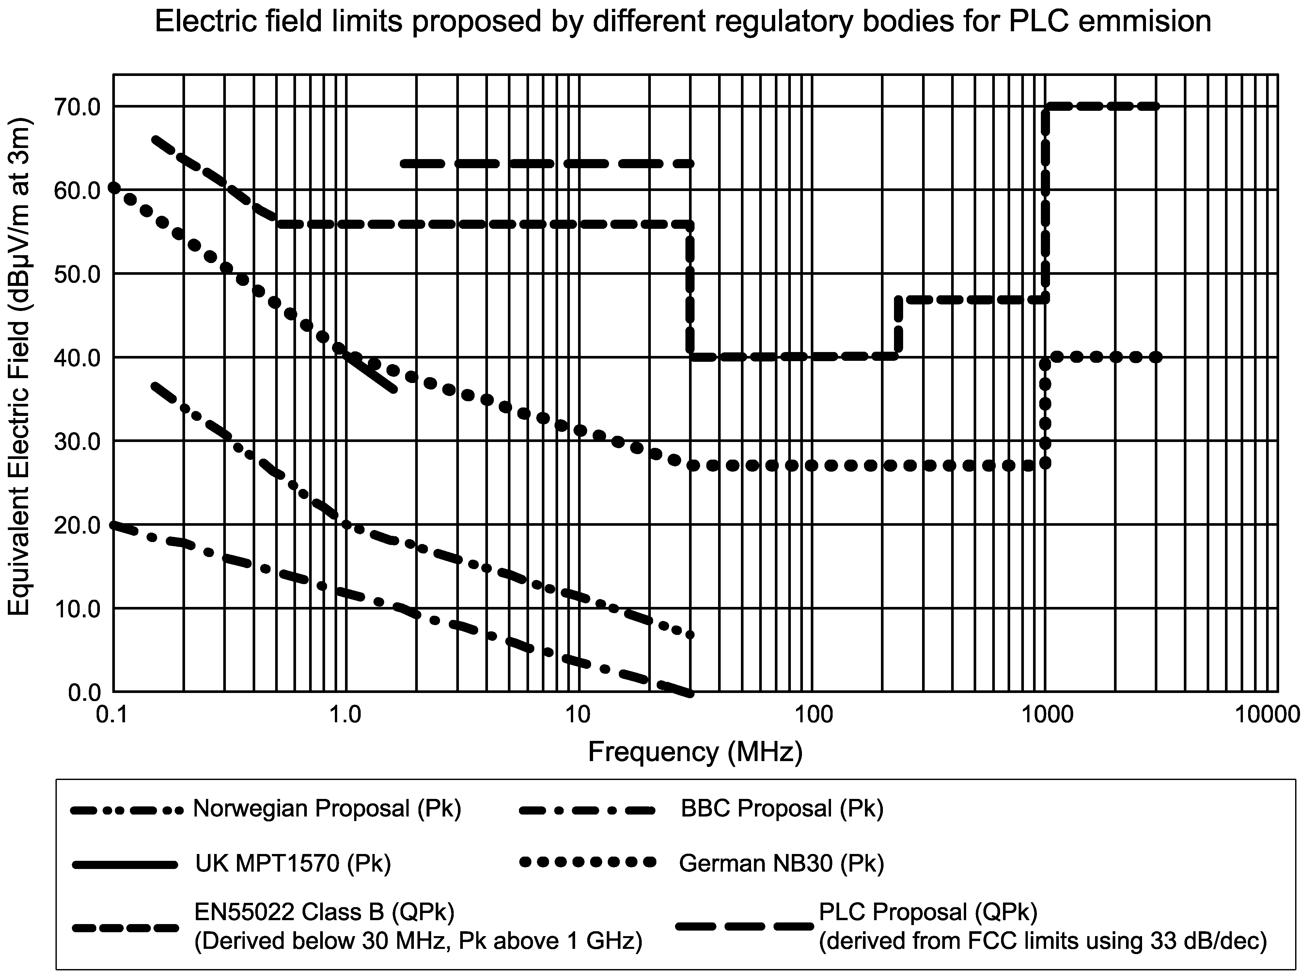

6 The amateur service has an active role in providing communications in emergencies and its MF, HF and VHF allocations should be protected from harmful interference. Article No. 25.9A (Rev.WRC–03), states: Administrations are encouraged to take the necessary steps to allow amateur stations to prepare for and meet communication needs in support of disaster relief. In many countries, amateur stations provide a valuable back up to normal communications systems in case of breakdown or overload. Administrations rely on this capability at times of emergency.
7 The IARU supports continued ITU-R studies to determine the impact of Power Line Telecommunications (PLT) systems on radiocommunication systems operating at LF, MF, HF and VHF below 80 MHz and specifically, to determine the proper distance extrapolation factor for these systems.

_______________

