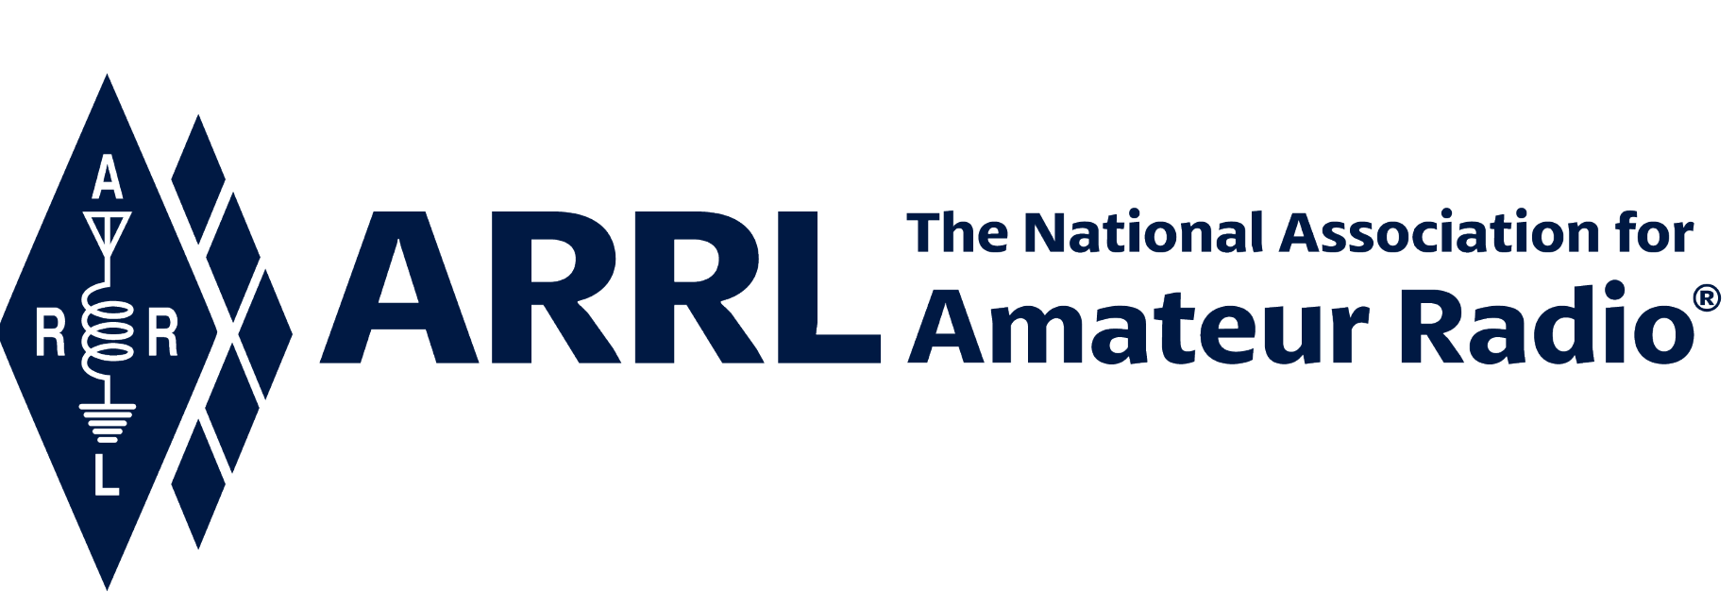
IN-NEWSLETTER
October 15, 2021

Vol. 52, No. 33 Covering October 11-15, 2021

Upcoming Meetings and Events

Events listed below are subject to change at any time; information will be updated as soon as it becomes available.

Pacificon- October 15-17, 2021

ARRL Executive Office Updates
Kelly Wells, Executive Assistant

David Minster, NA2AA, and Diane Middleton, W2DLM, hosted the several meetings including the Management Council Meeting, Marketing Communications Monthly Business Meeting, and Field Services Monthly Meeting.

Diane and David continued to have discussions around the 2022-23 Plan.

Product Development, Public Relations and Outreach
Reported by Bob Inderbitzen, NQ1R

Bob Inderbitzen, NQ1R, participated in planning for our production of a Solar Cycle 25 video with Steve Goodgame, K5ATA and our subject matter experts. Bob also held the monthly Public Relations Committee meeting.

We are trying some additional approaches for recruiting candidates for current position openings. Bob distributed information for the PR job postings to public information volunteers including a new flyer: Download Flyer (PDF). A “Career Opportunities” graphic is also posted in the rotating carousel on our website home page.

A “2022 Scholarships” graphic has been added to the home page, urging student-hams to apply Nov. 1 to Dec. 31.

Social media posts promoting the ARRL Online Auction, produced by Marketing Communications, are being regularly administered and scheduled to ARRL’s accounts on Facebook, Twitter, and Instagram.

Bob has engaged Bruce Godley Littlefield, the grandson of Paul Godley, on planning to mark the historic achievement of the ARRL Transatlantic Tests nearly 100 years ago. In 1921, ARRL sent Paul Godley to Scotland where he successfully received the signals of radio amateurs in North America – heralding the dawn of amateur radio transatlantic communications.

Additional equipment, including monitors and mounts, were selected, and ordered for installation at each of the operating positions in the new ARRL Radio Lab.

President Rick Roderick’s statement, “Putting Unused Spectrum to Work for Public Service, Education and Technology,” was published to a page on the website to support related stories posted in the ARRL Letter and ARRL News: http://www.arrl.org/arrl-statement-on-3-ghz-band-oct-2021

We are pleased with the engagement created by our Facebook post, congratulating sisters Kanushi KE8RNA & Jashvi Desai KE8QHI, and their mentor Dr Dennis Klipa N8ERF, for recently earning their licenses. The sisters, both students and one an ARRL member, have enjoyed attention in Michigan-area media outlets: https://www.facebook.com/ARRL.org/posts/10158832702257408

Bob Nauman, W5OV
Director of Operations

As our CEO, David Minster, NA2AA reminds us in the “Second Century” column of the new issue of QST, it is time to “Fall into Contesting!”

W1AW is where all of this began: “From its inception the station was a major relay link in the National Traffic System (NTS) the founding principal of the ARRL. During these early years the station not only handled traffic, but also originated and transmitted bulletins and announcements addressed QST, “to all radio amateurs”. (Excerpt from “The Early Logbooks of Hiram Percy Maxim” which is downloadable on ARRL.org).

Therefore, W1AW is going to comply with that directive, and we will have many opportunities to actively participate (operate) or observe what contest operating is all about! Plus, several SSB (voice) only contests will be entered by W1AW as multi-operator entries. Everyone at HQ is invited and participate at a level you are comfortable with.

If you are interested in any of the contests below, please contact Joe Carcia, NJ1Q, our W1AW Station Manager at JCarcia@arrl.org . More specific details about the contests will be published closer to the date of each event.

October 30 & 31: CQ Worldwide SSB contest. This is the premier world-wide DX operating event of the entire year! W1AW will be operating most of the weekend, but additional help will be appreciated. In this contest, many rare DX Entities and contest DXpeditions will be on the air.

November 20 & 21st: ARRL November Sweepstakes SSB Contest. This contest has an exchange that is modeled after our own ARRL Radiogram and is a tribute to the origins of the ARRL as the American Radio Relay League where providing no cost communications to the public was our collective mission.

December 11 & 12th, 10-meter Contest. We will have one station on the air for this contest while there are other Transatlantic Test commemorative activities going on simultaneously at W1AW.

W1AW
Joe Carcia

Joe updated the web code practice files and archives and processed seven qualifying Run certificates and five (5) endorsements. Scott worked on slow and fast code practice files for the week and processed eight (8) paper and sixteen (16) electronic VUCC applications for a total of 2,136 credits.

Joe is continuing the reorganization of the visitor operating studios.

Radiosport
Sharon Taratula

Paper/Fieldcheck Processing Time | 3 Weeks
Logbook Processing Time | 5 – 6 Business Days
2021 DXCC Applications | 8,081
2021 WAS Applications | 2,566
2021 VUCC Applications | 1,470
2021 WAC Applications | 96
2021 WPX Applications | 771
2021 WAZ Applications | 686

Edited by Kelly Wells, Executive Assistant

