Document #23
Ms. Joyce Birmingham, KA2ANF, Chairperson

Report of the Historical Committee
January, 2012 meeting – ARRL Board

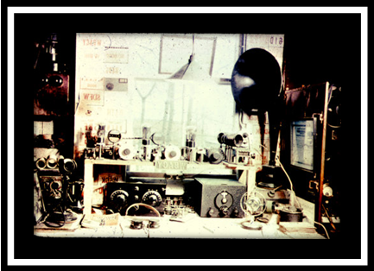

The Historical Committee (HC) cares for and administers the ARRL’s considerable collection of photographs, preserved documents and donated artifacts. Most of these are located in a caged area on the 2nd floor of the League’s offices in Newington, Connecticut, and many of the artifacts are displayed in the foyer and first floor hallway.

As reported previously, until February 24, 2011, the care and cataloging of the collection was provided by the part-time services of Perry Williams, W1UED, Curator, and the volunteers, Charles Griffen, W1GYR and Michael Marinaro, WN1M. Both Perry Williams, W1UED and Charles Griffen, W1GYR, officially retired on February 24, 2011. Michael Marinaro, WN1M continues as the lone volunteer in the department. Mike returned from medical leave in April.

Principal ongoing focus has been on the system used to “catalog” the archive files that have been partially edited from the original move from the attic. Objectives are to understand the system, determine the extent of the conversion work and prepare a guide for finding documents. Many hours have been spent on this endeavor with the result that the online system of recording was deciphered and a hard copy “directory” prepared.

Simultaneously, the cage was reorganized. Unidentified files from the top of file cabinets and shelves were archivally boxed as well as a number of open cartons that have been shelved. These were marked for further examination and possible organizing. All extraneous objects and materials were removed including one of the two obsolete computers. We have requested that the area be thoroughly cleaned - Please, and some additional fluorescent fixtures be added. The lighting is poor in this area and it is hard to examine some of the documents as well as the photos.

We are on our way to assuring a well-organized, professional workspace.
Work has continued on the following projects:
- Scanning slide collections.
- Development of the ‘FLICKR’- unofficial ARRL web site for viewing of selected slide collections. This is a pioneering effort and still has not been formally acknowledged or publicized.

YASME has generously donated funds to purchase a state of the art slide scanner which we are using to batch scan some of our slide collections. We are grateful for this easy-to-use scanner. Slide collections can be viewed on our internal system. We have recently scanned some additional 1000 slides. Subjects vary from an AWA program, featuring vintage straight keys, to Oscar 7, Oscar 8 and “Polar Adventures” - an extensive narrative of the 1956 expedition “Operation Deep Freeze I” to Antarctica led by Admiral Richard Byrd. Also included in the collection is a feature concerning the Radio Astronomy telescope at Arecibo, Puerto Rico.

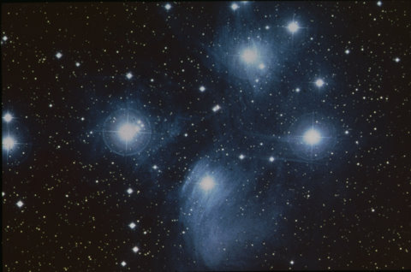

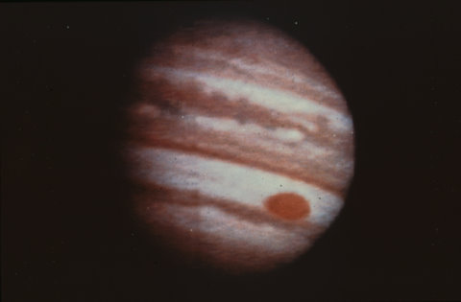

We scanned into the system several old callbooks including a complete 1922 issue and some lists published in early QST. We are planning to continue this work scanning in those old books that are beginning to deteriorate. Also, we organized the Annual Reports that were stored in the cage and listed them so gaps could be filled and storage centralized.

The article by our volunteer Archivist/Historian “Ham History SOS” appeared in the December issue of QST. It narrates the history of this committee and our efforts and solicits volunteers. Judging by local comments and Emails it was well received. We hope to use this article and a more presentable work area to attract interns from nearby Central Connecticut State University,

Our principal objectives for 2012 are to:
- Continue the preservation of the QST photographic prints in the cage file cabinet drawers.
- Survey the movies and videos that have not been examined.

& most importantly:
- Examine the unfiled boxed material accumulated in the cage, and material in the file drawers that have not been cataloged and classify them by importance, historical value and retention need. Documents worthy of preservation may be scanned utilizing the Past Perfect program or a simpler library quality program that we are seeking. This program will be adopted for all future cataloging and become our standard. It is not likely that we will attempt to utilize the system previously used for any new documents.

The following members currently serve on the Historical Committee:

Joyce Birmingham, KA2ANF – Chairperson
Tom Frenaye, K1KI
Art Goddard, W6XD
Gary Johnston, KI4LA
Michael Marinaro, WN1M
Dick Norton, N6AA
Dave Sumner, K1ZZ

While we do continue to look for volunteers within the organization as well as the surrounding amateur community, our immediate need is for dedicated Administrative support.

Respectfully submitted:

Joyce Birmingham, KA2ANF
Chairperson, ARRL Historical Committee

