**2013 ACTIVITIES – PRESERVATION AND CONSERVATION OF ARRL HISTORICAL COLLECTIONS**

**JOINT REPORT OF DATA & HARDWARE GROUPS**

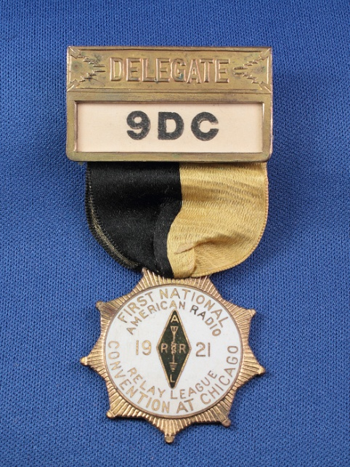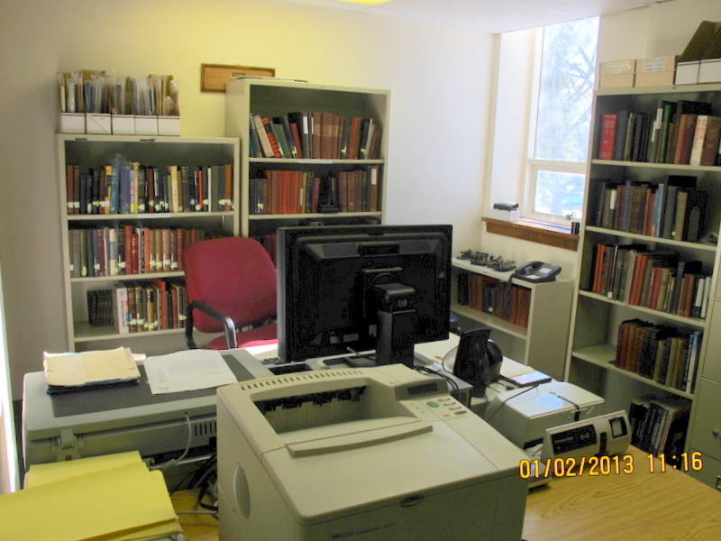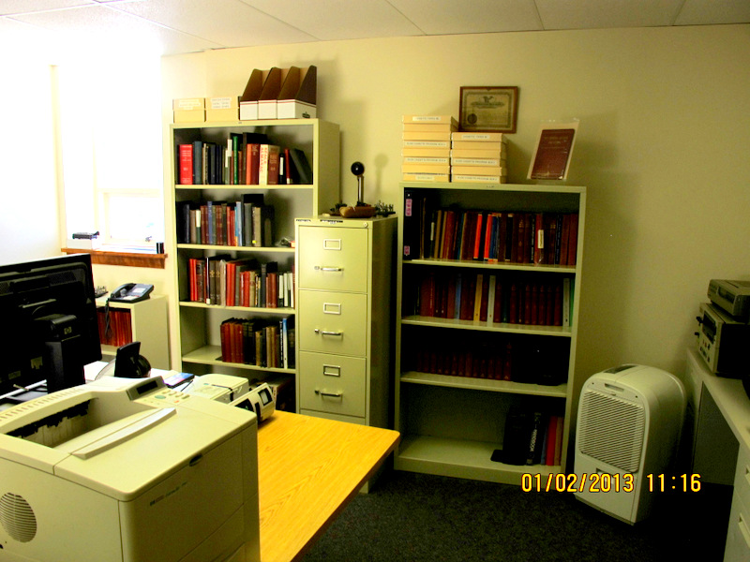

Historical Preservation Center & Library Delegates Badge-1st ARRL Convention 1921

**The year began with the QST publication of the article *A Professional Approach to Amateur Radio* in the February issue. Therein was discussed *The ARRL Historical Collection Statement of Purpose* which had been adopted by the Board at the previous midyear meeting. Overall objectives were stated here.**

**DATA GROUP**

**Collections:**

**The complete Historical Collection of all but hardware material is comprised of thirteen individual collections.**

**The major collection is designated C and contains the paper documents. Considerable progress has been made to catalog the heretofore unlisted files. Beginning where the previous effort, with the bulk of the material, left off we adopted and implemented a new system of cataloging and filing based on the Microsoft *ACCESS* data baseprogram. The *ACCESS* program was selected after extensive evaluation of the available data bases as it is:**

**a. User friendly**

**b. Permits integration of existing *EXCEL* data bases and is compatible with *NSQL*, the ultimate level program/language used for internet data base establishment.**

**c. Highly flexible with large descriptive field capacity.**

**d. Excellent “finding” capabilities.**

**e. Used extensively in house.**

**After Beta testing and with management approval we have completed the cataloging of this archive. More than 300 new files have been established and stored in this PHASE ONE of the project. We intend to apply this same system to the archiving of the valuable material in the executive area. This PHASE TWO project will begin in January.**

**The balance of the collections numbered I through XII all received additions. Each of these is active, and open ended and has its own *EXCEL* database.**

**Resource:**

**The improved organization of our collections has enabled us to satisfy many member and editorial staff inquiries; and to assist in the preparation of the historical TIMELINE for the Centennial. The research ability of our heritage has been improved enormously. We know what we have and where it is. In addition we have made discoveries which have illuminated our history and provided substance for QST historical articles.**

**K5VT Donation:**

**The donated Vince Thompson, K5VT collection was cataloged. Over 1000 items have been listed in EXCEL and the items are stored in sixteen archival boxes. These telegraph history oriented ephemera and books are now available for sale as a lot to a auction house or book store; or individually by auction or online. The small portion of the collection pertaining to radio- pamphlets and books was removed and integrated into our existing collection.**

**2014 Objectives**

**Projects for the coming year:**

**a. Undertake the cataloging and storage of the executive office documents.**

**b. Complete examination and organization of remaining 35MM slides. Scan these slides into local computer storage. Integrate these and *Flickr* and *Picassa* held slides into the single Collection X.**

**c. Continue and complete the preservation of the QST photographic prints stored in the cage cabinets.**

**d. Participate in the Centennial celebration by setting up at HQ a historical display table of artifacts (first ARRL convention of 1921 ?) and a continuous slide presentation for those visitors on tour ? This to be consistent with the museum equipment exhibits.**

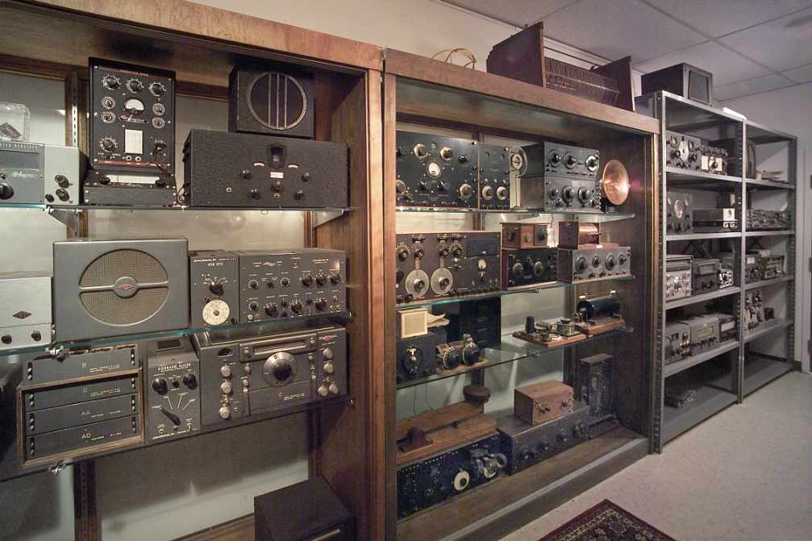

PORTION OF MUSEUM EXHIBIT

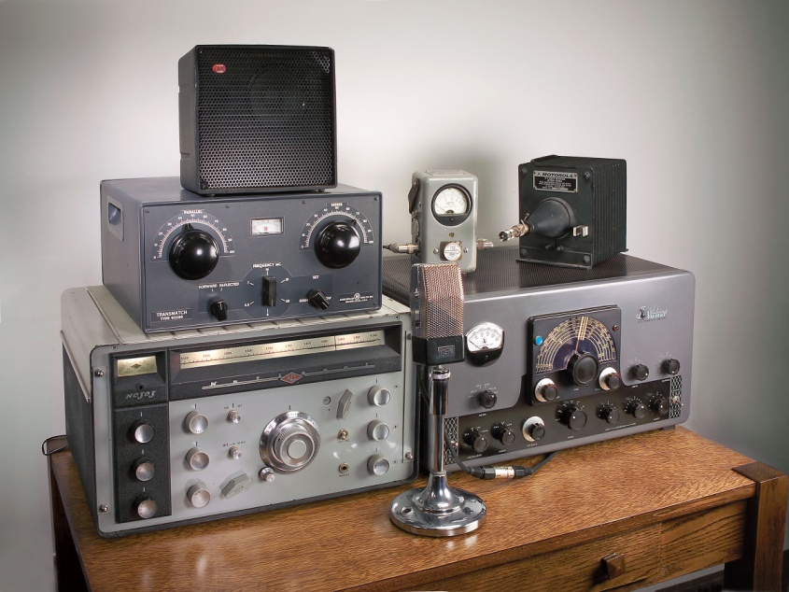

ONE OF HISTORICAL STATIONS ON EXHIBIT

**HARDWARE GROUP**

**Collection:**

**The equipment and allied stores had been designated as collection XIII and will remain so for the time being.**

**Again after extensive research and with the assistance of the IT group it has been decided to utilize a modified and specialized version of the *PAST PERFECT* museum artifact data base program for cataloging and inventorying. This program was selected principally because it is compatible with bar coding-the method preferred for identification of the individual non paper items in the collection. A specialized template of the input screen has been devised and is currently being reviewed and tested for operator ease of usage. Simultaneously, a step by step system plan is being developed for the entire process: retrieval-identification-photographing-bar coding-inputting-storage.**

**We have received several donations of equipment in the interim and these have been documented and shelved. However, the process of opening boxes of not entirely identified equipment has been curtailed for the moment.**

**2014 Objectives**

**Historical oriented projects for the coming year:**

**a. Undertake the systematic recording of the not entirely identified equipment stores.**

**b. Prepare the “equipment museum” for the Centennial HQ tours.**

**BOTH COORDINATED GROUPS**

**Petitions:**

**At midyear we formally petitioned management for support in two areas which are related to the efforts of both groups:**

**a. We asked for a modest increase in space in which to conduct our activities.**

**It was requested that a modest portion of the outer office, exterior to the current packed office, be relinquished by the IT group for the Data Group to table, examine and record material and set up a work station.**

**The Hardware Group required space to store and examine the unidentified equipment inventory. It was proposed that an underutilized portion of the warehouse, adjacent to the Data cage, be caged off for this purpose.**

**These space requests were apparently approved but have not been implemented.**

**This is a matter for our discussion with our supervisory management.**

**b. We requested the services of a part time input clerk to assist the volunteer Curator and conduct the *ACCESS* program for document archiving. This operator would be available to input information into the *PAST PERFECT* program, on occasion, for the Hardware Group. This request has been approved and budgeted for 2014. How exactly this position will be funded is also a matter for our discussion with our supervisory management.**

**Volunteer:**

**Volunteer Jonathan Allen, K2KKH has been of considerable assistance in accomplishing all of the above and should be recognized for his effort.**

**We have no prospects of additional volunteers at this time. The matter of attracting and properly applying volunteers is a complex one and will be addressed in a separate writing. Suffice to say recruiting is a major mutual objective and any assistance in this regard would be appreciated.**

**Funds:**

**The Board allocated funds for our operations. Very little of this allocation has been spent to date. We understand that these funds will be available into the coming year. We hope that our progress towards the utilization of these funds and our need for additional funding is adequately explained here.**

**Recognition:**

**We also wish to acknowledge the work of John Proctor, K1JMP of the IT group who has guided us in the adaption of the two data base programs to our needs.**

**M.W. Marinaro**

**B. Allison**

**12/06/2013**