No. 2192-W December 21, 2010

NOTICE OF ANNUAL MEETING

ALL DIRECTORS:

In compliance with the requirements of the Articles of Association and the relevant provisions of the Bylaws, the 2011 Annual Meeting of the Board of Directors of The American Radio Relay League, Incorporated, is hereby called for 9:00 A.M. Eastern Standard Time, Friday, January 21, 2011, at the Windsor/Hartford Airport Marriott at 28 Day Hill Rd., Windsor, Connecticut.

Arrangements have been made for a group dinner on the Thursday evening preceding: attitude adjustment at 5:30 P.M. and dinner at 6:00 P.M. Other group meals are Friday and Saturday breakfast and lunch, and Friday dinner. Note that there will be a cash bar, not an open bar, prior to the dinners. Purchases from the cash bar are not reimbursable. We expect the meeting will conclude by 5:00 P.M. on Saturday. A group photograph will be taken on Friday after the luncheon break; the dress code for that occasion is business attire (for men, jackets and ties).

Honorary vice presidents, directors emeritus, past presidents, and past directors are invited to attend in observer status at personal expense. Vice directors are authorized to attend with expenses charged to the Board Meeting account. Cash advances are available upon request for those traveling at League expense.

Transportation from and to Bradley International Airport will be provided by Marriott. There is a Marriott courtesy phone located in the baggage claim area. An accommodation form accompanies this Notice; please return the form or respond by email as soon as possible to Lisa Kustosik, KA1UFZ, at HQ: lkustosik@arrl.org. Accompanying spouses are invited to attend breakfast and dinner with the Board family.

The tentative agenda for the meeting will be circulated separately by email. The Secretary has received no proposals for amendments to the Articles of Association and Bylaws for advance circulation.

It is requested that insofar as possible, motions to be submitted at the meeting be prepared in advance in writing so that a copy can be handed to the Secretary at the time of presentation. It is important that the motion as handed to the Secretary be the same as that submitted for Board consideration. While we will have word-processing and duplicating capability at the meeting site, this should not replace advance preparation. If you wish to have a proposed motion circulated in advance, either send it to me as soon as possible or post it on the Board’s electronic remailer.

Please also note Standing Order 30: “Each Director offering a motion requiring the expenditure of funds for implementation shall include with the motion his [or her] estimate of the costs involved and the suggested method of funding those costs.”

Also note Minute 42 of the 2004 Annual Meeting: “Any motion to create or substantially modify a program or activity shall include documentation of the expected revenue and expense generated by the proposed program or activity.”

Finally, meeting attendees are advised that the proceedings will be recorded electronically.

Sincerely,
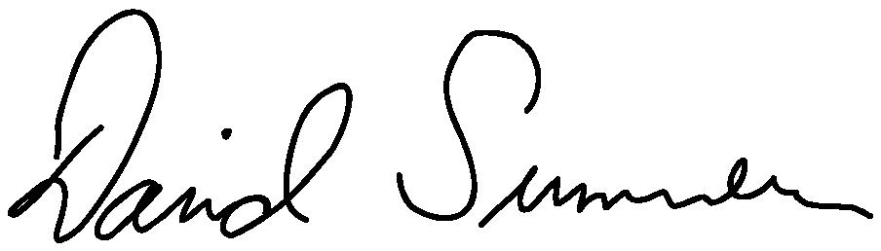
David Sumner, K1ZZ
Secretary

