Document #2

ARRL Foundation
Summary of Activity
January-June 2004

The ARRL Board elected Walt Stinson, W0CP, as a new ARRL Foundation member in January. The ARRL Foundation's annual meeting was in February, and we elected a new Treasurer, Jim McCobb, W1LLU, and Secretary, Mary Hobart, K1MMH. The transition of responsibilities to the new officers, and the transfer of funds and securities to a new bank has gone quite smoothly over the past several months.

Financially, our overall fund balance as 6/30/2004 was $2.115m, approximately the same level as we had on hand six months ago.

In early May the Foundation announced the winners of 39 scholarships totaling $37,000. In addition the Goldfarb Scholarship was awarded to Jonathan Krentzel, KC0AMG, of Leoti KS. His award will be well in excess of $10,000 and cover his college expenses (beyond family and other scholarship awards) for his undergraduate degree at Wichita State University. As usual, we had a large number of applicants, many with exceptional grades and community involvement. We could easily find well-qualified winners for many more scholarships than we currently administer.

Three new scholarships are being announced in August 2004 QST. The Al Hix, W8AH, Memorial Scholarship was endowed by the Kanawah ARC and some friends of W8AH, and will initially be for $500 with a preference for West Virginia hams. The IRARC Memorial Joseph P Rubino, WA4MMD, Scholarship was established by the Indian River ARC, will be for $750 with a preference for Brevard County FL hams, and the William Bennett, W7PHO, Memorial Scholarship was established by the Western Washington DX Club and friends of W7PHO. The award will be for $500 and has a preference for Northwest, Pacific and Southwest Division residents.

A fourth new scholarship, the Yankee Clipper Contest Club Scholarship, for $1500 and a preference for those living in or going to school in New England, Eastern NY, and NYC/Long Island, was approved by the Foundation Board in early July.

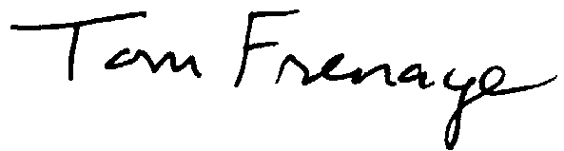
ARRL Foundation Board Members
Tom Frenaye, K1KI, President
Jay Bellows, K0QB, Vice President
Roger Franke, K9AYK, Treasurer
Frank Butler, W4RH
Tom Comstock, N5TC
Frank Fallon, N2FF
Gene Hastings, W1VRK
Greg Milnes, W7OZ
Walt Stinson, W0CP

13 July 2004

