Document #26
Entry Level Licensing Committee
January 2019 – ARRL Board

The ELL Committee continued to be mostly inactive since the January 2018 Board meeting. At that meeting, a petition to the FCC was authorized for the purpose of modernizing the Technician license by adding some band segments for digital and voice modes on 80, 40 and 15 meters. The ARRL filing to the FCC was made on February 28, 2018 and nearly a year later the proposal has not been given a Rule Making (RM-) number.

We’re pleased to know that some effort was made last fall by HQ management to encourage the FCC to take action on a number of pending issues, including our Technician change proposal.

As was stated in July, in order to stay out in front of this effort, ARRL should be planning some strategic efforts to lay the groundwork for positive responses to the FCC when they ask for comments on our proposal. The future success of the Amateur Radio service is being impacted each day there is a delay in any modernization of the Technician license.

It appears that good progress has been made in the “discovery and strategy phase” of the Lifelong Learning Initiative Project initiated last January. The project is designed to improve upon how ARRL interacts with newly licensed hams and to build resources that will help them to get on the air and involved in various aspects of ham radio. Originally the initial phase was to be completed in July and the Board would then decide whether to proceed with the full rollout. We’re now at a point a year later and a decision should be made to fully fund and move ahead with the initiative.

Committee member K1BG continues to make presentations to New England radio clubs and at the September ARRL New England Division convention on changes to the entry level license over the years. The presentation documents how the original Novice license study materials from the early 1950s was only four pages long, compared to the many, many pages in current training publications for the Technician license.

Previously, the committee recommended that a serious effort be undertaken to improve the question pools used for the Technician license. The amateur community has the ability to streamline the question pool used for the Technician exam. The current pool of questions and answers uses language using obscure and unnecessarily complex terms and phrases. Compounding that, ARRL and other publishers of study materials have written them at too high of a reading level. Much more effort and care on this topic will make it possible for more people to pass the exams without reducing the subject areas covered.
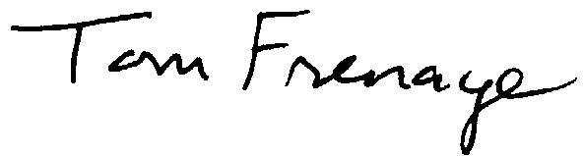
Committee members:
Tom Frenaye, K1KI, chairman
Bonnie Altus, AB7ZQ
Tom Delaney, W8WTD
Maria Somma, AB1FM
Bruce Blain, K1BG
Andrea Wayward, KG4IUM
Ward Silver, N0AX

