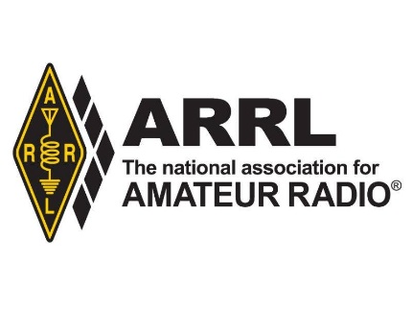

**American Radio Relay League/ 225 Main St. / Newington, CT 06111**

**Contact: David Isgur, ARRL Communications Manager, 860-594-0328 / disgur@arrl.org**

**FOR IMMEDIATE RELEASE:**

**ARRL Reshaping its Podcast Offerings for 2020**

Newington, CT – December 19, 2019 – In conjunction with the launch of its new *On the Air* magazine, which is aimed at those just beginning their journey in amateur radio, the American Radio Relay League is reconfiguring its lineup of podcasts.

Heading up the new lineup will be a free companion podcast to the bimonthly *On the Air* magazine. The “On the Air” podcast will take a deeper look into select features and projects from the magazine. Each month, host and *On the Air* Editorial Director Becky Schoenfeld, W1BXY, will offer additional resources, techniques, and hints to help less experienced amateur radio operators get the most from the magazine’s content.

In addition to the podcast, ARRL will also introduce a free “On the Air” blog featuring curated content from the communicators and makers who are the driving force of today’s amateur radio hobby. The blog, which will be curated by ARRL Product Development manager Bob Inderbitzen, NQ1R, will highlight all the opportunities and activities available to new licensees. The “On the Air” blog is an excellent entry point into the world of amateur radio for those looking for original voices and perspectives from the community. Readers will be invited to take part in the conversation, share their stories and experiences by emailing [ota-blog@arrl.org](mailto:ota-blog@arrl.org).

The current ARRL podcast “So Now What?” will end in January 2020, as the full complement of *On the Air* content is rolled out.

In addition, “The Doctor is In” podcast, which has served more experienced amateurs since 2016, will conclude its remarkable four-year run on December 19, 2019. A new biweekly podcast designed to appeal to experienced amateurs, “Eclectic Tech,” will launch in February 2020. In the interim, “The Doctor is In” co-host Joel Halas, W1ZR, is selecting some of his favorite podcast episodes for re-broadcast. The complete archives of “The Doctor is In” podcast is available at <http://www.arrl.org/doctor>. Halas will also continue **answering questions about Amateur Radio in** QST magazine***'s* "The Doctor is In" column.**

“Eclectic Tech,” hosted by *QST* Editor Steve Ford, WB8IMY, will highlight technical topics involving amateur and non-amateur technology, offer brief interviews with individuals who are involved in projects of interest to amateurs, and will also include practical information that would be of immediate benefit to amateur radio operators.

The “ARRL Audio News” podcast will steadfastly continue to provide weekly coverage of news and activities within the amateur radio community.

*The American Radio Relay League (*[*www.arrl.org*](http://www.arrl.org)*), represents the interests of amateur (or “ham”) radio operators across the country. Founded in 1914 by Hiram Percy Maxim, ARRL, The national association for Amateur Radio®, has a proud history of achievement as the standard-bearer in amateur affairs. Now in its second century, ARRL remains focused on “advancing the art, science, and enjoyment of Amateur Radio.”*

—30 —