ARRL EMC Committee Semi-Annual Report
Doc. # 21
For The
American Radio
Relay League
Board of Directors Meeting
January 21-22, 2011
Submitted By
Kermit Carlson, W9XA
Chairman, ARRL EMC Committee
Mission Statement:
The EMC Committee monitors developments in the Electromagnetic Compatibility (EMC) field and assesses their impact on the Amateur Radio Service. The Committee informs the ARRL Board of Directors about these activities and makes policy recommendations for further action, if appropriate.
The overall goals of the committee are:
- Advise the ARRL Board about issues related to radio-frequency interference
- Advise the ARRL HQ staff on the content of its publications
- Make recommendations to the ARRL Board and HQ staff
Members of the Committee:
- Mr. Kermit Carlson, W9XA, ARRL Central Division Vice Director, EMC Committee Chairman
- Mr. Jody Boucher, WA1ZBL, RFI troubleshooter, Northeast Utilities
- Mr. Brian Cramer, PE, W9RFI, Electrical Interference Solutions, Inc.
- Mr. Mike Gruber, W1MG, ARRL Lab RFI Engineer, HQ Staff Liaison
- Mr. Ed Hare, W1RFI, ARRL Laboratory Manager
- Mr. Ron Hranac, N0IVN, Technical Leader, Cisco Systems; past member of the Board of Directors, Society of Cable Telecommunications Engineers
- Mr. Steve Jackson, KZ1X, VDSL and wireless communications
- Dr. Ron McConnell, W2IOL, T1E1.4 VDSL Standards Committee
- Mr. Jerry Ramie, KI6LGY, ARC Technical Resources, Inc.
- Mr. Cortland Richmond, KA5S, EMC Engineer
- Mr. Mark Steffka, WW8MS, Automotive EMC engineer
- Dr. Steve Strauss, NY3B, Home Phone Networking Alliance Technical Committee
- Mr. Brent Zitting, KB4SL, International Broadband Electric Communications. Inc. (IBEC)
HQ Staff:
The role of the ARRL HQ staff consists of the following:
- Answer individual inquiries from hams (and sometimes their neighbors) about RFI problems
- Write and publish articles about RFI
- Write and publish the ARRL RFI Book
- Design and update ARRL's RFI web pages
- Maintain a database at ARRL to facilitate EMC case tracking and reporting
- Work with ARRL's D.C. office on various spectrum and RFI-related filings
- Maintain contact with industry
- Participate in standards and industry groups, as a voting member or as a liaison. This includes ANSI accredited C63®, Society of Automotive Engineers EMC and EMR committees, Home Phone Networking Alliance, VDSL, HomePlug, FCC and individual companies.
Mr. Gruber handles the majority of the staff work on EMC matters. In the 2nd half of 2010, he also continued with work in a number of key areas:
  - Adding updates to the ARRL RFI Web pages. Some of this effort was driven by the new ARRL Web site.
  - Facilitating and providing assistance on resolving long standing power line noise cases with the FCC.
  - Testing the conducted emissions of suspect consumer electronic and electrical devices. Devices that exceed FCC specified absolute limits can be identified and reported to the FCC. Of particular concern are grow lights for indoor gardening. Several cases have been reported in California. One grow light was tested in the Lab and exceeded the FCC limits by a considerable margin.
  - Working with AT&T engineering staff to help resolve RFI complaints with U-Verse systems.
  - Reviewing proposed EMC related material for ARRL publications.
Second Half 2010 Year Total RFI-case statistics:
New RFI Cases – 153
New electrical power-line cases – 44
- ARRL Letters sent – 18
- FCC 1st Letters submitted – 12
- FCC 2nd Letters submitted – 2 (Note: Laura Smith had issued a number of FCC letters based on need and input from the ARRL. These letters were not formally submitted by ARRL. Many of these letters were follow-up in nature and therefore required custom legal language.)

Electric Utilities:
Power-line interference has continued to be the single number one known interference problem reported to ARRL HQ. Interference cases, including power line noise, had been pretty much on track since Laura Smith was hired on January 20, 2009. Earlier this year however, Ms. Smith had been out of the office for several extended periods of time, including maternity leave. As a result, it these cases had fallen behind at the FCC.

Mike Gruber reports that he and Mr. Hare met with Laura Smith in September. While in Gettysburg, Mr. Hare and Gruber met with other FCC officials to discuss the details and state Cooperative Agreement with the Commission, a process of having the FCC contact power companies about interference complaints. It was also encouraging to note that some FCC officials in Washington participated by video teleconference. In a later meeting with Ms. Smith, she indicated the RFI enforcement backlog was only temporary. She clearly remains interested in RFI matters and continuing with the Cooperative Agreement.

Jerry Ramie reports that he has investigated a number of PG&E power line and other interference cases in northern California.

Of particular interest are four cases that have previously been reported in semi-annual reports. Each case remains ongoing since July with little or no forward progress in at least one. Here is the current status of each case:

- W1JA in Suwannee, Georgia: This case had resulted in a formal field investigation by the Atlanta Field office in May of 2007. Although this case had been ongoing for several years with no resolution, the FCC Field Agent later concluded the complainant should continue to work with the utility as he had been. John Pelham, W1JA, the complainant in this matter, reports the noise continued with little or no abatement after the investigation.

Mr. Gruber had to opportunity to visit the site of this complaint in November, 2008 and found four offending sources in about an hour’s time. This case remains ongoing but the utility is still actively working on it. Since the noise is only a problem during cool and dry weather, the interference diminishes during the summer months. The complainant continues to keep the utility, ARRL and FCC advised of any changes. This case was first reported to the ARRL in March of 2005, over five years ago.

- W4FGC in Lakeland, Florida: This previously reported case also remains ongoing. The FCC is investigating the matter at the present time, apparently as a result of the meeting between Messrs. Hare and Gruber with Laura Smith in September. This case was first reported to the ARRL in January 2003, about eight years ago.
- W0ZK in Northglenn, Colorado: This is another case previously investigated by Mr. Gruber. Mr. Gruber reports he was able to locate two noise sources during his investigation. A third source noted but went away before it could be pinpointed. Mr. Gruber’s subsequent report was sent to Laura Smith at the FCC for action. Although a number of letters between the utility and FCC have been sent, it remains ongoing with no resolution. It was first reported to the ARRL in February 2008, almost three years ago

- W2PM in Ramsey, NJ: This case involves a 69 kV transmission line with a tower in the complainant’s backyard. The utility’s RFI investigator initially concluded that there was a composite of noises that were being generated all along the line. The problem was not fixable. Based on a recording of the noise, Mr. Gruber concluded that there were only two noises affecting the complainant’s station. Mr Gruber found the two sources in November of 2009. Based on his reports, the utility’s RFI investigator took a second look. He concluded there were hardware issues with approximately four towers that needed replacement. These towers were somewhat unique as a result of hardware incompatibility when the voltage was increased on the line several years ago to 69 kV.

- Last year, the utility’s RFI investigator informed Mr. Gruber that they would need to shut down the line in order to make the repairs. The repairs were expected to be completed before the start of the air conditioning season. The repairs were never started, and the utility never contacted the ARRL or complaint to advise of the schedule change. The case then wet to the FCC and Laura Smith issued an advisory notice.

The case remains ongoing but there has been considerable effort on the part of the utility to fix it. The primary source tower now appears to be quiet. An attempt to work on the second tower was delayed due to access issues involving an easement. It case was first reported the ARRL in May of 2009. Mr. Gruber believes the remaining noise is substantially fixable and would make a great example case for stations near high voltage transmission lines.

Mike Martin, K3RFI of RFI Services is planning to conduct an RFI Workshop at ARRL HQ in April. Plans and discussion remain ongoing to conduct a specialized version of the Workshop for FCC personnel in Gettysburg.

Committee Membership

It is with deep regret that I note the passing of Hugh Turnbull, W3ABC. Mr. Turnbull had been an ARRL Honorary Vice President and EMC Committee Member Emeritus. He will be deeply missed.

PAVE PAWS

Mr. Hare has continued to work with Dan Henderson, Paul Rinaldo and Chris Imlay to analyze PAVE-PAWS interference and systems. Ed has been running Longley-Rice propagation calculations on repeaters, helping to identify ways that some of the repeaters on “the list” of repeaters requiring mitigation can be kept on the air.

Broadband over Power Line (BPL):

Broadband over power line (BPL) is the use of electrical wiring or power-distribution lines to carry high-speed digital signals. There are two types of BPL of concern to amateurs. Both in-building and access BPL have signals that occupy most or all of the HF range, extending into VHF. The power-line or electrical wiring can act as an antenna and radiate these signals. In-building BPL can be used to network computers within a building. It uses the building wiring to carry digital signals from one computer to another. Most in-building BPL operates under the HomePlug industry specification, which does not use the Amateur bands and thus poses no significant threat to Amateur operation.

Access BPL provides broadband Internet access to homes and businesses, using a combination of techniques and wiring. Although some BPL feasibility trials have shut down, one US company, IBEC, continues to market BPL to rural electric cooperatives, relying heavily on government loans and grants. In-building applications are also on the rise.

BPL is also one of several options for the developing smart-grid technologies, although it is far from being the front runner in current smart-grid deployments.

In general, the number of BPL installations in 2010 has been declining. Major systems have shut down, such as the ones in Houston, TX; Manassas, VA and Briarcliff Manor, NY.

The primary focus points toward BPL to continue to be deployed in rural areas, subsidized by US-government loan, multi-dwelling and in-home BPL and grid automation. The company that is installing these rural systems has continued some notching of Amateur bands, but it has changed over from a policy of fixed, permanent notches to adding notches to the Amateur bands only in response to interference to fixed Amateur stations. Recent testing of several of these systems by ARRL staff showed widespread, strong noise in the Amateur bands, emissions limits violations and failure to notch the federal bands protected by the Part 15 FCC rules.

Mr. Hare continues to represent Amateur Radio’s stake in BPL standards development on various industry committees. These include the IEEE P1775 BPL EMC committee; the IEEE EMC Society Standards Development Committee and ANSI ASC C63®. The IEEE P1775 BPL EMC standard has completed its balloting process, rejecting comments provided by the IEEE EMC Society Standards Development Committee (SDCom). As a result, SDCom had chosen to seek to withdraw as a co-sponsor of the BPL EMC standard.

Mr. Hare prepared a number of reports about BPL notching that were used in an ARRL pleading in the still-open ET04-37 FCC rulemaking on BPL. He also did extensive testing of BPL systems in Virginia and Pennsylvania, documenting emissions-limit violations and failure to provide the notching of federal spectrum as required by FCC rules.
ARRL’s information on BPL is found at www.arrl.org/bpl.

Smart-Grid and related standardization

The ARRL white paper "Electric Utility Communications, Applications and Smart Grid Technologies" posted at www.arrl.org/electric-utility-communications-applications-and-smart-grid-technologies was previously edited into three PowerPoint versions for delivery to Communications, Power and EMC audiences. Each version features the League's logo on the opening slide and the ARRL white paper in the Bibliography as a major source. The EMC version was submitted mid-year to the IEEE - EMC Society Distinguished/Respected Lecturer program for consideration. It was accepted in late 2010 and is now available through their Distinguished Lecturer program, thus allowing smaller Chapters of the EMC Society to have the travel & lodging expenses for the speaker picked up by the Society. The "EMC & Smart Grid reliability" message will be more widely heard because of EMC Committee work.

A previously described PowerPoint report, commissioned by the League under its logo, on the inaugural activities of the P2030 Smart Grid Interoperability Guide working group meetings was re-purposed and given by Andy Drozd, the Chairman of the IEEE EMC Society Standards Development Committee and Past President of the EMC Society.

Mr. Drozd gave this report to a workshop at Connectivity week in Santa Clara in June, 2010, resulting in the formation of the new NIST-EMI Working Group. (Note: P2030 did not want any EMC content in their documents.) The Presentation was also re-purposed and given to the NIST Home-to-Grid Domain Experts Working Group (H2G-DEWG) on September 17, 2010. This resulted in the SDCom of the EMC Society authoring a derivative of the P2030 white paper pertaining to the Home Area Network portion of the smart grid. This white paper was delivered by Jerry to the H2G-DEWG a few weeks later. The H2G-DEWG then began a work item to draft a consensus document on Home-to-Grid EMC concerns. Efforts to reach compromise with the "no immunity testing required" position of the Consumers Electronics Association are now being lead by Ghery Phetit of Intel. (a League member who's acting as liaison between the NIST-H2G-DEWG and the EMC Society SDCom) In effect, ARRL - EMC Committee work is now driving smart grid policy discussions in the US, both in the Home-to-Grid and Transmission & Distribution DEWGs.

Automotive EMC:

The Headquarters staff continues to send all reports of automotive EMC problems to interested people in the automotive industry. While these reports are advisory, they are helpful to the industry in planning for future designs. Mr. Steffka also helped prepare some responses to Technical Information Services (TIS) questions for ARRL members.
Mr. Steffka also reports that General Motors received an RFI complaint (via the League) regarding a 2010 truck. This issue was taken very seriously and they are pursuing a workable solution. Various engineering personnel are discussing the implementation of a short term solution to address the immediate needs of any customers experiencing this problem, as well as (more importantly) a long term solution that will eliminate this problem from future products. Mr. Steffka also points out that they were initially unaware of this problem. ARRL involvement in this case was very useful to GM and their engineering team.
Mr. Hare continues as the ARRL representative on the Society of Automotive Engineers EMC (Electromagnetic Compatibility) and EMR (Electromagnetic Radiation) Committees.
Cable Television:
As a whole, the cable industry continues to do a good job at adhering to the FCC's regulations about signal leakage and interference. ARRL has received only a few reports of problems, indicating that most cable systems are either clean or are addressing complaints effectively. Only a couple of these cases have required Mr. Hranac’s involvement and ARRL follow up. Mr. Hranac writes a monthly column in Communications Technology magazine (a cable TV engineering publication), and his September 2010 column, titled “Update: The Interference Report Card,” discussed signal leakage interference to and from Amateur Radio. An online version of the article is available at www.cable360.net/ct/sections/columns/broadband/42840.html.

In October of 2010, Mr. Hranac was inducted into the Society of Cable Television Engineers’ Hall of Fame.

Home Phone Networking Alliance

Dr. Strauss reports there are no issues relative to EMI [conducted or radiated] that have been reported that he is aware of during the past quarter. Dr. Strauss' company also no longer participates nor supports HPNA technology.

RFI-Case Database:
The ARRL HQ staff maintains a database of RFI reports and cases. This is used primarily as a case-management tool for the several hundred RFI cases ARRL handles every year, but the information the Lab staff are gathering about types of interference cases, involved equipment and frequencies will provide a wide range of reporting capability. Here are some statistics from the database for the 2nd half of 2010 and compared to the three previous years:
Category of Case Reported to ARRL Lab/EMC Engineer | 2008 | 2009 | 2010-1 | 2010-2
BPL | 2 | 1 | 3 | 0
Unknown Unintentional Radiators | 49 | 65 | 25 | 32
CABLE TV | 11 | 26 | 5 | 3
Computing Devices and Modems | 15 | 21 | 3 | 1
Power Line Noise | 81 | 113 | 46 | 44
Plasma TV Receivers | 8 | 12 | 5 | 5
Other Broadcast Receivers | 3 | 2 | 3 | 4
Other Receivers | 1 | 4 | 2 | 6
Other Transmitters | 11 | 1 | 0 | 2
Broadcast Transmitters | 2 | 2 | 1 | 2
Lighting Devices | 12 | 12 | 7 | 8
Fence Systems | 3 | 4 | 4 | 0
Battery Chargers | 6 | 2 | 1 | 0
Wheelchair | 0 | 0 | 1 | 0
Water Pump Systems | 1 | 1 | 3 | 0
HVAC Systems | 5 | 4 | 5 | 6
Alarm Systems including detectors | 3 | 4 | 3 | 3
Other Appliances | 12 | 7 | 1 | 2
GFIC | 5 | 1 | 0 | 1
AUTOMOBILE Systems | 12 | 8 | 2 | 2
Manufacturing and Retail Generated Noise | 1 | 2 | 0 | 1
AT&T U-Verse Systems | 3 | 10 | 2 | 8

Data from this table now appears in tabular form. It is important to note that power line noise has consistently been the most reported and problematic RFI problem reported to the ARRL Lab. As Committee member Ed Hare indicted, more hams suffer from power line noise right now than will ever suffer from BPL.

The following graphs indicate the percentage of calls and emails to the ARRL Laboratory and to the ARRL EMC Engineer, Mr Gruber, for help during the years 2008, 2009 and 2010 as compiled from the ARRL EMC database. The record clearly indicates that Power Line Noise is the most commonly encountered RFI problem to Amateur installations referred to the ARRL for assistance.
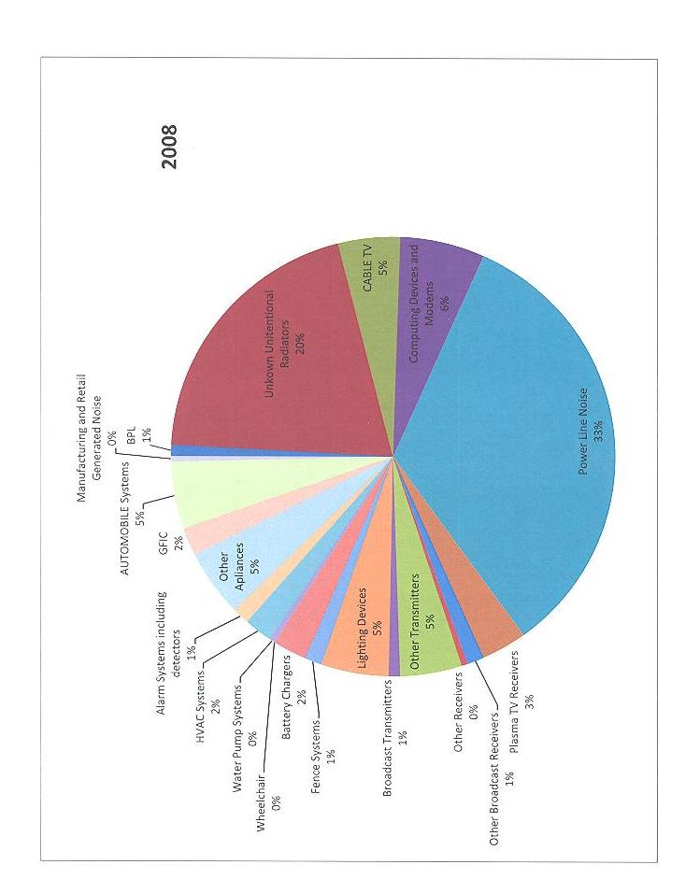
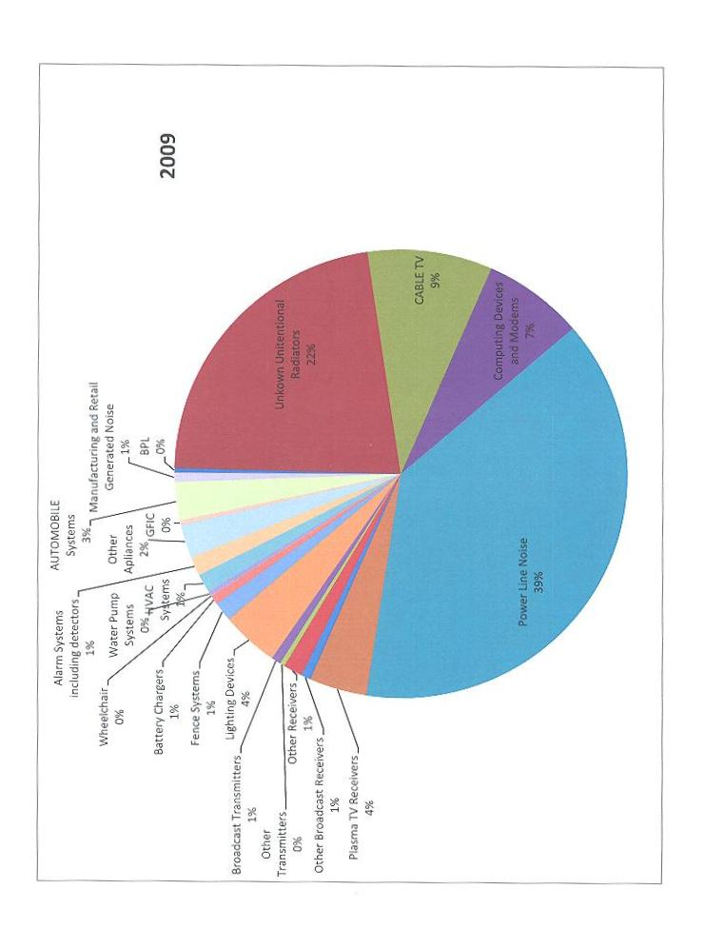
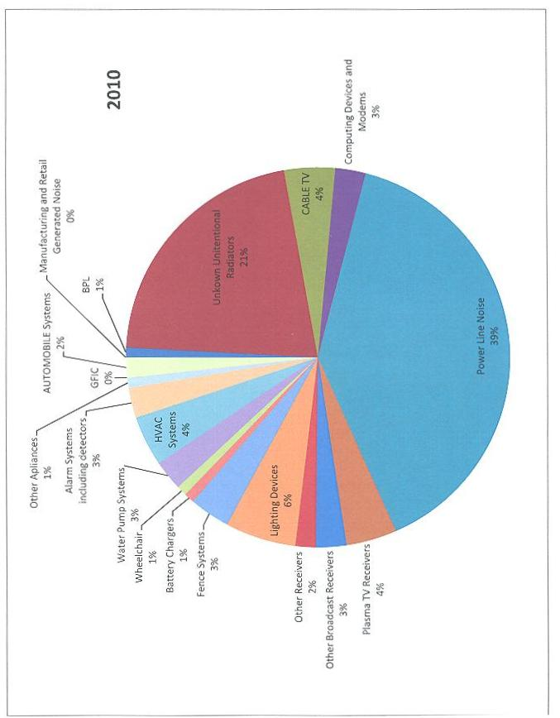
Committees:
ARRL continues to be represented on professional EMC committees. Messrs. Hare and Carlson continue to represent the interests of Amateur Radio on the ANSI ASC C63® EMC committee. Mr. Hare is the Primary ARRL C63® representative; Mr. Carlson is the Alternate. Mr. Hare serves as the Cochairman of Subcommittee 5, Immunity. Mr. Hare also chairs the C63® committee's Task Force on testing below 30 MHz. Mr. Ramie serves as the C63® Secretary and as a member of the Below 30 MHz Task Group. At its April meeting, Mr. Hare was given an award by C63®, in appreciation for his work helping to develop the C63.org web page.
The C63® committee is working on developing industry standards for immunity, emissions and testing of electronic devices. ARRL serves as a resource to the committee to protect the interests of Amateur Radio. Subcommittee 1 continues to work on a variety of EMC projects, primarily related to test site standardization. Subcommittee 5 deals with immunity and immunity measurement issues. Subcommittee 8 deals with various types of medical equipment. The multiple ARRL EMC-Committee representation on C63 watches immunity and testing developments.
ARRL also continues its participation in the Society of Automotive Engineers EMC and EMR Committees. Mr. Hare is the ARRL representative on those committees. Mr. Steffka also serves on the committees, representing his employment in the automotive industry.
The EMC’s Committee Study of Repeater Narrowbanding :
The EMC Committee was formally charged with the task of;
“investigating the technical issues present when adjacent frequencies are used with the existing equipment pool. Such a study could give technical insight (using already gathered information on the susceptibility in 15/20Khz channel use) into the possibility for problems that might be encountered with the existing user radio pool if it were to be subjected to a narrowbanding environment. studying the possible interference issues arising from narrow band repeaters.”

The EMC Committee has been in consultation with the ARRL Laboratory Staff,
Messrs Hare, Gruber and Allison to create a testing method to effectively sample
the technical characteristics of equipment in common use within the Amateur
Community. The purpose of this sampling will be to create an understanding
of the impact that various narrowbanding bandplans will have on the existing
equipment pool. This Study remains a work in progress.

The Future of EMC and Amateur Radio:
The ARRL Laboratory Staff in concert with the EMC Committee has been exploring the possible methods of expanding the number of technical and engineering experts available to help perform field work for the Lab in the investigation of power-line gap noise and other important EMI/EMC field investigations. At present the Lab uses a small core of specially trained, educated and experienced ARRL member-volunteers who are Professional Engineers and professionally qualified EMC engineers and technicians who conduct field surveys at the direction of the Laboratory and the EMC Committee. One specific goal is to slowly add to this list of highly-qualified people who will function in an adjunct field investigator capacity in the area of EMC issues when needed. It may in the future become necessary for this Committee to seek funding for the acquisition of professional-grade field measurement equipment to support efforts of this group.
Interference to hams appears to be the present major work of the committee. Although immunity problems still do occur, this is being addressed at the national and international standards level. RFI from unlicensed devices poses a major real threat to Amateur Radio at this time. This will continue to require significant Committee and ARRL staff attention. To the extent possible with existing staff, or with additional resources, the ARRL should increase its contact with standards organization, industry groups and individual companies, and continue to work on all aspects of RFI problems and solutions.
ARRL's information about RFI can be read at:

www.arrl.org/radio-frequency-interference-rfi.

Respectfully Submitted,

Kermit A Carlson, W9XA
EMC Committee Chairman
ViceDirector Central Division

From the ARRL Narrow-Band Study committee report, Document 26, Item 4, June 2010 ARRL Board of Directors meeting.

