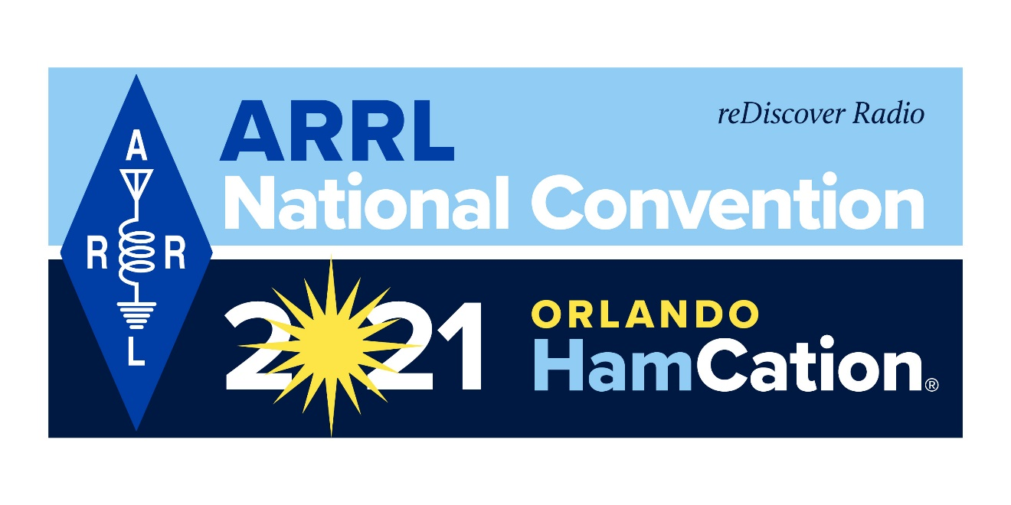ef

Bob Inderbitzen, NQ1R, ARRL Product Development Manager  
tel 860-594-0213; [expo@arrl.org](mailto:expo@arrl.org)  
  
Kathleen Callahan, KC1MBY, ARRL Marketing and Communications Manager  
tel 860-594-0235; [kcallahan@arrl.org](mailto:kcallahan@arrl.org)   
  
**www.arrl.org/expo**

FOR IMMEDIATE RELEASE

**ARRL TO HOLD NATIONAL CONVENTION  
AT ORLANDO HAMCATION® IN FEBRUARY 2021**

June 23, 2020

NEWINGTON, CONNECTICUT — ARRL, the national association for Amateur Radio®, has announced that Orlando HamCation® will host the 2021 ARRL National Convention in Orlando, Florida, February 11-14. The convention will mark the 75th anniversary of HamCation® — one of the largest annually held gatherings of radio amateurs in the US. The convention theme, “reDiscover Radio,” is a rallying call for radio amateurs committed to developing knowledge and skills in radio technology and radio communications.

The convention will kick off on Thursday, February 11 with a series of day-long ARRL Training Tracks and the National Convention luncheon at the DoubleTree by Hilton Hotel Orlando at SeaWorld. ARRL will announce a complete program and presenters later this summer, and will open registration in the fall. On Friday, Saturday, and Sunday, Feb 12-14, HamCation will host the rest of the convention at the Central Florida Fairgrounds and Expo Park in Orlando — an 87-acre lakefront fairgrounds.

HamCation is sponsored by the Orlando Amateur Radio Club, an ARRL-affiliated club, and is supported by volunteers from radio clubs throughout the region. The published gate figure for 2020 was 24,200 (all 3 days). The HamCation website, [www.hamcation.com](http://www.hamcation.org), includes details on tickets and information about forums, exhibits (including information for vendors and tailgaters), testing, travel, and preferred hotels with special rates. HamCation will open online ticket sales in August, and tickets purchased (postmarked) by December 1, 2020 will be $15 and valid for all 3 days at the fairgrounds.

ARRL and HamCation acknowledge that this year’s pandemic has introduced uncertainty into any long-term planning. Both organizations will follow all government and health requirements and guidelines as plans are committed for the 2021 event. Further details and any changes will be shared via these official websites:

* 2021 ARRL National Convention [www.arrl.org/expo](http://www.arrl.org/expo)
* Orlando HamCation [www.hamcation.com](http://www.hamcation.com)

For information about ARRL and amateur radio, visit [www.arrl.org](http://www.arrl.org) and [www.arrl.org/what-is-ham-radio](http://www.arrl.org/what-is-ham-radio).

**# # #**

**2021 ARRL National Convention at Orlando HamCation®  
Fact Sheet**

**What:** 2021 ARRL National Convention, hosted by Orlando HamCation®

**When/Where:**

* **ARRL Training Tracks and National Convention Luncheon** — Thursday, February 11, 2021  
  DoubleTree by Hilton Hotel Orlando at SeaWorld, 10100 International Dr, Orlando, FL 32821

*ARRL will announce program details by mid-summer 2020, and registration will open fall 2020.*

* **Orlando HamCation®** — Friday, Saturday, and Sunday, February 12-14, 2021  
  Central Florida Fairgrounds and Expo Park, 4603 West Colonial Drive, Florida 32808

*HamCation will open online ticket sales in August 2020.*

**Official Websites:**

* [www.hamcation.com](http://www.hamcation.com)
* [www.arrl.org/expo](http://www.arrl.org/expo)

**Other Related Activities and Information:**

* The Florida Contest Group (FCG) Contest Banquet — Friday, February 12, 2021

[www.floridacontestgroup.org](http://www.floridacontestgroup.org)

* Orlando travel planning — [www.visitorlando.com](http://www.visitorlando.com)
* What is amateur radio (or “ham radio”) — [www.arrl.org/what-is-ham-radio](http://www.arrl.org/what-is-ham-radio)

Use this version of the convention logo on HamCation’s official press release:

