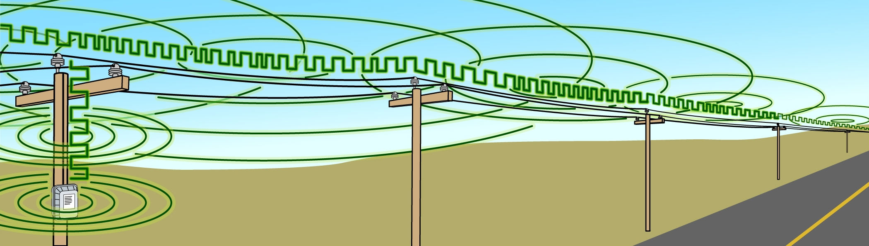

Broadband over Power Line:
Why Amateur Radio Is Concerned about Its Deployment

Radio amateurs are not opposed to broadband services. On the contrary, they tend to be early adopters of new technology. However, there are ways to deliver broadband that do not pollute the radio spectrum as Broadband over Power Line (BPL) does. These include fiber-to-the-home, cable, DSL, and wireless broadband. The ARRL–The National Association for Amateur Radio– is supportive of broadband access for all Americans; however, it opposes the use of BPL as a solution to achieving this goal.

What is Broadband over Power Line?

BPL is the delivery of broadband Internet signals using electrical wiring to conduct high-speed digital signals to homes and businesses. BPL systems are designed to deliver Internet services using medium voltage power lines as the distribution medium and generally use the frequency range between 1.7 and 80 megahertz (MHz).

What is the status of BPL?

BPL has been deployed at several locations around the country for testing purposes. After receiving over 5100 responses to an April 2003 Notice of Inquiry in ET Docket No. 03-104 (most of which were from radio amateurs and others opposing BPL because of its potential interference to licensed radio services), the Federal Communications Commission adopted a Notice of Proposed Rule Making (NPRM) in ET Docket No. 04-37 with new requirements and measurement guidelines for BPL systems. The NPRM was released on February 23. The deadline for comments is May 3, 2004.

The Concern: Broadband + Power Lines = Interference

Because power lines are not designed to prevent radiation of RF energy, BPL represents a significant potential interference source for all radio services using this frequency range, including the Amateur Radio Service. Overhead electrical power lines and residential wiring act as antennas that unintentionally radiate the broadband signals as radio signals throughout entire neighborhoods and along roadsides. Interference has been observed nearly one mile from the nearest BPL source.
What about regulations already in place to protect Amateurs?

The FCC Rules require that unlicensed emitters such as BPL systems must protect licensed radio services from interference, and that they must accept any interference to their operation that is the result of normal operation by licensed radio services. However, in practice it is often difficult to resolve such interference problems in the field.

The present FCC Part 15 limits, which BPL must comply with, are set with short-duration and narrowband emissions in mind. Such emissions, like those from a garage door opener, have a small potential to cause harmful interference. The same limits cannot be applied to long-duration, broadband emissions without greatly increasing the risk of harmful interference. At existing FCC Part 15 rules limits, BPL signals radiated from these power lines have a significant potential for interfering with nearby radio receivers. Instead of the radio signals one would normally hear, one will hear either tones or noise radiated from the BPL system.

Has the interference potential been proven?

The ARRL laboratory has made observations of BPL radiation at a number of trial areas. The lab’s findings of interference and related information are available on the Web at www.arrl.org/bpl. There have been other observations of radio-frequency interference at BPL test sites in the US and are a matter of public record in Docket 03-104.

In late 2003, the National Telecommunications and Information Administration (NTIA) performed measurements of BPL radiation at a number of test sites. ARRL has also commissioned independent measurements of BPL field strengths based on objective, international standards. The results of both of these studies are to be published soon.

Although BPL proponents dispute these claims of interference to licensed services, they have provided little in the way of calculations or measurements of BPL radiation levels. Until now, BPL systems have been limited to small, little-publicized test areas. Even so, the number of complaints of actual interference is growing steadily and efforts to resolve them have had limited success.

Others at risk

- The “short waves” - the only part of the radio spectrum that supports long-distance, intercontinental radio communication. The short waves are used for international broadcasting, aeronautical, maritime, disaster relief, and other services including the military.
- The “low-band VHF” frequency range that is heavily used by volunteer fire departments, police, and other first responders.
- Depending on their distance from a BPL system, some public safety and federal government radio systems could receive harmful interference.

ARRL – The National Association for Amateur Radio
www.arrl.org • Newington, CT 06111
March 2004

