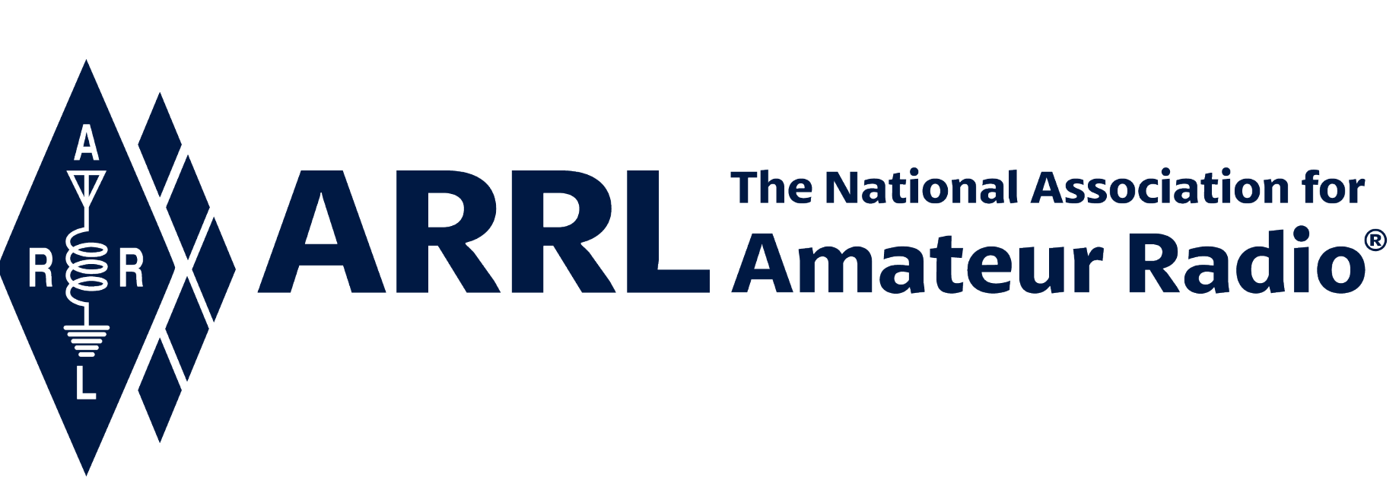
IN-NEWSLETTER
August 20, 2021
Vol. 46, No. 27 Covering August 7-13, 2021

Upcoming Meetings and Events:

Please note: Events listed below are still subject to cancellation at any time as circumstances change. This section will be updated as new information becomes available.

QSO Today Virtual Ham Expo (online)
August 13-15

Huntsville Hamfest
August 21-22 @ Huntsville, AL

Northeast HamXposition
September 10-12 @ Marlborough, MA

RRRA Hamfest
September 25 @ West Fargo, ND

Chief Executive Office
Kelly Wells, Executive Assistant

David Minster, NA2AA, and Diane Middleton, W2DLM, held the Marketing Communications & Field Services department monthly meetings. In addition to the recurring meetings, the 2022 Plan kickoff meeting was held.

Kelly has assumed the responsibility for the upcoming election cycle. She is in the process of working with the Ethics and Elections Committee for the upcoming Director/Vice Director elections. The elections are for the following divisions: Central, Hudson, New England, Northwestern, and Roanoke.

Development
Melissa Stemmer, KA7CLQ

We are pleased to welcome Louis G. Arnold, K9ALP, of the Great Lakes Division into the Ambassador Class of the Maxim Society!

Melissa, along with several ARRL staff members, participated in the QSO Today Virtual Ham Expo on August 14, engaging with attendees as an ARRL Representative.

As a reminder, the ARRL Foundation Grant Program will be accepting proposals from October 1 until October 31. Interested organizations can find more information including eligibility criteria and guidelines at www.arrl.org/amateur-radio-grants. The 2022 ARRL Foundation Scholarship Program applications will open on November 1, 2021, and will close at midnight on December 21, 2021. All transcripts and any additional documentation needed are now required to be submitted with the application as opposed to being emailed to the Foundation email as was done in the past. Scholarship recipients will be notified in May 2022. Additional information on the Scholarship Program including descriptions and terms for each scholarship can be found at www.arrl.org/scholarship-program.

Product Development
Bob Inderbitzen, NQ1R

In the hours following the tragic earthquake in Haiti on Saturday, Aug. 14, ARRL supported a request from the Emergency Coordinator for IARU Region 2 to keep certain frequencies clear for EmComm traffic with a bulletin to members and a posted news item.

Our monthly webinar to help network college and university radio clubs and their student leaders was held on Tuesday, Aug. 10, 2021. This month we focused on supporting club presidents and incoming club members as the new school year begins. Topics included the following: effective ways to recruit new student interest, popular club activities, remote exam sessions, and social media. Among the participating clubs were students from Cal Poly, Grand Valley State University, Purdue, University of Texas at Austin, and Penn State Wilkes-Barre.

Member-volunteers Andy Milluzzi, KK4LWR, and Tony Milluzzi, KD8RTT, run the meetings with staff liaison Bob Inderbitzen, NQ1R. The ARRL Collegiate Amateur Radio Initiative is sponsored in part by the W1YSM Snyder Family Collegiate Amateur Radio Endowment Fund, established in 2017. To discover more details at: www.arrl.org/WeWantU

ARRL operated a virtual booth for the third QSO Today Virtual Ham Expo, held Aug. 14-15. Registrants topped 5,600. We had 1,388 unique “visits” to the booth – ranked 5th out of the 29 exhibitors – and counted by including anyone who clicked on the ARRL booth or selected ARRL from the list of exhibitors. Our staff representatives kept shifts on Saturday and Sunday, supporting live video at our lounge tables. The team included Kathleen Callahan, KC1MBY; Diane Petrilli, KB1RNF; Janet Rocco, W1JLR; Yvette Vinci, KC1AIM; Jon Faasen, AA1EZ; Melissa Stemmer, KA7CLO; Margie Bourgoin, KB1DCO; and Kim McNeill, KM1IPA. On Friday night, Steve Goodgame, K5ATA, Bob Inderbitzen, NQ1R, and Director Ria Jairam, N2RJ, took part in a live stream that included many video content producers for ham radio YouTube channels. On Saturday, Mike Walters, W8ZY, networked with Section Managers and other Field Organization volunteers at one of our virtual lounge tables. And, on Sunday, Ed Hare, W1RFI, presented “How to Comply with FCC RF Exposure Rules” in the virtual auditorium, and with live Q&A afterwards.

We are saddened by the loss of 26-year-old Burlington, Connecticut firefighter, Colin J. McFadden, KB1YYG, from Bristol, Connecticut. McFadden died following a medical emergency he suffered while fighting a terrible fire he responded to in New Hartford on Tuesday, August 10. He passed away on Thursday, August 12. He was an ARRL member, Vice President of the Bristol Radio Club, and a young man committed to public service.

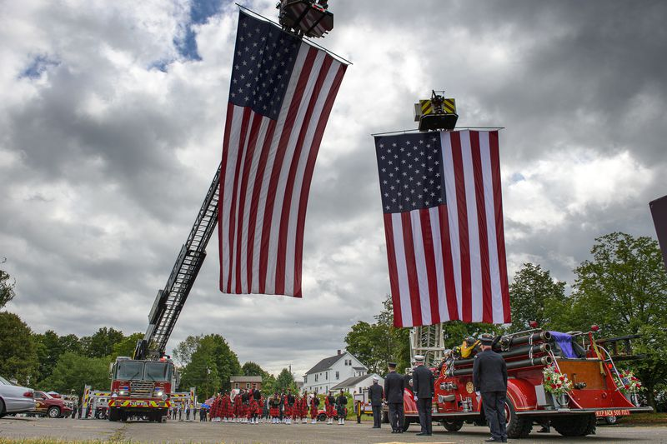

Bob Inderbitzen has made a life-long friend attending Hamfest Conventions over the last years and now they have become pen pals!

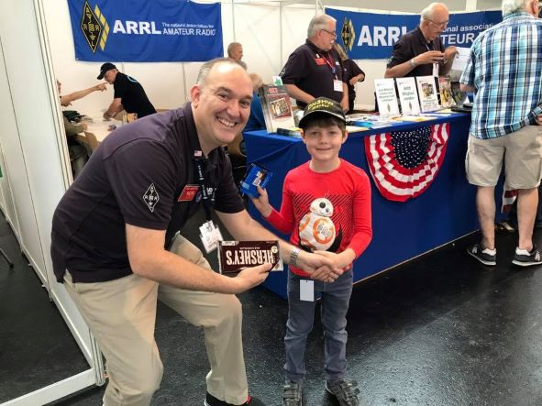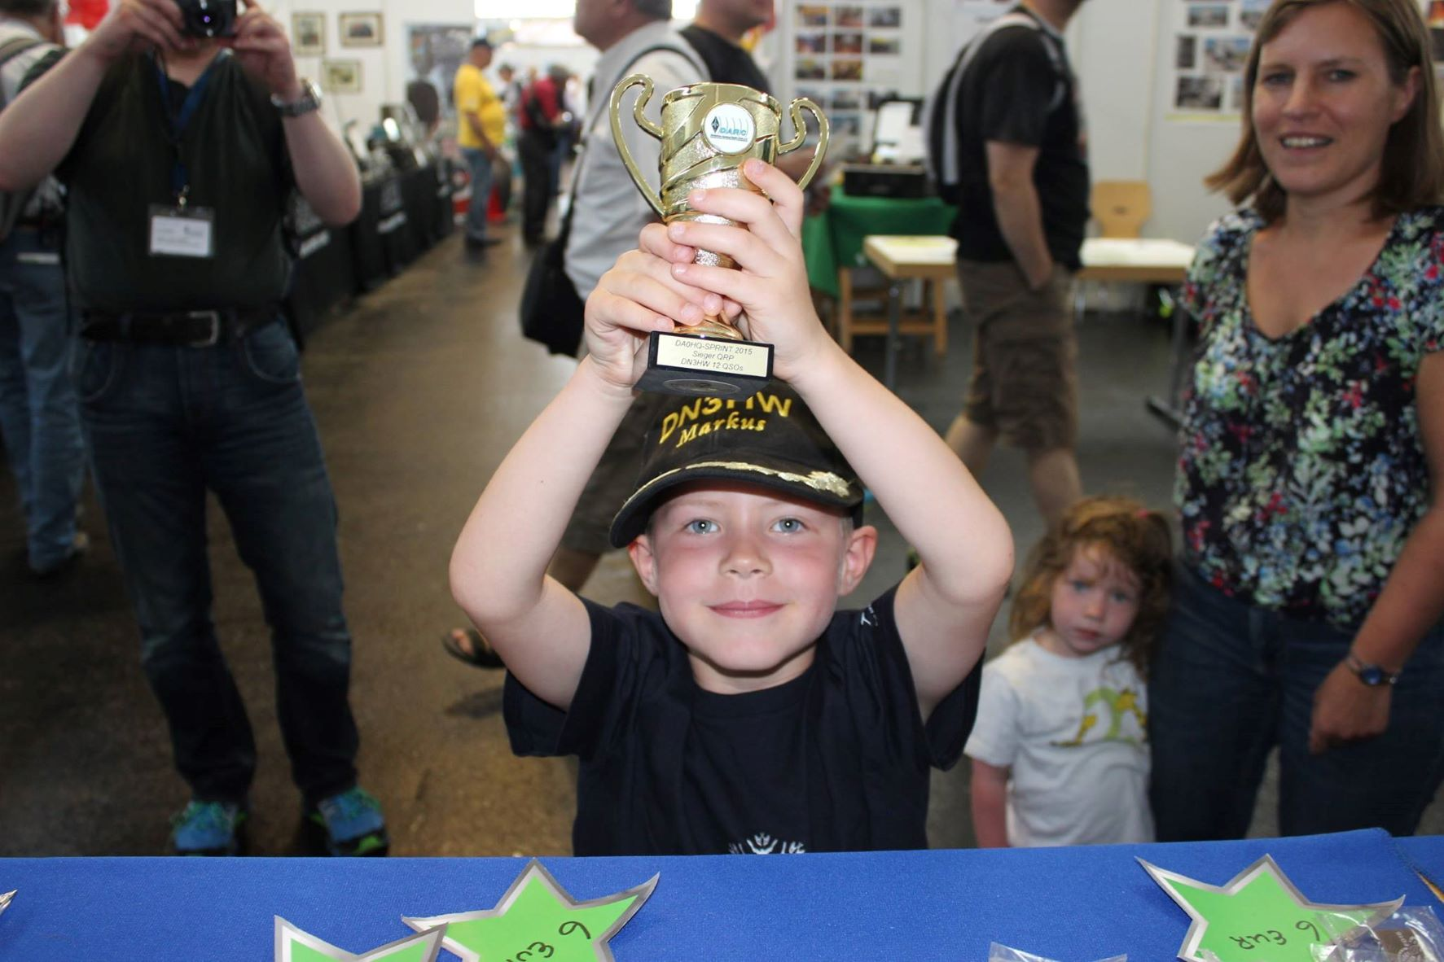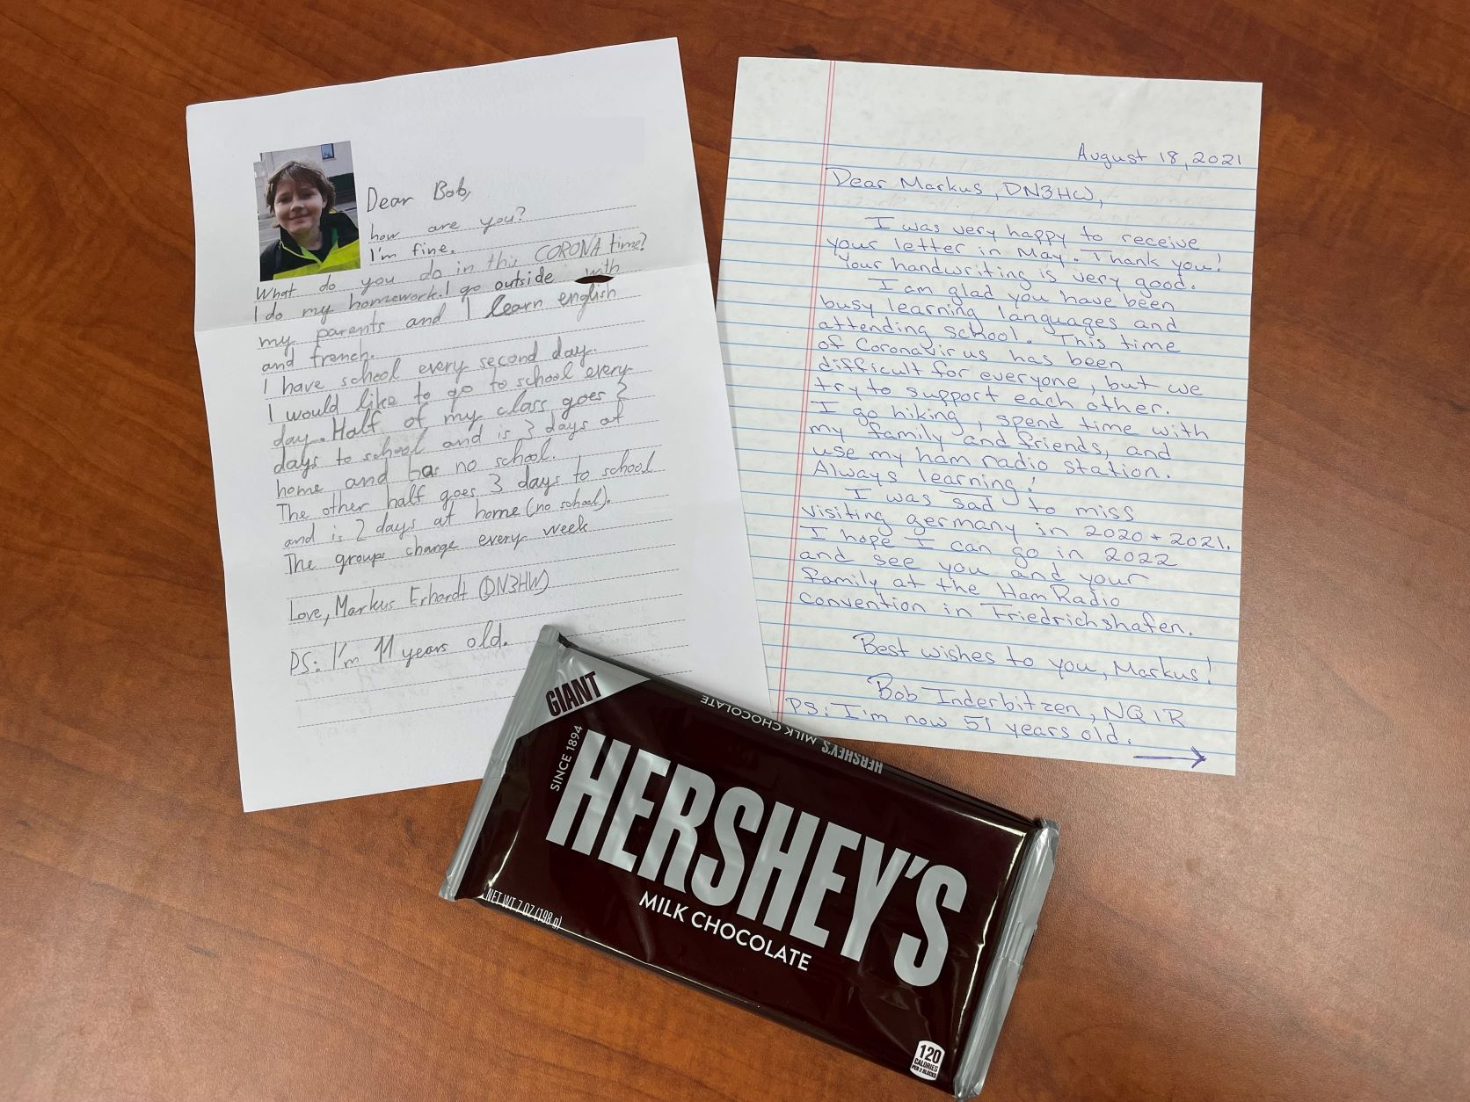

Bob wrote the following on the transcontinental friendship, “I met Markus Erhardt at the Ham Radio convention in Friedrichshafen, Germany 11 years ago. He was a baby, accompanied by his mother, Anja, and father, Jörg, DJ3HW, whom is the IARU coordinator for the Deutscher (German) Amateur Radio Club.

As I returned to the annual convention each year, Markus would make a beeline to the ARRL booth to say hello to me, anticipating our traditional exchange of chocolate gifts. One year, Markus proudly showed off his new call sign to me, embroidered on his hat: DN3HW! He loves to participate in all the ham radio youth activities throughout the convention.

In 2016, his visit to the booth was to show off the trophy he earned for making 12 QSOs during a Sprint.

After two years of canceled conventions in Germany, I was thrilled to receive a handwritten letter from Markus, in which he was able to practice his written English. I sent him a letter in return and keeping up with our tradition, included chocolates!”

Field Services
Steve Ewald, WV1X

Leona Adams reports that Roger Parsons, KK4UDU, of Mulga, Alabama, has been nominated to run for the office of Alabama Section Manager. In addition, Western Massachusetts Section Manager Ray Lajoie, KB1LRL, of Lunenburg, has also been nominated to run for a new term of office. Nominating petitions for this Section Manager election cycle are due at Headquarters no later than September 10, 2021.

Leona assisted Steve Ewald in preparing the July Field Organization Reports column that will be published in October QST.

Steve compiled and edited October QST’s Convention and Hamfest column.

Mike participated in the QSO Today Virtual Hamfest manning the Member Meet Up room for three hours on Saturday. Several folks stopped in including Mike Ritz, W7VO, Northwestern Division Director. More Division calls in prep for the next Section Managers call coming on the 24th.

ARRL Newsletters Circulation
The ARRL Contest Update: 25,665
The ARRL Letter: 112,127
The ARES Letter: 38,194

Radiosport
Sharon Taratula

Paper/Fieldcheck Processing Time | 6 Weeks
Logbook Processing Time | 5-6 Business Days
2021 DXCC Applications | 6,475
2021 WAS Applications | 2,139
2021 VUCC Applications | 1,254
2021 WAC Applications | 83
2021 WPX Applications | 673
2021 WAZ Applications | 548

Hamfests/Conventions/Meetings with ARRL Representation
David Minster 08/13 - 08/15 Huntsville Hamfest
Kathleen Callahan 08/13 – 08/15 Huntsville Hamfest
Bob Inderbitzen 08/13 - 08/15 Huntsville Hamfest

Edited by Kelly Wells, Executive Assistant

