To: A & F Committee
From: Harold Kramer, Chief Operating Officer
Date: May 31, 2006
Subject: Radios On-Line Evaluation

Executive Summary

This is the second of two formal program evaluations that the A &F requested me to do at their last meeting. The first report evaluated the ARISS program. This report will evaluate the Radios On-Line Program.

Similar to the ARISS evaluation, this process evaluates each program using a series of questions and a Decision Matrix to evaluate each program or service and to make a recommendation about its future. The final recommendation for this program is to either divest ourselves of this program in an orderly manner or acquire a partner who is already successful in the business. Thanks to Dennis Motschenbacher for his assistance with this evaluation.

Program Description: Radios On-Line

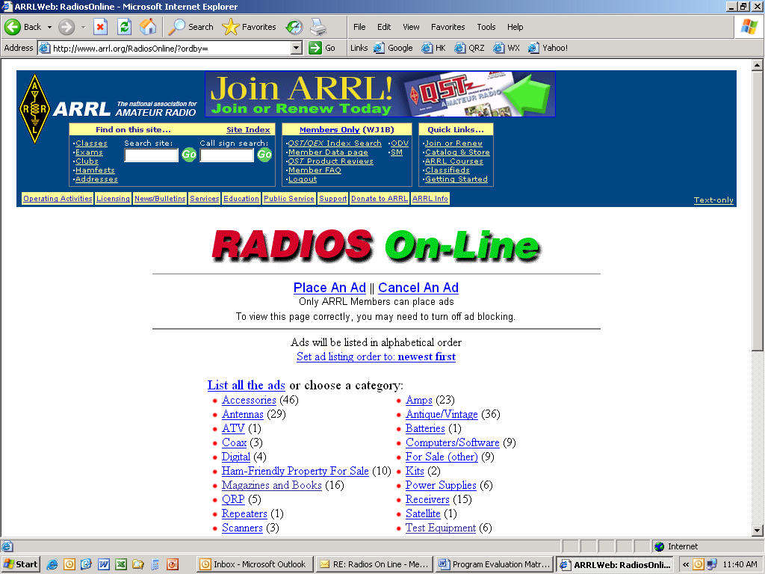
From the Radios On-Line Web Site:
Radios On-Line classified ads are offered as a free service for ARRL members who wish to buy and sell merchandise pertaining to Amateur Radio. ARRL membership is required to sell items, and members must be registered with and logged in to the Web site to place an ad. Ads are available for viewing by all on the public part of the ARRL Web site.
Radios On-Line is intended for noncommercial, personal use. Commercial advertisers are welcome to contact the ARRL Advertising Department for other advertising options. ARRL affiliated clubs are welcome to contact the Field and Educational Services Department for information about listings in our Hamfest and Convention Database or Affiliated Club Database.
No Radios On-Line ad may use more than 100 words. A last name or call sign must appear in each ad. You may cancel your ad at any time, and we encourage you to cancel ads for sold items. Ads will be cancelled automatically after 30 days, but you may repost your ad as often as needed to sell your item.
Individual advertisers are not subject to scrutiny, and ARRL in no way warrants any products advertised here. ARRL does not discriminate in its advertising on the basis of race, color, religion, age, sex, sexual orientation, marital status, or national origin. The League reserves the right to decline or discontinue advertising without notice for any other reason.
Radios On-Line Statistics

Radios On-Line statistics are not archived and we only retain three months of data at any one time.

Statistics for the months of February, March and April 2006:

- Number of unique members who used the system: 634.

- Average number of ads posted, per user: 3.5.

Number of users posting 30-40 ads: 4
Number of users posting 20-29 ads: 12
Number of users posting 10-19 ads: 34

- The ads are date-stamped, and according to the database the counts for the last three full months of this year are:
765 February
812 March
680 April

Therefore, 634 members posted 2,257 ads. 50 of those 634 members posted over 700 of those 2,257 ads. (Are these 50 running a business?)

The Radio On-Line users comprise only about .4% percent of our total membership.

Program Evaluation Criteria

- Mission Alignment:
a. Is this program aligned with our mission? | Minimally because it is connected with amateur radio. However, we do not have any mandate to provide a web based method of selling used equipment.
b. Is it a core competency of our organization? | No
c. Is it relevant? | Not to our overall strategy
d. Is it a “good fit”? | No
e .Is this a “Soul of the Agency” program? | Absolutely not

- Financial and Economic Implications:
a. How much does this program cost, directly and indirectly? | It requires less than an hour a week of staff time to review the ads.
b. Do we have a financial gain or loss from this program? | Revenue neutral
c. Does it require more capital to make it grow? | It would require capital for programming time, enhancements, marketing, and promotion.
d. What are its future funding requirements? | Unknown – but can be left status quo.
e. Will the program grow or shrink in the future? | Probably shrink due to better positioned and well funded competitors

- Outcomes and Benefits to Members and The Amateur Radio Service:
a. Do the program’s outcomes provide positive benefits to members? What are these benefits? | There are some positive benefits. The service is free but so are some of the competitors. Making less expensive used radios available is a benefit to some members.
b. Do the program’s outcomes provide positive benefits to Amateur Radio? What are these benefits? | No
c. Do the program’s outcomes provide positive benefits to our Country? What are these benefits | No
d. Are the above benefits, short term, intermediate, or long term? | Not applicable
e. Are we making sufficient progress towards predicted outcomes? What are the indicators of its success? | It appears that usage is neither increasing nor decreasing.

- Implementation and Efficiency:
a. Is this program easy or difficult to implement? | Easy
b. Is it fully staffed? | No dedicated staff
c. Is the staff adequately trained to provide the services? | No dedicated staff
d. What additional resources does it require? | None
e. Do we have efficient and clear operational processes in writing? | The business process is defined by the web interface.

- Membership Impact:
a. What is the impact on members if this program is changed or eliminated? | Minimal to none
b. Do members join or leave the organization because of this program or service? | No
c. Will members leave if this program is scaled back or eliminated? | Unlikely
d. Will more members join if this program is enhanced or grown? | No

- Competitive Position:
a. Do we have competitors for this program? | Yes, many including , QTH.com and QRZ.com
b. Are they for profit organizations or non-profit organizations? | All are for-profit
c. How strong or weak is our competitive position? | The competition is very strong. They carry thousands of amateur radio related ads on any given day.
d. Are the competitors aggressive or non-aggressive? | Aggressive
e. What market share do we have for this program? | Miniscule 600-700 ads is a small percentage
f. Are there alternatives that are better/worse/ the same as compared to our program? | The alternatives are much better. They have more listings, better search engines, more users and more payment and transaction options.

- Organizational Implications and Structure:
a. What part of its life cycle is the program? (e.g. mature) | Mature – but could be grown.
b. Is this program free-standing or does it involve a partnership or collaboration? | Free Standing
c. What partnership commitments do we need to honor? | None
d. Does it report into the appropriate place in the organization? | This program reports to Sales and Marketing

- Goals and Measurements:
a. Does the program have written, well understood goals? | No
b. Are there system is place to measure progress against goals? | No
c. Are there timelines and deadlines? | No

- What is the Human Resource Impact?
a. Is the program sufficiently staffed? | No full time staff or person is responsible for its growth. The program is completely automated
b. Does the staff have the proper training to provide the service? | Not applicable
c. Can it be outsourced? Is there an advantage to outsourcing the program? | Yes
d. If it is currently outsourced, can it be brought back in-house? Is there an advantage to brining it back in-house? | No

- External Stakeholders Impacts:
What is the:
a. What is the political impact of changing this program? | None
b. What is the regulatory impact of changing this program? | None
c. What are the public and media relations and impact of changing this program ? | Some members will complain but less than half of one percent use it now.
d. What is the reader impact of changing this program? | None

Final Recommendations and Matrix

The final Recommendation is to either divest ourselves of this program in an orderly manner or acquire a partner who is already successful in the business.
:
- It is not a good “fit” for the ARRL. We are not in the used equipment sales business.
- It is not aligned with any of our strategic objectives.
- It is an “Easy Program” to administer but provides little advantage to us and we bring no unique benefits to the program.
- The number of members who use it is less than .5% of our total membership.
- There are strong, well funded, competitors such as eBay.

Other Recommendations:

We should get out of this business or merge and/or partner with an existing amateur radio equipment sales web site. The service suffers from benign neglect on our end and only a very small percentage of our members use the service. Based on this preliminary analysis, we have already begun informal discussions with some web based amateur radio sales sites about such an arrangement.

Decision Matrix

 |  | High Program Attractiveness:  “Easy Program: |  | Low Program Attractiveness:  “Difficult Program”
 |  | Alternative  Coverage  High | Alternative  Coverage  Low | Alternative  Coverage  High | Alternative  Coverage  Low
GOOD  FIT | Strong  Competitive  Position | 1. Aggressive Competition | 2. Aggressive Growth | 5. Build up the Best Competitor | 6. Soul of the Agency
GOOD  FIT | Weak  Competitive  Position | 3. Aggressive Divestment | 4. Build Strength or Get Out | 6. Orderly Divestment | 7. “Foreign Aid” or Joint Venture
POOR  FIT |  | 9. Aggressive Divestment |  | 10. Orderly Divestment

Note: I did not create this matrix. I have used it on other projects, but I cannot find the original source. I believe that it was written by Dr. Philip Kotler, who has written many textbooks on marketing and program evaluation.

