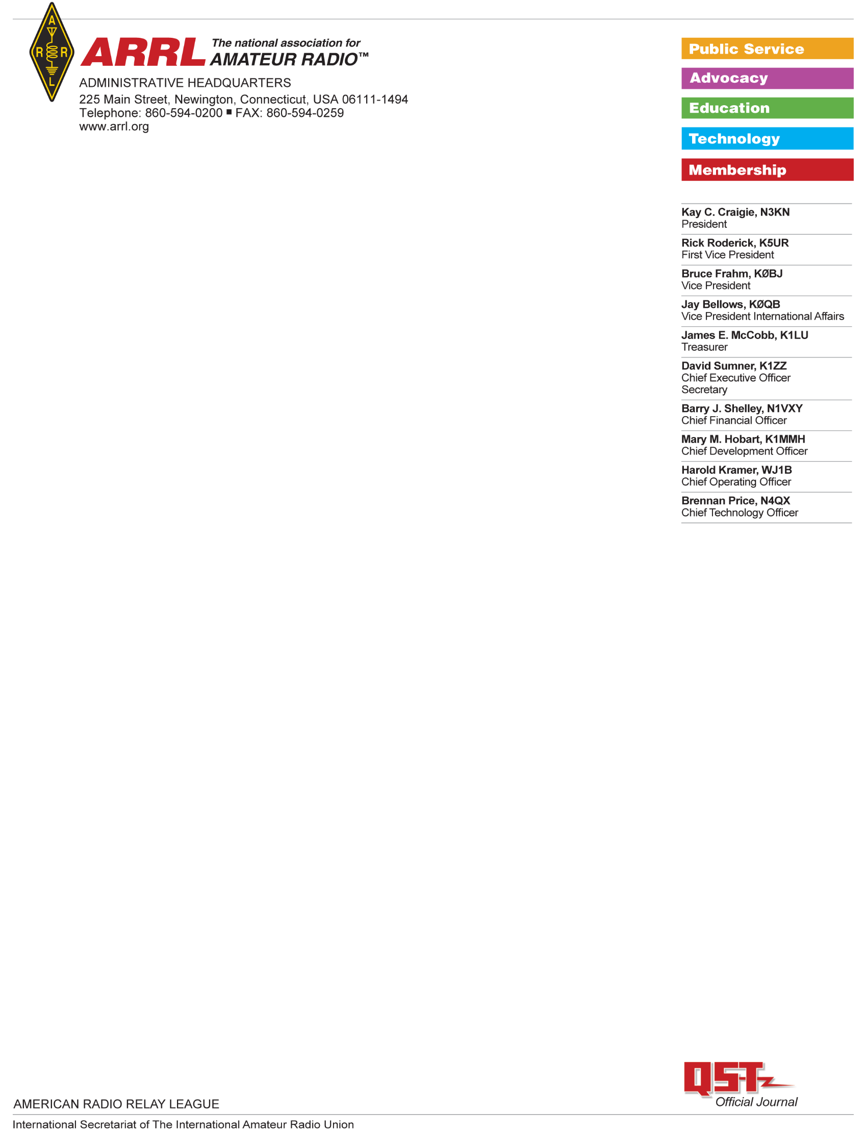

UV5-R EX Test Report

Test Results: Baofeng UV5-R EX

Serial number: UV5REX-13036

FCC ID: 2AJGM-UV5R (see text in report)

Date ordered:   
Seller:

Vendor:   
  
The MODEL was shipped from a US distributor and received in the ARRL Lab on <date>.

The unit was opened in the ARRL Lab and found to contain a desktop charger, a set of headphone “buds, a “rubber ducky” style antenna, a belt clip and a user’s manual. It did not contain any of the optional accessories such as the programming cable.

|  |  |  |
| --- | --- | --- |
|  | **SIGNATURE** | **DATE** |
| **Testing performed by:** | Bob Allison, ARRL Laboratory Test Engineer | 2 Apr 2021 |
| **Results Reviewed by:** | Ed Hare, ARRL Laboratory Manager | 2 Apr 2021 |

FCC Certification:

The unit was visually inspected and it did have an FCC ID number, 2AJGM-UV5R, FCC certificated under CFR 47, Part 90. The FCC certification database shows a different frequency range for the UV5R than is seen in this model, so the FCC ID number may be inappropriately applied. The unit is capable of front-panel programming to transmit over its entire frequency range, so it does not comply with the Part 90 requirements to sell units programmed only for the frequencies authorized to the end user.  
  
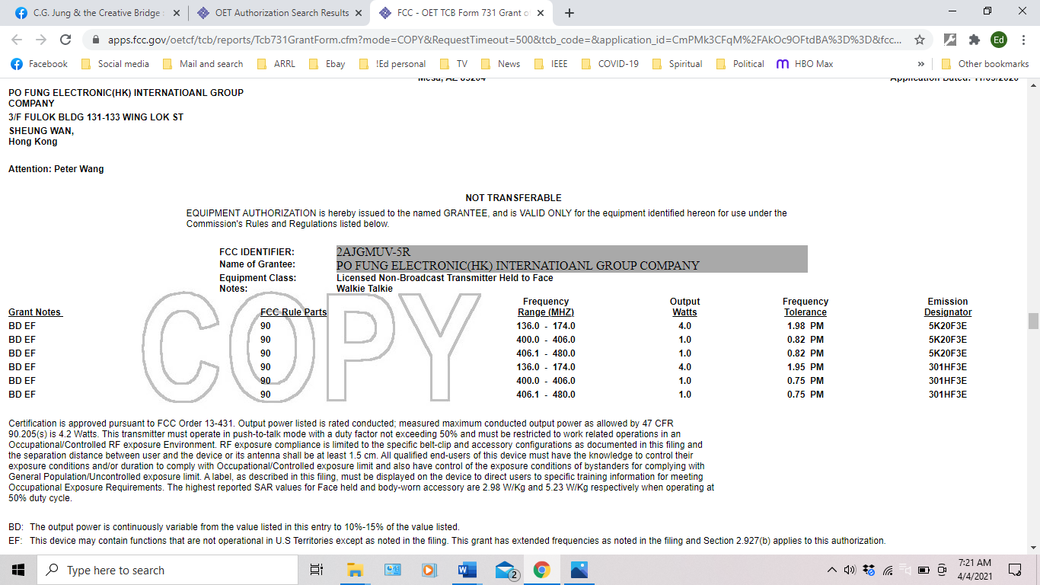  
  
*Figure 1: FCC Grant of certification for FCC ID FCC ID: 2AJGM-UV5R.*

Frequency Range:

The frequency range specified in the user’s manual and FCC certification for the unit is 136.000 to 173.975 MHz on VHF and 400.000 to 519.975 MHz on UHF.   
  
The measured frequency range of the unit tested is 136.000 to 173.995 MHz on VHF and 400.000 to 519.995 MHz on UHF.  
  
The frequency range listed in the FCC certification data for the FCC ID number placed on the unit is 136.000 to 174.000 MHz on VHF and 400.000 to 480.000 MHz. On UHF, the unit is capable of transmitting outside the frequency range listed on the FCC certification.

**Default Frequency:**  
  
Channel Mode: A - 453.225 MHz; B -402.225 MHz

Frequency Mode: VFO A - 155.500 MHz; VFO B - 439.500 MHz

Power Output:

Low power: 1.5W at 146 MHz; 1.4W at 430 MHz  
High power: 4.0W at 146 MHz; 4.5W at 430 MHz

Transmitter spurious emissions:

This transmitter was tested for spurious emissions only within the amateur bands. This unit does comply with Part 97 regulations for spurious emissions.

|  |  |  |
| --- | --- | --- |
| Frequency | 2nd harmonic | 3rd harmonic |
| 146 MHz LOW power | -70 dBc | <-80 dBc |
| 146 MHz HIGH power | <-80 dBc | <-80 dBc |
| 430 MHz LOW power | <-80 dBc | <-80 dBc |
| 430 MHz HIGH power | <-80 dBc | <-80 dBc |

*Figure 2: Spurious emissions, 146 MHz, LOW Power*

*Figure 3: Spurious emissions, 146 MHz, HIGH Power*

*Figure 4: Spurious emissions, 430 MHz, LOW Power*

*Figure 5: Spurious emissions, 430 MHz, HIGH Power*

**Conclusions:**This transmitter is being marketed in the United States. It is certificated under Part 90. It can be programmed by the end user using an optional programming cable and software to operate on any frequency within its specified frequency range. It was sold capable of transmission on frequencies not authorized to the end user. A programming cable and software is also sold by the vendor that supplied this product.

**TEST EQUIPMENT LIST**

|  |  |  |  |  |
| --- | --- | --- | --- | --- |
| Manufacturer | Description | Model Number | Serial Number | Cal Due |
| Agilent | Spectrum analyzer | MXA 9020A | MY53420816 | 9/10/2021 |
| HP | Microwattmeter | 437B | 3125U20786 | 9/10/2021 |
| HP | Power sensor | 8482A | - | 9/10/2021 |
| Bird | Power attenuator | Tenuline | - | Self |
|  |  |  |  |  |