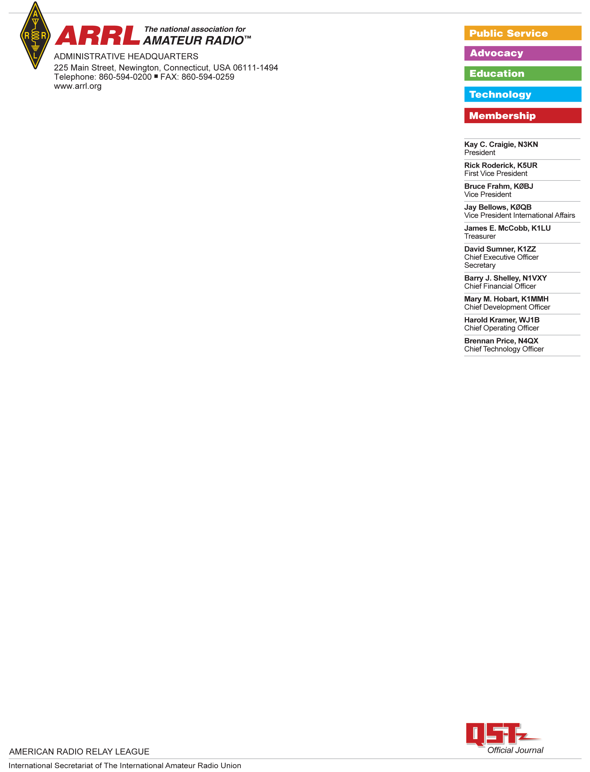

Baofeng UV9R-ERA Test Report

Test Results: Baoefeng UV9R-ERA

Serial number: 20UV9RERA04618

Date ordered: 14 January 2021  
Seller: Walmart.com  
Vendor: Online Retail Partners  
  
The UV9R-ERA was shipped and received in the ARRL Lab on 18 Jan 2021.

The unit was opened in the ARRL Lab and found to contain a UV9R-ERA, a battery charger, a battery-charger power supply, a set of headphone “buds” and a small “rubber ducky” style antenna. It did not contain any of the optional accessories such as the programming cable.

|  |  |  |
| --- | --- | --- |
|  | **SIGNATURE** | **DATE** |
| **Testing performed by:** | Bob Allison, ARRL Laboratory Test Engineer | 17 Feb 2021 |
| **Results Reviewed by:** | Ed Hare, ARRL Laboratory Manager | 17 Feb 2021 |

FCC Certification:

The unit was visually inspected and no FCC certification identification number was present on the unit, in the includes user documentation or on the box used to ship the unit. ARRL staff were unable to locate any data for this transceiver in the FCC certification database.   
  
Documentation:

The documentation in the user’s manual is ambiguous about the use of this radio as a piece of amateur radio equipment. The manual states (emphasis added) (sic):

*Thank you for purchasing Amateur Portable Radio. We always offer high performance, stable wireless two way radio, factory developed IP57 water proof two way radio, especially for maritime, shipping users. Please read tis manual carefully before us. The information presented herein will help you to derive the maximum performance from your radio.*

Frequency Range:

The unit was tested to determine its transmit and receive frequency range. No programming cable was provided with this unit and programming was not necessary to transmit or receive over the entire frequency range. The frequency range was fully front-panel enabled from 130 – 176 MHz and 400 – 520 MHz  
  
Power Output:

The following measurements were made of the power output of this transceiver. Power was measured only at the frequency indicated within the 2m and 70cm amateur bands

|  |  |  |  |
| --- | --- | --- | --- |
| Frequency | Power low | Power mid | Power high |
| 146 MHz | 1.25W | 2.25W | 3.2W |
| 430 MHz | 1.7W | 2.7W | 3.2W |

Transmitter spurious emissions:

This transmitter was tested for spurious emissions only within the 2m and 70cm amateur bands. It complies with FCC Part 97 rules for spurious emissions from amateur transmitters.

|  |  |  |  |  |  |  |
| --- | --- | --- | --- | --- | --- | --- |
| Frequency | 2nd harmonic low power | 3rd harmonic low power | 2nd harmonic med power | 3rd harmonic med power | 2nd harmonic high power | 3rd harmonic high power |
| 146 MHz | -67 dBc | <-82 dBc | -70 dBc | -80 dBc | -75 dBc | <-82 dBc |
| 430 MHz | -75 dBc | <-80 dBc | -77 dBc | <-80 dBc | -73 dBc | -72 dBc |

The Part 97 limits for spurious emissions for low, medium and high power from this device are -47 dBc, -49 dBc and -52 dBc respectfully for the low, medium and high-power ranges. There are no specific limits for spurious emissions for Part 97 transmitters operating above 225 MHz. This device meets the standards for spurious emissions for transmitters in its power class when operated in the amateur bands. The spurious emissions on the 70 cm amateur band appear to be reasonable engineering practice.

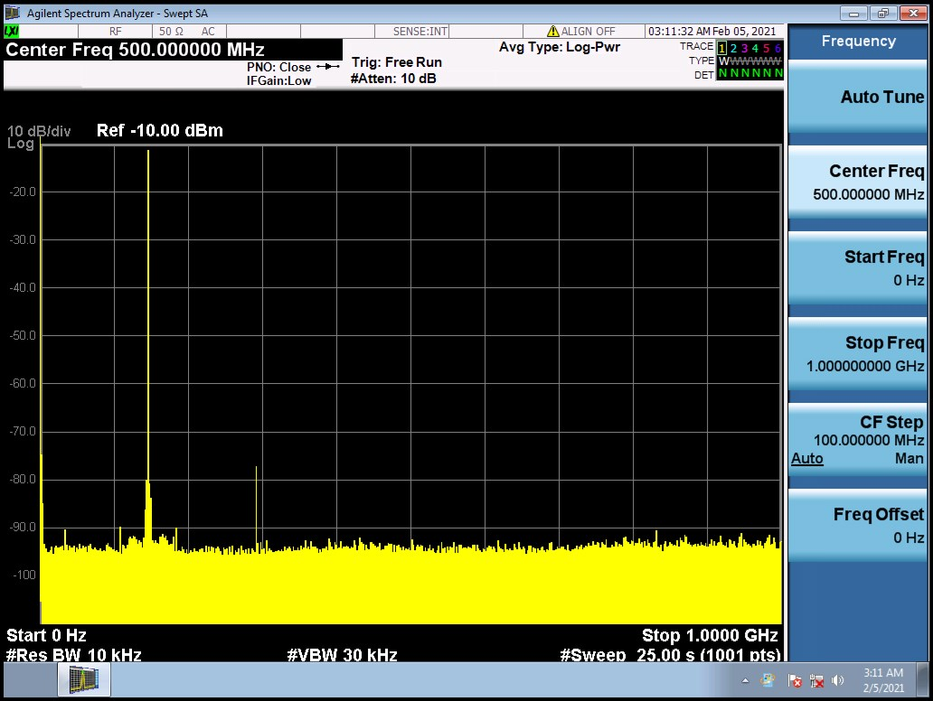

Figure 1: Spurious emissions, 146 MHz, low power

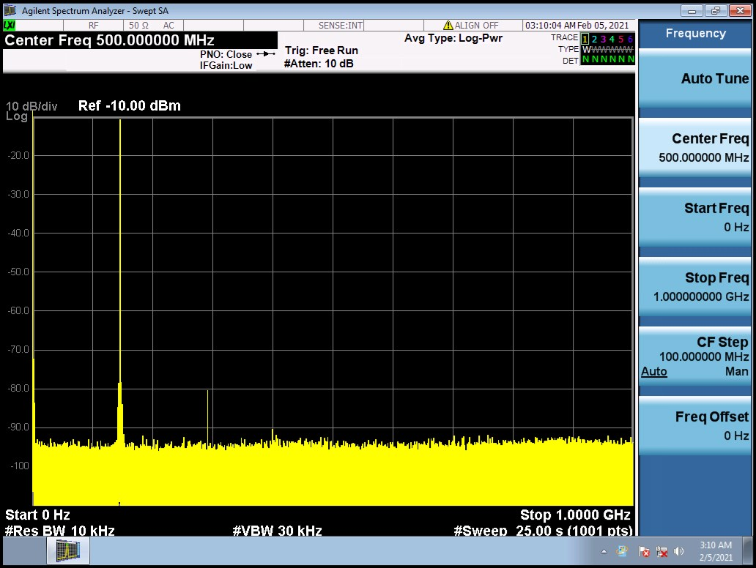

**Figure 2: Spurious emissions, 146 MHz, medium power**

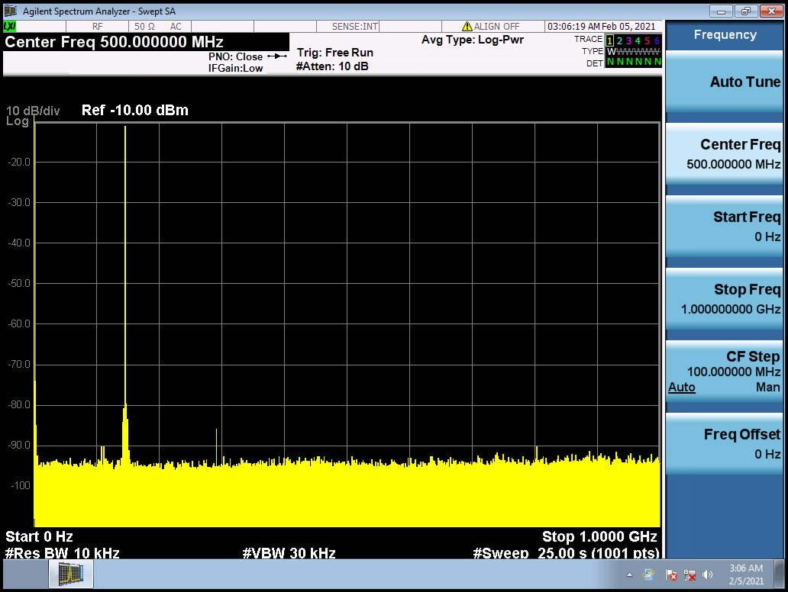

**Figure 3: Spurious emissions, 146 MHz, high power**

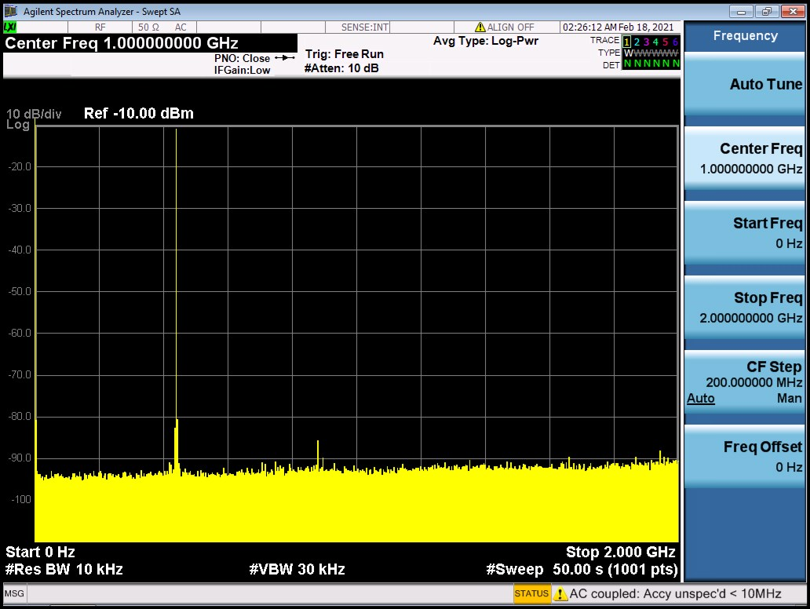

**Figure 4: Spurious emissions, 430 MHz, low power**

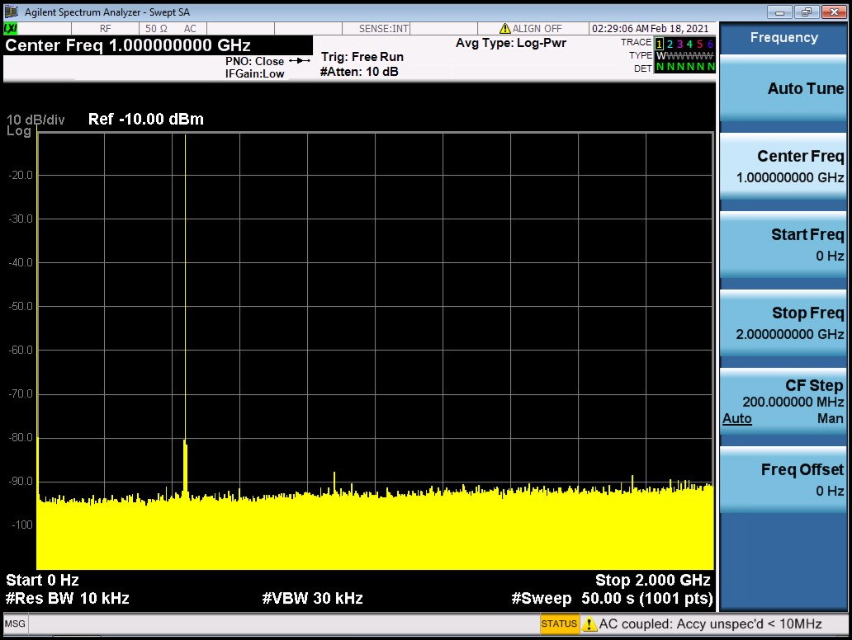

**Figure 5: Spurious emissions, 430 MHz, medium power**

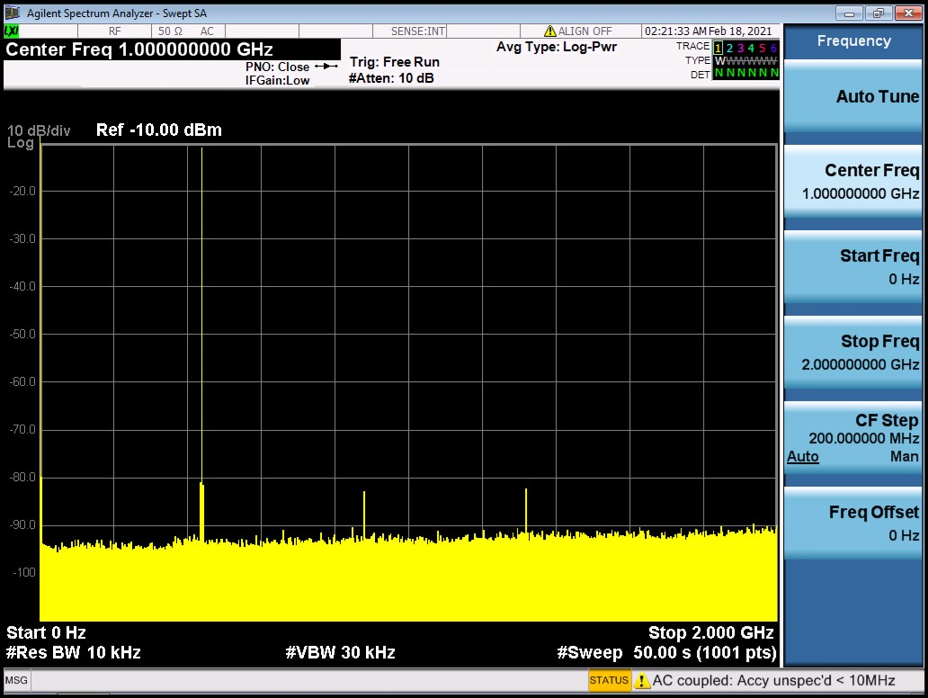

**Figure 6: Spurious emissions, 430 MHz, high power**

**Conclusions:**This transmitter is being marketed in the United States, but has not been certificated as required by FCC rules. It transmits outside the amateur bands, so it is not exempt from certification on the basis of being manufactured and marketed as a Part 97 amateur transmitter. Although the manual mentions amateur radio, discussion in the manual that this radio is intended for use in “shipping” indicates that it is being marketed to commercial users.  
  
It is not certificated, so it cannot be so marketed. It also transmits on all frequencies within its operating range, so it could not be marketed as a Part 90 radio even if certificated as such because Part 90 requires that Part 90 radios be programmed only for frequencies authorized to the Part 90 licensee at the point of sale*.*

**TEST EQUIPMENT LIST**

|  |  |  |  |  |
| --- | --- | --- | --- | --- |
| Manufacturer | Description | Model Number | Serial Number | Cal Due |
| Agilent | Spectrum analyzer | MXA 9020A | MY53420816 | 9/10/2021 |
| HP | Microwattmeter | 437B | 3125U20786 | 9/10/2021 |
| HP | Power sensor | 8482A | - | 9/10/2021 |
| Bird | Power attenuator | Tenuline | - | Self |
|  |  |  |  |  |