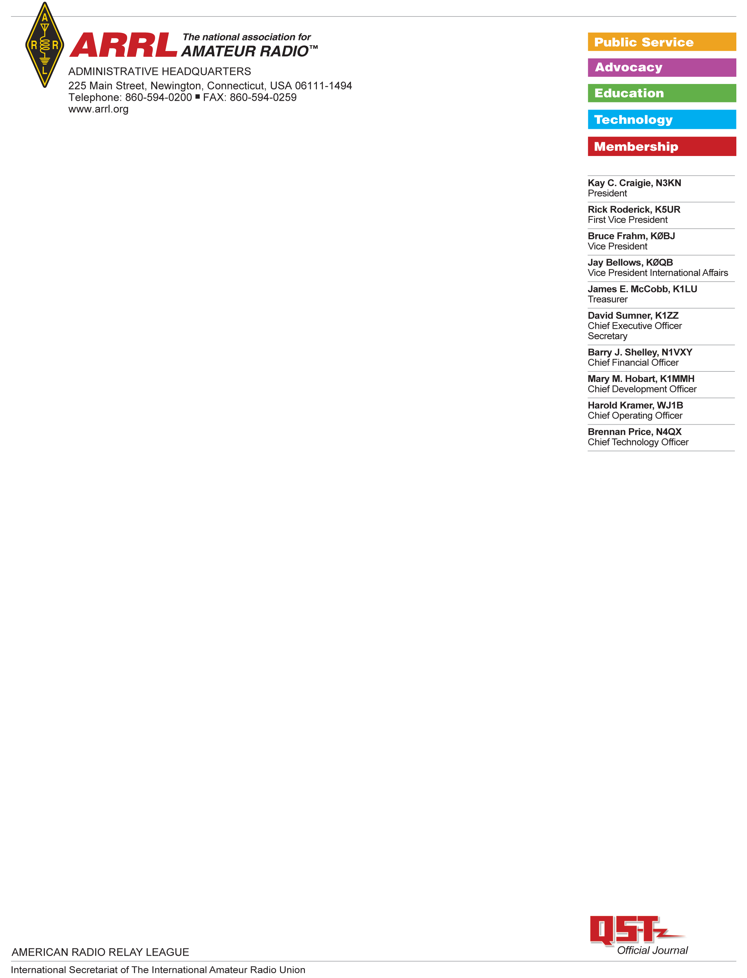

Baofeng UV-5R Test Report

Test Results: Baoefeng UV-5R

Serial number: 20U38362702

Date ordered:   
Seller: Walmart.com  
Vendor:   
  
The UV-5R was shipped and received in the ARRL Lab on <date> .

The unit was opened in the ARRL Lab and found to contain a UV-5R, a battery charger, a battery-charger power supply, a set of headphone “buds” and a small “rubber ducky” style antenna. It did not contain any of the optional accessories such as the programming cable.

|  |  |  |
| --- | --- | --- |
|  | **SIGNATURE** | **DATE** |
| **Testing performed by:** | Bob Allison, ARRL Laboratory Test Engineer |  |
| **Results Reviewed by:** | Ed Hare, ARRL Laboratory Manager | 3 March 2021 |

FCC Certification:

The unit was visually inspected and no FCC certification identification number was present on the unit, in the includes user documentation or on the box used to ship the unit. In a thorough search of the FCC certification database, ARRL staff found several entries for the model UV-5R. One was a Change in Identification, indicating that Po Fung Electronic (HK) International Group (as spelled in multiple places in the database) was identifying the former XP5BF-5RA under the new ID number of 2AJGNUV-5R. There are no current entries in the certification database under the grantee code XP5BF nor any entries under product code -5RA, so it does not appear that this certification is currently in force. Additional entries are found under the FCC ID number ZZrUV-UV-5RV2, issued to Amcrest Technologies and 2ARTCUV5R issued to Henan Aofeng Industrial, but these two IDs are for scanning receivers only (Part 15B). The unit is capable of transmitting outside of the frequency bands allocated to the amateur radio service, so this model cannot be marketed without certification as a Part 97 amateur transmitter. Based on the above research into the FCC database and the lack of an FCC ID number on the unit, it appears that this unit is not certificated under any FCC rule.

Documentation:

The documentation in the user’s manual identifies this as an amateur radio transmitter. The unit operates outside the amateur bands, in the bands allocated to Part 90 and other services, so this model cannot be marketed without certification as a Part 97 amateur transmitter.  
  
The manual states:

*“PREFACE: Thank you for purchasing our Amateur Portable Radio, which is a dual-band/dual-display radio. This easy-to-use radio will deliver you secure, instant and reliable communications at peak efficiency…”*

Frequency Range:

The unit was tested to determine its transmit and receive frequency range. No programming cable was provided with this unit and programming was not necessary to transmit or receive over the entire frequency range. The frequency range was fully front-panel enabled from 136 – 174 MHz and 400 – 470 MHz  
  
Power Output:

The following measurements were made of the power output of this transceiver. Power was measured only at the frequency indicated within the 2m and 70cm amateur bands

|  |  |  |
| --- | --- | --- |
| Frequency | Power low | Power high |
| 146 MHz | 1.6W | 4.3W |
| 430 MHz | 1.0W | 3.0W |

Transmitter spurious emissions:

This transmitter was tested for spurious emissions only within the 2m and 70cm amateur bands. It complies with FCC Part 97 rules for spurious emissions from amateur transmitters.

|  |  |  |  |  |
| --- | --- | --- | --- | --- |
| Frequency | 2nd harmonic  low power | 3rd harmonic  low power | 2nd harmonic  high power | 3rd harmonic  high power |
| 146 MHz | -70 dBc | <-80 dBc | -76 dBc | -75 dBc |
| 430 MHz |  |  |  |  |

The Part 97 limits for spurious emissions for low, medium and high power from this device are -47 dBc, -49 dBc and -52 dBc respectfully for the low, medium and high-power ranges. There are no specific limits for spurious emissions for Part 97 transmitters operating above 225 MHz. This device meets the standards for spurious emissions for transmitters in its power class when operated in the amateur bands. The spurious emissions on the 70 cm amateur band appear to be reasonable engineering practice.

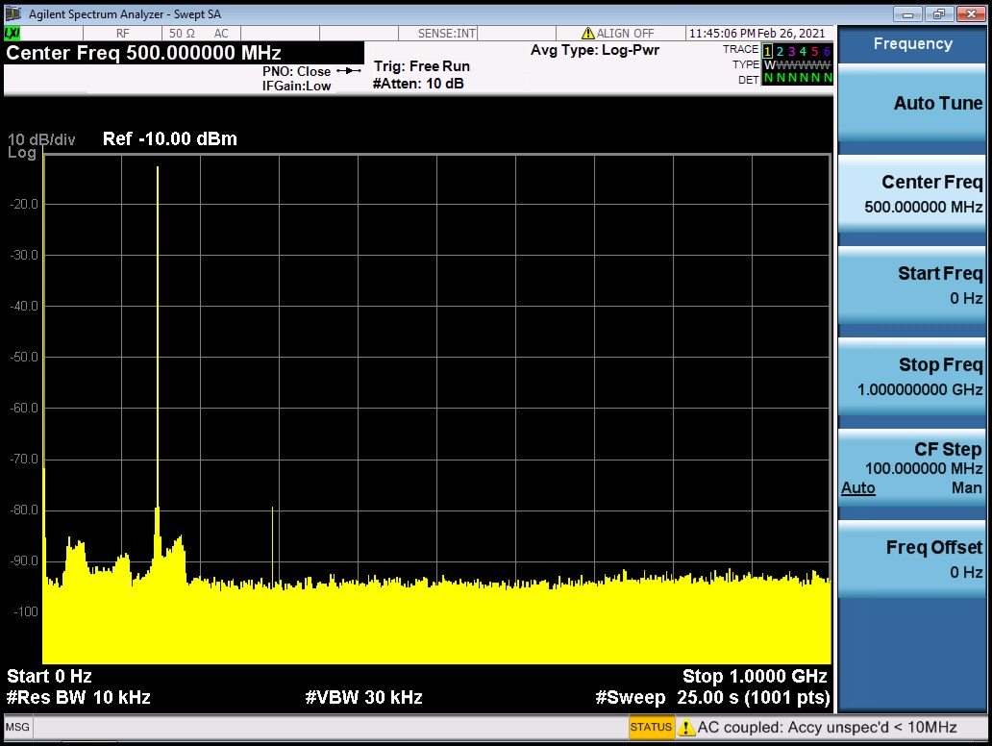

Figure 1: Spurious emissions, 146 MHz, low power

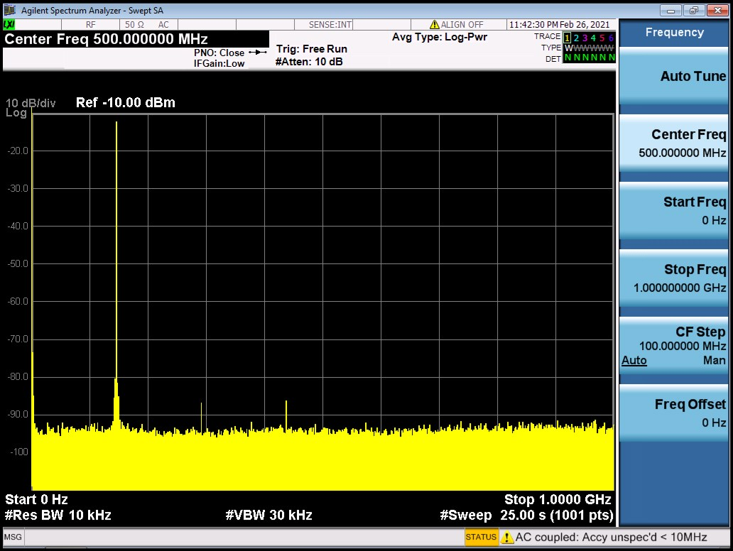

**Figure 2: Spurious emissions, 146 MHz, high power**

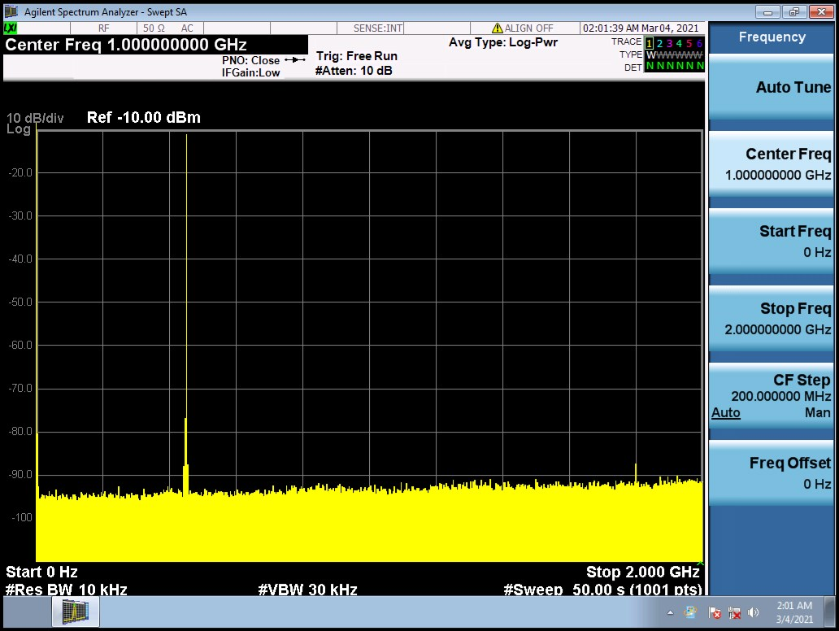

**Figure 3: Spurious emissions, 430 MHz, low power**

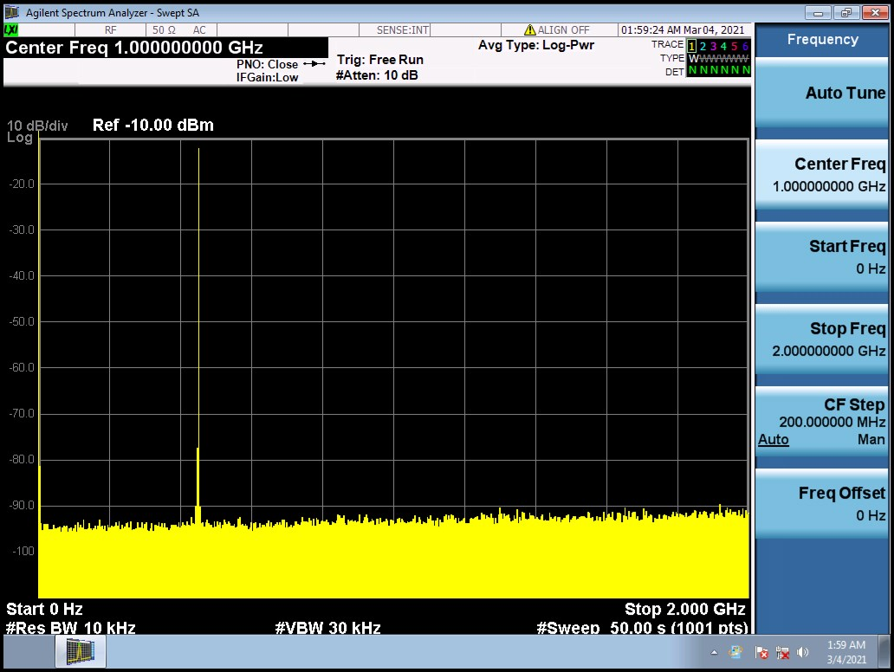

**Figure 4: Spurious emissions, 430 MHz, high power**

**Conclusions:**This transmitter is being marketed in the United States, but based on its not including an FCC ID number on the unit and not being found as a currently certificated transmitter in the FCC certification database, it does not appear to be certificated as required by FCC rules. Its front panel controls allow a user to transmit outside the amateur bands, so it is not exempt from certification on the basis of being manufactured and marketed as a Part 97 amateur transmitter.

It is not certificated, so it cannot be so marketed. It also transmits on all frequencies within its operating range, so it could not be marketed as a Part 90 radio even if certificated as such because Part 90 requires that Part 90 radios be programmed only for frequencies authorized to the Part 90 licensee at the point of sale*.*

**TEST EQUIPMENT LIST**

|  |  |  |  |  |
| --- | --- | --- | --- | --- |
| Manufacturer | Description | Model Number | Serial Number | Cal Due |
| Agilent | Spectrum analyzer | MXA 9020A | MY53420816 | 9/10/2021 |
| HP | Microwattmeter | 437B | 3125U20786 | 9/10/2021 |
| HP | Power sensor | 8482A | - | 9/10/2021 |
| Bird | Power attenuator | Tenuline | - | Self |
|  |  |  |  |  |