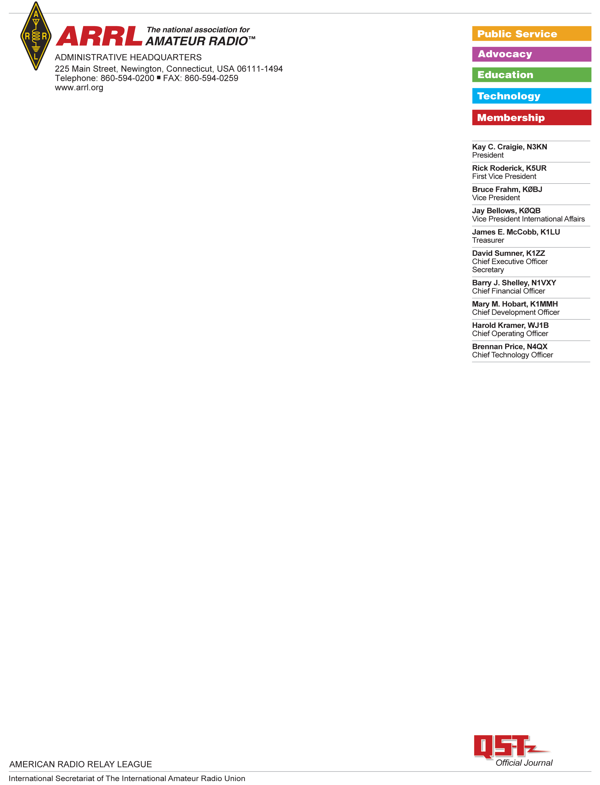

Baofeng BF-888S Test Report

Test Results: Baofeng BF-888S

Serial number: None found

Date ordered:   
Seller: Walmart.com  
Vendor:   
  
The BF-888S was shipped from a US distributor and received in the ARRL Lab on <date>.

The unit was opened in the ARRL Lab and found to contain two UV-888Ss, a battery charger, a battery-charger power supply, two sets of headphone “buds” and two small “rubber ducky” style antenna. It did not contain any of the optional accessories such as the programming cable.

|  |  |  |
| --- | --- | --- |
|  | **SIGNATURE** | **DATE** |
| **Testing performed by:** | Bob Allison, ARRL Laboratory Test Engineer |  |
| **Results Reviewed by:** | Ed Hare, ARRL Laboratory Manager | 3 Mar 2021 |

FCC Certification:

The unit was visually inspected and no FCC certification identification number was present on the unit, in the included user documentation or on the box used to ship the unit. The ARRL Lab staff, however, identified FCC ID number ZP5BF-888S issued to Fujian Nan’an Baofeng Electronics Co as having been certificated under Part 90 rules. This was reassigned to Po Fung Electronic (HK) International Group Company under the new FCC ID 2AJGMBF-999S. It appears that this unit is certificated under Part 90, but being marketed for frequencies other than those licensed to a Part 90 licensees.  
  
Documentation:

The documentation in the user’s manual identifies this as a “professional two-way radio.”

Frequency Range:

The frequency range specified in the user’s manual and FCC certification for the unit is 400-470 MHz. The unit was tested to determine its transmit and receive frequency range out of the box. It operated on 16 memory channels that can be programmed by the end user using optionally available software and a programming cable. No programming cable was provided with this unit. The frequency range of this unit did not cover the amateur bands, but it specified frequency range is 400-470 MHz, so it could be programmed to operate on amateur radio using the optional programming cable and software. It was marketed with pre-programmed frequencies that were not authorized to the end purchaser (ARRL) as licensed Part 90 frequencies.  
  
Frequency Range, both TX and RX, 16 pre-programmed channels (MHz):

1. 462.125
2. 462.225
3. 462.325
4. 462.425
5. 462.626 (Channel 16, FRS)
6. 462.625
7. 462.725
8. 462.825
9. 462.925
10. 463.025
11. 463.125
12. 463.225
13. 463.525
14. 450.225
15. 460.325
16. 469.950

Power Output:

Unit 1, 1,.6 W; Unit 2, 1.5 W

Transmitter spurious emissions:

This transmitter was tested for spurious emissions only within the 2m and 70cm amateur bands. It complies with FCC Part 97 rules for spurious emissions from amateur transmitters.

|  |  |  |
| --- | --- | --- |
| Frequency | 2nd harmonic | 3rd harmonic |
| 462 MHz | -75 dBc | <-80 dBc |

There are no Part 97 emissions limits for the 70cm amateur band. The unit did not transmit on the amateur band out of the box.

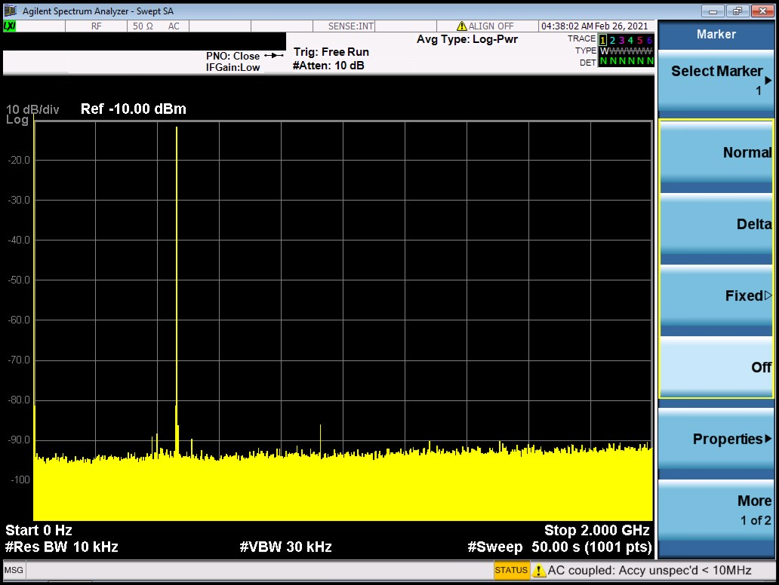

**Figure 1: Spurious emissions, 462 MHz (unit 1)**

**Conclusions:**This transmitter is being marketed in the United States. It is certificated under Part 90. It can be programmed by the end user using an optional programming cable and software to operate on any frequency within its specified frequency range of 400 to 470 MHz. It was sold pre-programmed to frequencies not authorized to the end user.

**TEST EQUIPMENT LIST**

|  |  |  |  |  |
| --- | --- | --- | --- | --- |
| Manufacturer | Description | Model Number | Serial Number | Cal Due |
| Agilent | Spectrum analyzer | MXA 9020A | MY53420816 | 9/10/2021 |
| HP | Microwattmeter | 437B | 3125U20786 | 9/10/2021 |
| HP | Power sensor | 8482A | - | 9/10/2021 |
| Bird | Power attenuator | Tenuline | - | Self |
|  |  |  |  |  |