DX Advisory Committee Semi-Annual Report
June 30, 2004

To the American Radio Relay League
Board of Directors

Submitted by
James C. O’Connell, W9WU
Chairman, DX Advisory Committee
Central Division Representative

Introduction
Some of the major DX news items during the first half of 2004:

DXAC Members continue to receive favorable feedback on the expansion of LOTW from the DX community. A number of stations operating from Iraq (YI) have been approved and on the air.

DX Entity Rule

There appears to be little community interest in expanding the number of DX entities by rule change. Several members conducted informal polls on this issue at recent DX meetings .

Other Issues

DXAC Members attending the Dayton Hamvention met informally on Friday evening. Eight members attended and had the opportunity to meet our new Board Liaison, Bob Vallio, W6RGG. No Committee business was discussed.

Jim Reisert, AD1C joined the DXAC as the New England Division member, replacing N1NG. Bill Leahy, K0MP of the Rocky Mountain Division and W5ZPA, Mike Mayer of the Delta Division resigned their appointments during the reporting period. There are presently two vacancies on the Committee from those Divisions.

The DXAC will continue to solicit feedback from the DX community on important current DX issues and pass those opinions on to the PSC and ARRL staff. We are ready to discuss and make recommendations on any matter or issue referred to DXAC by the PSC or Board of Directors.

Respectfully submitted,
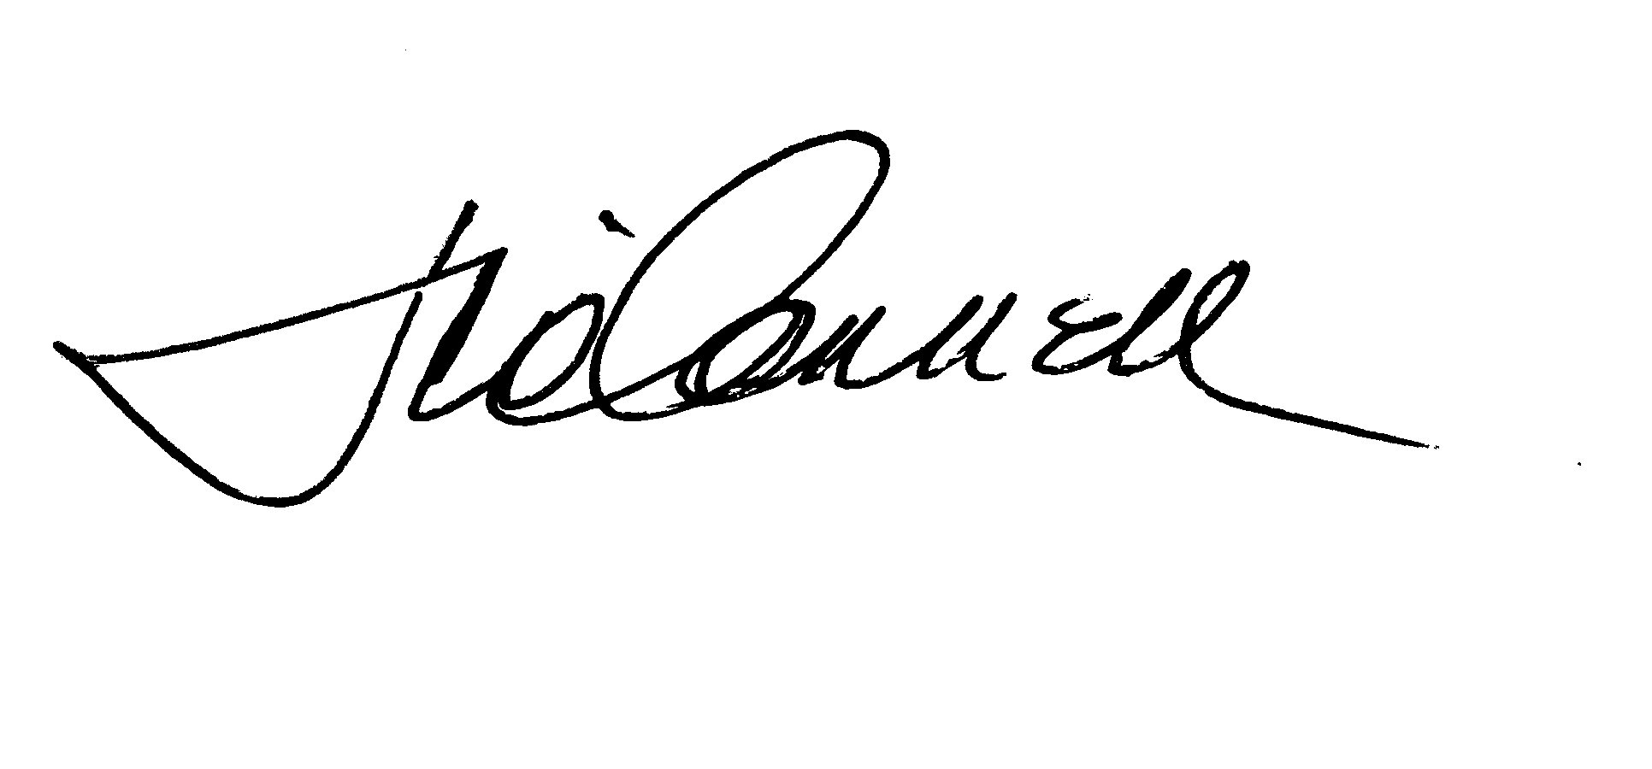James C. O’Connell, W9WU
Chairman, DX Advisory Committee
Central Division Representative

