2193-R June 1, 2016
ARRL OFFICERS, DIRECTORS, AND VICE DIRECTORS:
In accordance with Standing Order 19, you are hereby notified that the formal call for the 2016 Second Meeting of the ARRL Board of Directors, July 15-16, 2016, will be sent on or about June 15.
Please note the provisions of Article 10 of the ARRL Articles of Association:
These articles may be amended by a three-fourths vote of all Directors, or, provided due notice of the proposed amendment shall have been placed in the mail to each Director at least thirty days in advance, by a two-thirds vote of all Directors. The Board of Directors may from time to time adopt By-Laws not inconsistent with the Articles and applicable statutes. By-Laws may be amended by a three-fourths vote of all Directors, or, provided due notice of the proposed amendment shall be mailed to each Director at least thirty days in advance, by a two-thirds vote of all Directors. Notices shall be sent by First-Class mail or electronic mail to the last known address to each Director.
Our meeting will be held at the Hartford/Windsor Airport Marriott, 88 Day Hill Rd., Windsor, CT.
A group dinner is scheduled for Thursday evening, July 14. The Board meeting will begin at 9:00 AM Friday and is expected to be completed by dinnertime Saturday. Expenses related to Board Meeting attendance and travel will only be reimbursed for Thursday through Sunday. Should your membership on a committee require you to arrive earlier to attend a meeting of that committee, the additional expenses will be charged to the appropriate committee account.
Standing Order 04-1.39 (amended January 2005) reads: "The Board of Directors authorizes the attendance of Vice Directors at Board meetings. Expenses for attendance will be chargeable to the Board Meeting account."
I look forward to seeing you and to our having another productive meeting.

Sincere 73,
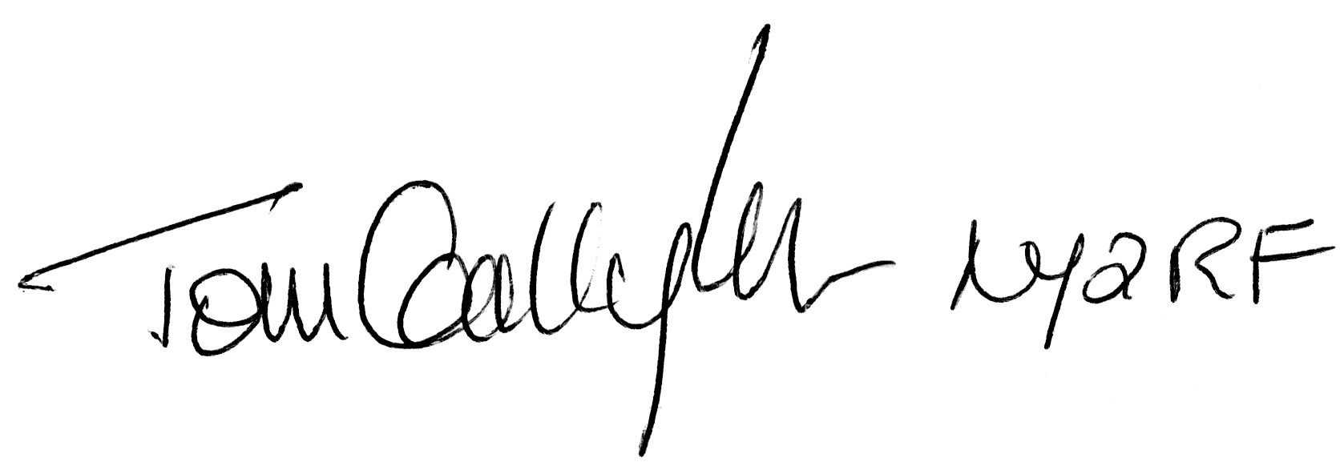
Tom Gallagher, NY2RF
Secretary

