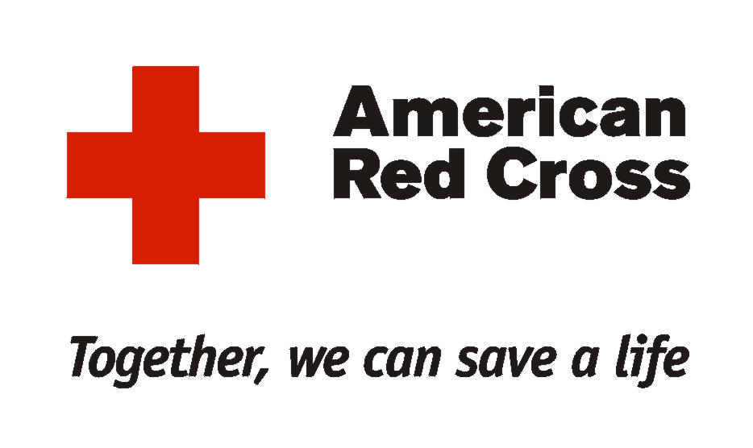

National Headquarters

May 8, 2008

Mr. Joel Harrison
ARRL
Office of the President
225 Main Street
Newington, CT 06111

Dear Mr. Harrison:

In your letter of November 28, 2007, you requested that I take action on the background check forms and suggested processes used by the American Red Cross for volunteers affiliated with its local chapters and Disaster Services Program. You advised that a number of ARRL members believed the consent form to be too broad as related to its stated purpose and intention. You also indicated this issue was of significant concern to you and your organization, and that it would need to be resolved before the ARRL could consider entering into a Statement of Understanding with the American Red Cross.

Upon receipt of your letter we started to work within the American Red Cross to address the concerns expressed. This included a subsequent meeting between our attorneys to fully explore each issue and implications for both organizations. Following this session we routinely kept Dennis Dura informed of our progress. The intent here was to convey an ongoing sense of action and attention about all the issues before us.

I can now report back to you that these actions have been completed and changes have been instituted which I trust resolves the concerns detailed in your letter. This effort took considerably more time and attention than originally envisioned, but I believe the results will now benefit our respective organizations.

A new background consent form now to be used by all Red Cross chapters for ARRL members and other partner organizations. The form and related process is limited to the name and social security number verification of the individual, and a criminal background check. References and suggestions to other related investigative possibilities have been stricken. The enclosed document is the new consent form along with details on the related actions to be taken with those ARRL members seeking to support a Red Cross disaster relief response beyond a seven day period.

If you agree that the issues raised regarding the background check consent form are now satisfactorily resolved, then I suggest we collectively turn our attention to renewing the ARRL and Red Cross Statement of Understanding. Given the good working relationship established during these past months between Dennis Dura and Keith Robertory, I suggest that they proceed within the next few weeks to mutually develop a draft agreement. The intent here would be that we then promptly have the agreement formally accepted and adopted by our respective organizations.

Please accept my best wishes and sincere appreciation for you interest and commitment here. Clearly a strong working relationship between the ARRL and the American Red Cross will enhance our collective capabilities and value as positive forces when our fellow citizens are in need.

Sincerely,

Armond T. Mascelli
Vice President
Disaster Services, Response

