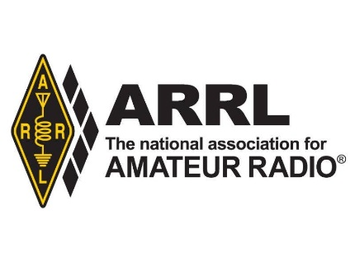

**American Radio Relay League/ 225 Main St. / Newington, CT 06111 /**

**Contact: David Isgur, ARRL Communications Manager, 860-594-0328 / disgur@arrl.org**

**FOR IMMEDIATE RELEASE:**

**ARRL to Launch New *On the Air* Magazine in January**

Newington, CT – November 4, 2019 – ARRL, the national association for Amateur Radio® is launching a new magazine, *On the Air,* in January 2020. To be published on a bimonthly basis, *On the Air* will offer new and beginner-to-intermediate-level radio amateurs a fresh approach to exploring radio communications. Each issue will include advice and insight on topics from the variety of Amateur Radio interests and activities: radio technology, operating, equipment, project building, and emergency communications. The goal of this new magazine is to be a vital resource in helping new and newer radio amateurs get active and involved in radio communications.

“*On the Air* responds to the brand new, and not-so brand new radio amateur seeking ideas and answers,” says Editor Becky Schoenfeld, W1BXY, who is part of the ARRL staff team that developed the new magazine. The planning included an extensive national-level study of new Amateur Radio licensees, identifying their motivations for getting licensed and their experiences of getting started. A focus group responded positively to a trial sample edition of the magazine.

“Too many new licensees never take the next step,” says Schoenfeld. “We’re excited to introduce a new amateur radio magazine for this audience, aimed at getting them active, getting them involved, and getting them on the air.”

The first issue of *On the Air* will be published in January 2020 (Jan/Feb issue) and will be introduced as a new ARRL membership benefit. When eligible members in the US join ARRL or renew their membership, they will be prompted to select the print magazine of their choice; *On the Air* or *QST*. *QST* magazine is ARRL’s official membership journal, published monthly since December 1915. *QST* supports active radio amateurs with ham radio news, equipment reviews, projects, and stories of public service, advocacy, and volunteerism. Current members receiving print *QST*, upon renewal, may choose to continue receiving *QST* (mailed monthly) or *On the Air* (mailed bimonthly). The online membership application will support the new magazine designation next month.

All ARRL members, including international members, will be able to access digital editions of both *QST* and *On the Air* magazines. Members who already access *QST* on the web or from the mobile app will be able to access *QST* and *On the Air* in January.

For information about ARRL and Amateur Radio, visit [www.arrl.org](http://www.arrl.org) and [www.arrl.org/what-is-ham-radio](http://www.arrl.org/what-is-ham-radio).

*The American Radio Relay League (*[*www.arrl.org*](http://www.arrl.org)*), represents the interests of Amateur (or “ham”) Radio operators across the country. Founded in 1914 by Hiram Percy Maxim, ARRL, The national association for Amateur Radio®, has a proud history of achievement as the standard-bearer in amateur affairs. Now in its second century, ARRL remains focused on “advancing the art, science, and enjoyment of Amateur Radio.”*

* **### —**