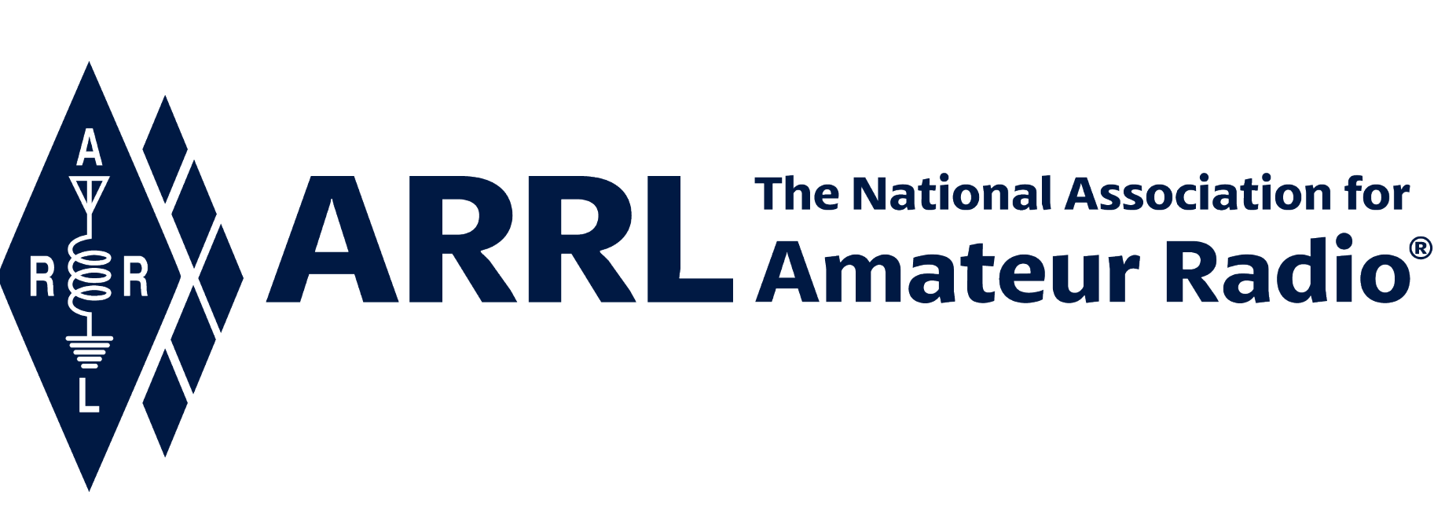
IN-NEWSLETTER
September 10, 2021

Vol. 49, No. 30 Covering September 7-10, 2021

Upcoming Meetings and Events

Events listed below are subject to change at any time; information will be updated as soon as it becomes available.

Northeast HamXposition
September 10-12 @ Marlborough, MA

W9DXCC
September 10-12 @ Chicago, IL

RRRA Hamfest and ARRL Dakota Division Convention
September 25 @ West Fargo, ND

ARRL Executive Office Updates
Kelly Wells, Executive Assistant

David Minster, NA2AA, is headed to the W9DXCC, in Chicago, where he is the keynote speaker!

David also attended various meetings with staff this week.

Kelly continues to work on the election cycle, and sends her thanks to Shelly, Kim, and Adam for their continued assistance in the process.

Bob Nauman, W5OV
Director of Operations

The HQ Sprint is fast approaching, more details about the event are forthcoming! Next week, team meetings will be held pertaining to the sprint, where the guidelines and rules will be discussed. An email will go out to HQ with all the details. The sprint is a favorite of staff!

Mike Walters and Bob will be at the Marlboro Ham Expo / New England Division Convention this weekend where Mike will be presenting on Field Services, and Bob will be helping with DXCC Card Checking activities. We will also be present at the ARRL Booth.

Membership, Marketing & Communications
Yvette Vinci, KC1AIM

August ended with 157,481 members putting us behind YTD forecast by 2,241 members. We gained 349 members this month; a loss of 19 was forecast.

Acquisition through email is up significantly this month – special thanks to the Marketing team!

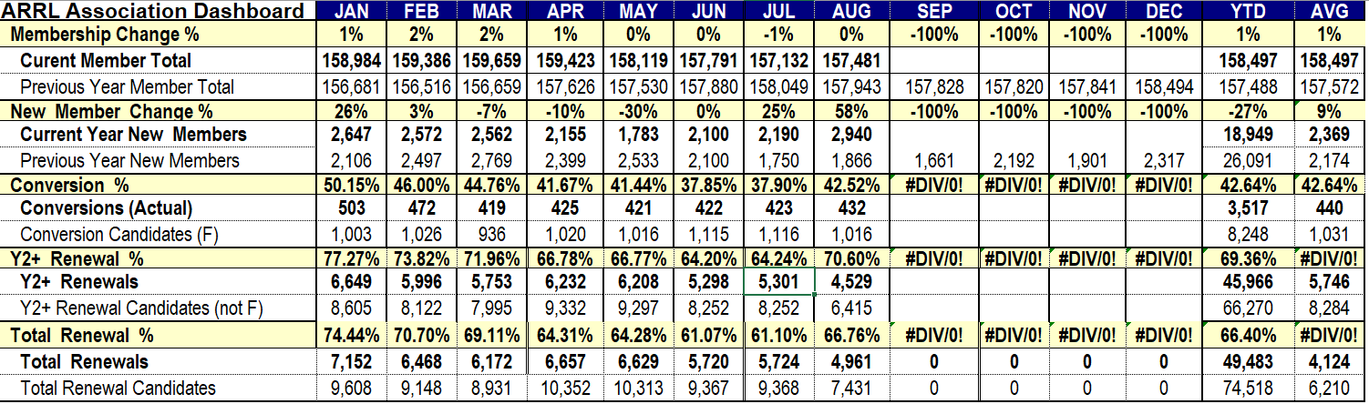

Employee Spotlight
Luci Goodwin, HR Generalist

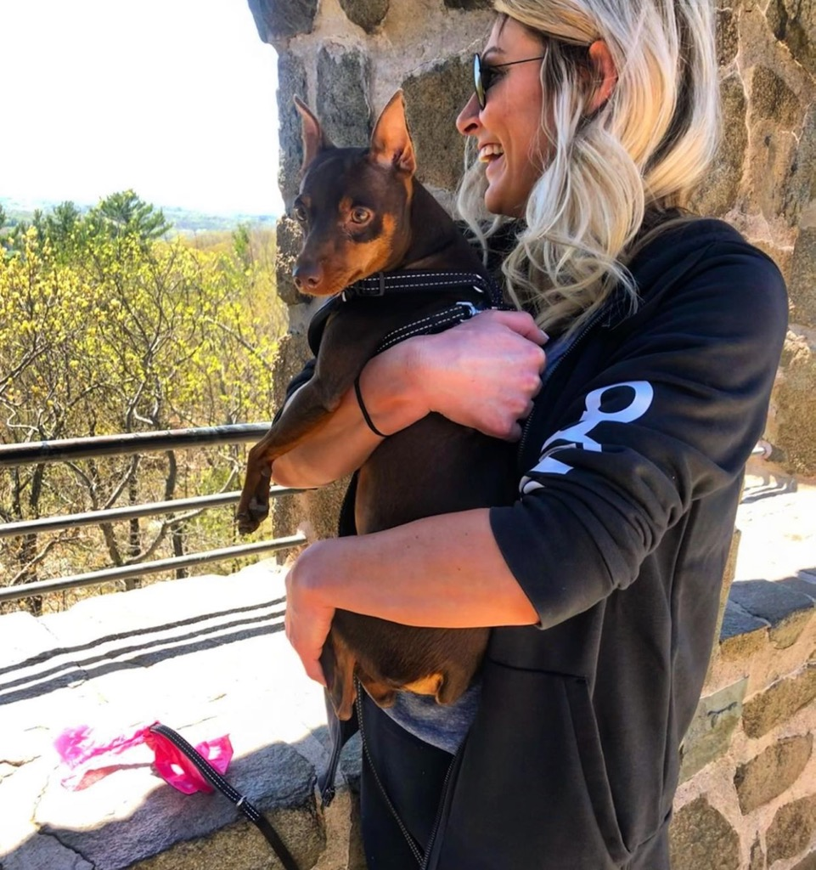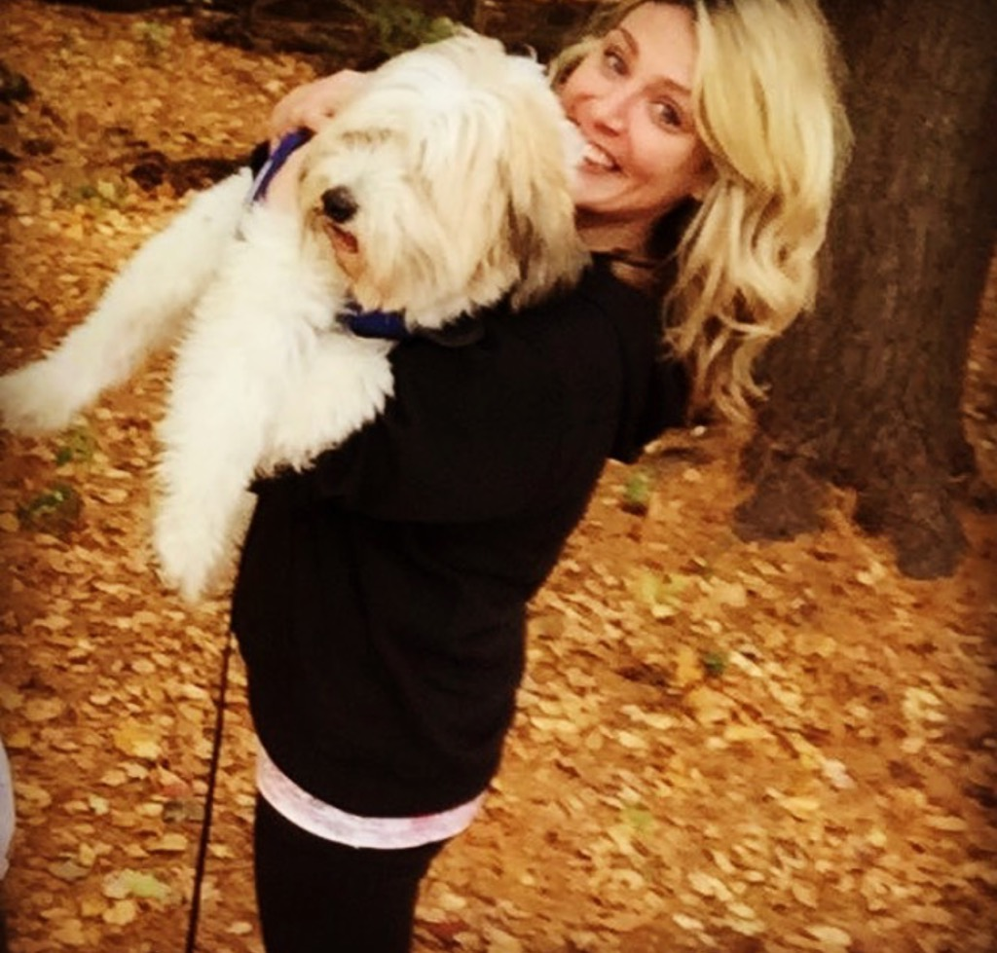

Luci Goodwin is the HR Generalist here at the League. She became a part of the ARRL team in June 2020 as its first Human Resource professional. Under the direction of the CFO, Diane Middleton, Luci is responsible for the day-to-day administration of human resource programs including compensation, benefits, leave, employment, employee orientation, and enforcing company policies and procedures.

She is the go-to person for all employee related issues and plays a key role in the organization offering guidance on recruitment, performance management, employee relations, progressive discipline, and HR best practices.

Luci is also a certified paralegal who worked for the Knights of Columbus world headquarters for almost a decade prior to switching career paths. Luci’s HR career began 13 years ago with the CT Lottery, where she started as an HR Assistant and found her niche. Luci went on to work for Robinson + Cole, a law firm in Hartford, before making her transition to the non-profit world becoming the HR Manager for the Community Health Center Association of Connecticut, an association that works for the greater good of the vulnerable populations and public health centers throughout CT.

In addition to her fulltime role, Luci stages houses part-time for real-estate marketplace sales. Her education includes a bachelor’s degree in Business Administration & HR Management, where she graduated Summa Cum Laude.

Luci was born & raised in Northford, CT, and currently lives in the Morris Cove section of New Haven with her two dogs Ollie & Deedle.

In the winter, she hopes her pursuit of her master’s degree in psychology will begin. When she isn’t at work stealing creamers from the CEO, she enjoys shopping, the beach, hiking, cooking, and reading.
Radiosport
Sharon Taratula

Paper/Fieldcheck Processing Time | 4 Weeks
Logbook Processing Time | 5 – 6 Business Days
2021 DXCC Applications | 7,092
2021 WAS Applications | 2,294
2021 VUCC Applications | 1,336
2021 WAC Applications | 90
2021 WPX Applications | 705
2021 WAZ Applications | 613

Edited by Kelly Wells, Executive Assistant

